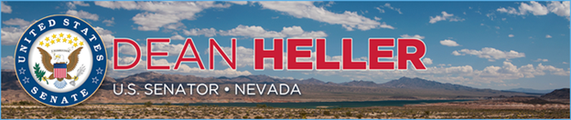

|  |  |
| --- | --- |
| **For Immediate Release:** | **Contact:** [Megan Taylor](mailto:Megan_Taylor@heller.senate.gov) |
| May 29, 2018 | 202-224-6244 |

**At Las Vegas Chamber of Commerce Event, Heller Says He Will Continue Fighting for Nevada’s Economy, Interstate-11, and Veterans***Heller Joined the Las Vegas Metro Chamber of Commerce for their Business Power Lunch Series*

**LAS VEGAS –** Speaking to a group of roughly 150 people, U.S. Senator Dean Heller (R-NV) today shared an update on his work to grow Nevada’s economy, stop Yucca Mountain, and support veterans during the Las Vegas Metro Chamber of Commerce’s Business Power Lunch series. At the event, Heller was also presented with the Spirit of Enterprise Award for his commitment to pro-growth policies.  
  
During his speech, Heller discussed how new laws that he helped craft are allowing small businesses to succeed and hardworking families to keep more of their paychecks. Heller, a member of the tax-writing Senate Finance Committee, was part of the team that wrote the [Tax Cuts and Jobs Act](https://www.heller.senate.gov/public/index.cfm/2017/12/heller-on-president-s-move-to-sign-tax-relief-bill-into-law-today-is-a-good-day-for-nevadans-and-americans-everywhere), which included his amendment that doubled the child tax credit to $2,000 per child and has helped deliver bonuses, expanded employee benefits, pay raises, and more to Nevada’s workers since becoming law in December 2017. Further, as a member of the Senate Banking Committee, he also secured seven of his provisions to help community lenders, protect consumers and veterans, and increase oversight into the recently signed [Economic Growth, Regulatory Relief, and Consumer Protection Act.](https://www.heller.senate.gov/public/index.cfm/pressreleases?ID=DA4EEB2D-45FF-44FC-AB5E-AF17183F6F02)

*“I’m a firm believer that when small businesses succeed, Nevada succeeds,”* ***said Heller.*** *“So I will continue promoting policies that will help ensure that the Silver State continues to thrive and that Nevada’s workforce remains one of the fastest growing in the nation.”*

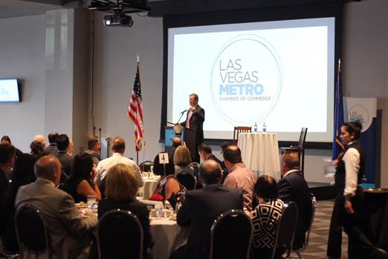

*Heller speaks at Las Vegas Metro Chamber of Commerce’s Business Power Lunch series.*

Heller also provided an update on his efforts to protect the Las Vegas tourism economy. Last week, he [successfully ensured that funding to revive Yucca Mountain was excluded from the U.S. Senate’s version of the defense funding bill](https://www.heller.senate.gov/public/index.cfm/pressreleases?ID=EBEE6498-492C-4E18-ACED-D32A8E90B8F4https://www.heller.senate.gov/public/index.cfm/pressreleases?ID=EBEE6498-492C-4E18-ACED-D32A8E90B8F4) as well as [the U.S. Senate Appropriations Committee’s Energy and Water Appropriations bill](https://www.heller.senate.gov/public/index.cfm/pressreleases?ID=26B7A8B3-58BD-4464-B39D-CC588587B3F5).

“*The House’s recent bipartisan approval of a bill to revive Yucca reinforces exactly what is at stake for the state of Nevada: without my leadership in the United States Senate, Yucca Mountain will get the green light*,” **Heller said**. “*As long as I am in the U.S. Senate, Yucca Mountain is dead. It’s that simple.”*

Additionally, today Heller announced that [as a result of his push, the Department of Homeland Security (DHS) has reconfigured the formula that determines the amount of funding that Las Vegas receives from the Urban Area Security Initiative grant program](https://www.heller.senate.gov/public/index.cfm/pressreleases?ID=2052CD16-A421-472E-9ACF-40F2622DC0C3). For years, Heller has fought for DHS and the Administration to change its formula so that Las Vegas has adequate resources to protect itself. the formula will now take into account visitor and special events data – a request that he has made repeatedly, particularly because Las Vegas hosts more than 20,000 conventions and welcomes more than 40 million visitors each year.

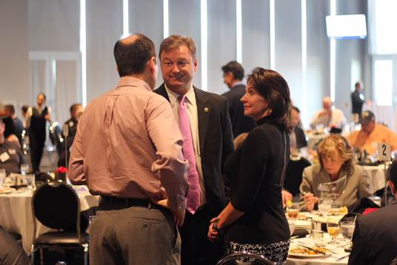

*Heller visits with Las Vegas Metro Chamber of Commerce CEO, Mary Beth Sewald, and others during today’s event.*

Heller, who sits on the powerful U.S. Senate Committee on Commerce, Science and Transportation, which has jurisdiction over infrastructure, also discussed his fight to ensure federal support for projects in Nevada such as the extension of Interstate 11 (I-11), which he helped push through the Senate and into law. In 2015, Heller [introduced legislation to extend I-11 from Las Vegas to Northern Nevada](https://www.heller.senate.gov/public/index.cfm/pressreleases?ID=FC4F8D0E-3B44-4E6A-82E1-6198DEC17667). He [secured this extension and designation of I-11 as a high-priority corridor](https://www.heller.senate.gov/public/index.cfm/pressreleases?ID=D94FBB96-DF60-4ED3-9AB7-6E6EFC351F0E) of the National Highway System in the Fixing America’s Surface Transportation (FAST) Act, the first long-term highway bill in a nearly a decade to be approved by Congress and signed into law.

*“Any infrastructure package coming out of Congress needs to be beneficial to Nevada and ensure the federal resources are there for this project,”* ***said Heller.*** *“So you have my commitment to work together to keep up the momentum and advocate for Nevada in an infrastructure package.*

And finally, Heller spoke about his ongoing efforts to stand up for Nevada’s 300,000 veterans. As a senior member of the Senate Veterans’ Affairs Committee Heller recently helped pass and send to the President’s desk the [VA MISSION Act](https://www.heller.senate.gov/public/index.cfm/pressreleases?ID=CFEFA8BC-5617-41EA-8B18-DA3A2254F863), which will further fund and reform the U.S. Department of Veterans Affairs (VA) Veterans Choice Program, expand eligibility for caregivers, recruit and retain doctors, and streamline the VA health care system

*###*