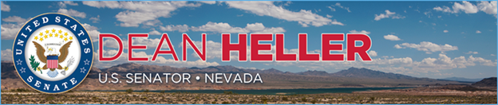

|  |  |
| --- | --- |
| **For Immediate Release:** | **Heller Contact:**[Megan Taylor](mailto:Megan_Taylor@heller.senate.gov) |
| August 24, 2018 | 202-224-6244  **Sheriff’s Office Contact:** [Bob Harmon](http://applewebdata/4DC9B91A-B0A8-4CF2-B785-089809524D6A/BHarmon@washoecounty.us)  775-785-6235 |

**At Washoe County Sheriff’s Office, Heller and Forensic Experts Discuss Efforts to Combat Nevada’s Rape Kit Backlog**

*Heller Authored Law to Help Law Enforcement Test, Track, and Audit Kits*

**RENO** – At the Washoe County Sheriff’s Office Forensic Science Division this morning, U.S. Senator Dean Heller (R-NV), Dr. Lisa Smyth-Roam, supervising criminalist, and Kerri Heward, director of the division, discussed Nevada’s progress in reducing the number of untested sexual assault kits.

Heller received a briefing from both Dr. Smyth-Roam and Brittney Chilton, criminalist, before taking a tour of the facility and seeing the lab. The Washoe County Sheriff’s Office Forensic Science Division provides forensic services for 13 of the state’s 17 counties.

Heller has championed several policies and fought for federal funding to combat the state’s rape kit backlog, by providing resources to support DNA analysis, lab capacity enhancement, and implement an evidence-based program to audit, track, and report untested sexual assault kits.

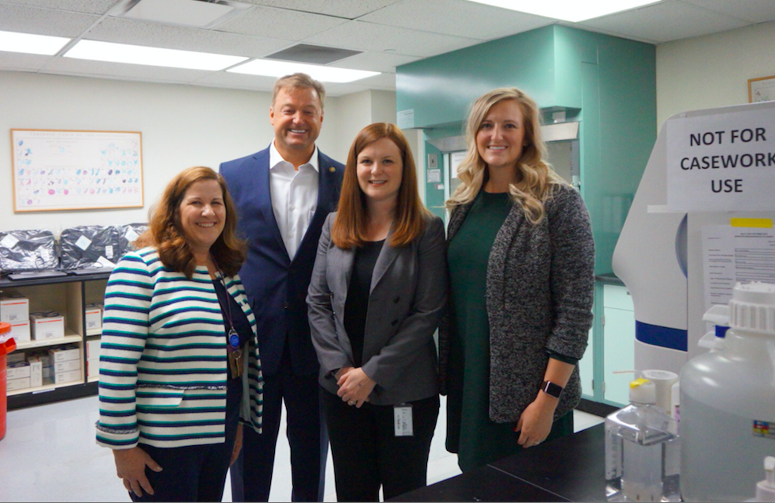  
*Heller with Forensic Science Division Director Kerri Heward, Supervising Criminalist Dr. Lisa Smyth-Roam, and Criminalist Brittney Chilton.*  
**\*Media has permission to use photograph\***

As of June 30th, 6,367 of the Nevada kits had been sent to labs for testing, while 4,871 had actually completed the testing process, or 63 percent, [according to a recent report](https://mynews4.com/news/local/83-percent-of-backlogged-sexual-assault-kits-in-nevada-tested-resulting-in-12-arrests). Out of those kits that completed the testing process, the DNA has hit a match in 466 of the cases. At least 12 arrests have been made in Nevada as a result.  
  
“Victims of heinous crimes such as sexual assault deserve swift justice, and that’s why I’m so proud of the work that the Washoe County Sheriff’s Office Forensic Science Division is doing to cut down on the state’s backlog of untested sexual assault kits,” **said Heller.** “As a strong supporter of authorizing and supporting legislation to fund grant programs that allow our law enforcement and forensic experts to continue their operations, I’m committed to doing everything I can to secure continued federal resources for this division, and all labs in Nevada.”  
  
“We agreed that it was important to test all previously un-submitted sexual assault kits. However, initially we were concerned about the size of the endeavor and its impact on our ongoing case load,” **Washoe County Sheriff’s Office Forensic Science Division Director Kerri Heward said**. “Thanks to substantial support from our federal and state partners, funding was secured to test all the un-submitted sexual assault kits in Northern Nevada with minimal impact to ongoing cases. All un-submitted sexual assault kits are expected to be tested by spring of 2019. Continued federal support, such as the SAFER Act, whichSenator Dean Heller introduced and pushed into law, will help to prevent backlogs from occurring in the future.   
  
Earlier this year, [President Trump signed into law a bipartisan bill Heller introduced](https://www.heller.senate.gov/public/index.cfm/pressreleases?ID=22188F0C-BA3C-40AC-B54A-4F03E5F45374) called the [Sexual Assault Forensic Evidence Reporting (SAFER) Act](https://www.heller.senate.gov/public/index.cfm/pressreleases?ID=AC843F36-1234-4CB6-BC03-173239BDD647) that reauthorizes, strengthens, and extends the SAFER program in an effort to reduce the nationwide rape kit backlog.  
  
Heller has also co-authored the [Debbie Smith Crime Victims Protection Act](https://www.heller.senate.gov/public/index.cfm/2018/3/heller-cornyn-feinstein-klobuchar-introduce-the-debbie-smith-crime-victims-protection-act),legislation to reauthorize the Debbie Smith Actand dedicate much-needed resources to state and local law enforcement agencies to conduct forensic analyses of crime scenes, including untested rape kits. In January, Heller teamed up with John Cornyn (R-TX) and Amy Klobuchar (D-MN) to introduce [the Justice Served Act](https://www.heller.senate.gov/public/index.cfm/2018/1/heller-cosponsors-bill-to-help-prosecute-sex-offenders-rapists-and-other-criminals-in-dna-cold-cases), which would provide funds to prosecute the rape kit backlog and deliver justice for victims of crimes like sexual assault by resolving cold cases and exonerating those wrongfully convicted of crimes they did not commit.   
  
In 2014, Senator Heller helped secure federal funding for the Sheriff’s Office to purchase an instrument for the Forensic Science Division that is used daily in the analysis of controlled substance cases. This instrument allows a Criminalist to analyze and identify controlled substances and report the results to the submitting agencies and the District Attorney’s Office for prosecution of cases.

###

[cid:image003.png@01D43BB8.EDC5C710](http://www.facebook.com/pages/US-Senator-Dean-Heller/325751330177)[cid:image004.png@01D43BB8.EDC5C710](http://twitter.com/SenDeanHeller)[cid:image005.png@01D43BB8.EDC5C710](http://www.youtube.com/user/SenDeanHeller)