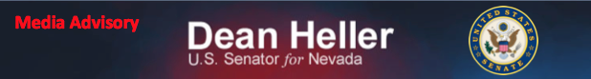For Immediate Release:
August 19, 2014

Heller Holds Media Availability in Reno Following VA Roundtable with Sec. Robert McDonald

Media Advisory

On Tuesday, August 19, 2014, Senator Dean Heller will attend and speak at a VA Roundtable with VA Sec. Robert McDonald. Senator Heller will discuss the Reno VA Regional Office and care provided to veterans at the Reno VA Hospital. Following the event, at approximately 5:30 p.m. PT, Senator Heller will be available to the media.

Who: U.S. Senator Dean Heller

What: Heller available to speak to media following Reno VA Roundtable.

When: Tuesday, August 19, 2014
Media availability: approximately 5:30-5:45 p.m. PT
Where: Reno VA Medical Center
975 Kirman Avenue
Reno, NV 89502

For more information, please contact Chandler Smith chandler_smith@heller.senate.gov or (202) 224-6244.

###

