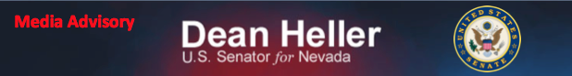For Immediate Release:
August 18, 2014

Heller Attends Lake Tahoe Summit; Meets with VA Secretary McDonald

Media Advisory

On Tuesday, August 19, 2014, Senator Dean Heller will be available to media following two events.

First, Senator Heller will attend and speak at the 2014 Lake Tahoe Summit. The Senator will discuss drought, wildfire and invasive species, and other issues affecting Lake Tahoe.

Who: U.S. Senator Dean Heller

What: Heller available to speak to media following 2014 Lake Tahoe Summit event. The event will take place from 10:00-12:00 p.m. PT.

When: Tuesday, August 19, 2014
Media availability after the event
Where: Valhalla Estate
1 Valhalla Road
South Lake Tahoe, CA

Second, Senator Dean Heller will be available to media following a meeting with VA Secretary Robert McDonald at approximately 5:15 p.m. PT, or at the conclusion of the meeting.

Who: U.S. Senator Dean Heller

What: Heller available to speak to media following meeting with VA Secretary Robert McDonald.

When: Tuesday, August 19, 2014
Media availability: approximately 5:15-5:30 p.m. PT or at the conclusion of the meeting
Where: Reno VA Medical Center
975 Kirman Avenue
Reno, NV 89502

For more information, please contact Chandler Smith chandler_smith@heller.senate.gov or (202) 224-6244.

###

