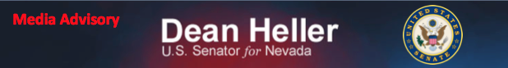For Immediate Release:
September 24, 2014

Heller Available to Media Following Las Vegas Asian Chamber Speech in Las Vegas

Media Advisory

On Thursday, September 25, 2014, U.S. Senator Dean Heller will be the keynote speaker at the Las Vegas Asian Chamber of Commerce meeting in Las Vegas at the Gold Coast Casino located at 4000 W. Flamingo Road in Las Vegas.

Media is invited to attend. Senator Heller will have media availability following the event at 1:00 p.m. PST.

Who: U.S. Senator Dean Heller

What: Keynote Speaker at the Las Vegas Asian Chamber of Commerce meeting

When: Thursday, September 25, 2014
11:30 a.m. to 1:00 p.m. PST
Where: The Gold Coast Casino, 4000 W. Flamingo Road in Las Vegas.

For more information, please contact Neal Patel at neal_patel@heller.senate.gov or (202) 224-6244.

###

