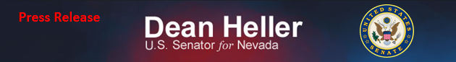
For Immediate Release: Contact: Chandler Smith
September 16, 2013 202-224-6244

Heller Statement on Navy Yard Shooting

(Washington, D.C.) – U.S. Senator Dean Heller (R-NV) issued the following statement regarding the Navy Yard shooting in Washington, D.C.

“As more details emerge, the extent of the shooting at Navy Yard is becoming even more apparent. Both Lynne and I are deeply saddened by this morning’s tragedy, and our thoughts and prayers go out to all of the victims and their families. Thank you to all of the first responders and medical personnel who continue to display their heroic acts.

“Our nation’s military men and women know all too well what it means to put themselves in harm’s way to spread freedom and democracy. It is unfortunate that the safety of those serving here at home at the Navy Yard base was compromised,” said Senator Heller.
###

