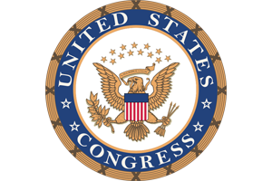 Press Release:

Nevada Congressional Delegation

**For Immediate Release:** Contact:

January 31, 2014 Chandler Smith (Heller)

202-224-6244

**Nevada Congressional Delegation Urges Secretary of Homeland Security to Ensure Las Vegas has Necessary Recourses to**

**Combat Potential Terror Attacks**

**(Washington, D.C.)** – Nevada’s congressional delegation sent a letter to Jeh Johnson, Secretary of Homeland Security, urging him to review current Federal Emergency Management Agency (FEMA) formulas used to determine risk of terror threats in urban areas such as Las Vegas. The letter asks Secretary Johnson to take into consideration the unique challenges that Las Vegas as a premier tourist destination poses in the ongoing changes to prevent terror attacks in the United States.

A PDF of the letter is attached with this release.

**Full text of the letter below**:

###