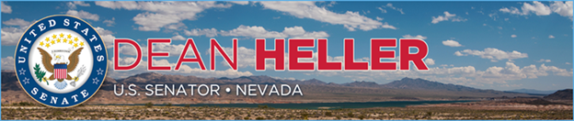

|  |  |
| --- | --- |
| **For Immediate Release:** | **Contact:**[Megan Taylor](mailto:Megan_Taylor@heller.senate.gov) |
| May 12, 2018 | 202-224-6244 |

**Nevada Media Reports on Heller’s Fight to Block the House’s Yucca Mountain Bill**

**WASHINGTON –**In case you missed it, Nevada media yesterday highlighted U.S. Senator Dean Heller’s (R-NV) push to block legislation passed by the U.S. House of Representatives that will resuscitate Yucca Mountain.   
  
[In a speech delivered on the U.S. Senate floor](https://www.heller.senate.gov/public/index.cfm/pressreleases?ID=515868C0-CB6C-4E48-9EB1-535874F528A7), Heller made clear to his colleagues that he will block the Nuclear Waste Policy Amendments Act, H.R.3053, which passed the U.S. House is a bipartisan vote of 340-72.   
  
  
[**Heller Says House Bill to Revive Yucca Mountain is "Dead on Arrival" in the Senate**](https://youtu.be/xxfd8BFvz9Y)Fox 5 Vegas  
  
[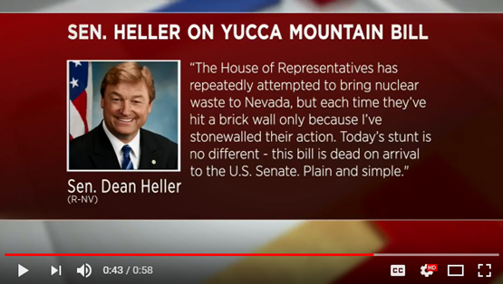](https://youtu.be/xxfd8BFvz9Y)

Click [HERE](https://youtu.be/xxfd8BFvz9Y) or the image above to play the clip.

[**[](https://youtu.be/q6riFXtcbQI)  
KRNV Reports on Heller's Opposition Yucca Mountain Bill**](https://youtu.be/q6riFXtcbQI)News 4 Reno

[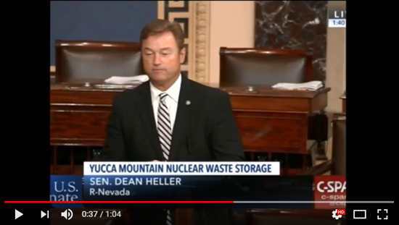](https://youtu.be/q6riFXtcbQI)

[Click HERE or the image above to play the clip.](https://youtu.be/q6riFXtcbQI)

###

[cid:image002.png@01D4707F.057F3FD0](http://www.facebook.com/pages/US-Senator-Dean-Heller/325751330177)[cid:image003.png@01D4707F.057F3FD0](http://twitter.com/SenDeanHeller)[cid:image004.png@01D4707F.057F3FD0](http://www.youtube.com/user/SenDeanHeller)