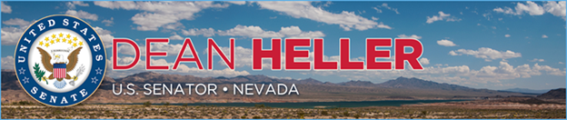

|  |  |
| --- | --- |
| **For Immediate Release:** | **Contact:**[Megan Taylor](mailto:Megan_Taylor@heller.senate.gov) |
| April 25, 2018 | 202-224-6244 |

**New Report: Heller 5th Most Bipartisan U.S. Senator**

**WASHINGTON** – [A new index released by the Lugar Center and Georgetown University McCourt School of Public Policy](http://www.thelugarcenter.org/assets/htmldocuments/Senate%20Scores%20115th%20Congress%20First%20Session.pdf) has ranked U.S. Senator Dean Heller (R-NV) as the country’s fifth most bipartisan senator serving in the U.S. Senate, or in the top 5 percent of the 98 U.S. Senators evaluated in the non-partisan index.  
  
[According to The Lugar Center](https://mccourt.georgetown.edu/bipartisan-index), the Bipartisan Index is a non-partisan tool that measures the degree to which representatives in Congress work across party lines. The rankings are based on bill sponsorship and co-sponsorship data in 2017 and the formula is applied uniformly to all members. The sponsors of the Index state that there are no subjective judgments made about individual members or bills, and that it serves to provide valuable information to constituents and the media about their representative.  
  
“Since coming to Washington, my number one focus has always been the people of Nevada. Their interests and their priorities are my priorities and have always – and will always – transcend party lines. From making sure our veterans have access to the care they need to combating the drug crisis, I’ve been proud to work with my friends across the aisle on bipartisan initiatives that are important to communities in Nevada,” **said Heller.** “Late Governor Kenny Guinn was a mentor of mine, and he often spoke about two types of people: those who solve problems and those who talk about them. I’ve carried his advice to be a problem solver with me, and by working with others I’ve been able to deliver results for my home state. Whether its pushing our legislation to help fight childhood cancers or supporting policies that will help ensure Nevada remains one of the fastest growing workforces in the nation, I’ll continue to champion bipartisan initiatives that will move Nevada – and this country – forward.”  
  
“Senator Heller’s high ranking on the Bipartisan Index shows that he was willing to consider good ideas from across the aisle in 2017 and to work hard to craft his own legislative initiatives so they would have broad appeal,” **said Sen. Richard Lugar (Ret.), Republican of Indiana and President of The Lugar Center.**

###

[cid:image002.png@01D4707F.057F3FD0](http://www.facebook.com/pages/US-Senator-Dean-Heller/325751330177)[cid:image003.png@01D4707F.057F3FD0](http://twitter.com/SenDeanHeller)[cid:image004.png@01D4707F.057F3FD0](http://www.youtube.com/user/SenDeanHeller)