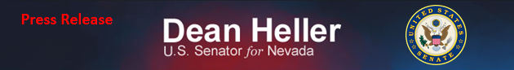
For Immediate Release: Contact: Neal A. Patel November 19, 2014 202-224-6244

Heller Statement on NHTSA Nomination

(Washington, DC) – United States Senator Dean Heller (R-NV), ranking member of the Senate Commerce, Science, and Transportation subcommittee on Consumer Protection, Product Safety, and Insurance issued the following statement on the nomination of Dr. Mark R. Rosekind to serve as the administrator of the National Highway Traffic Safety Administration (NHTSA):

“While it took the Administration almost a year to select a nominee, I’m relieved to see NHTSA will no longer be without a director. Protecting consumers by overseeing motor vehicle safety laws continues to be a responsibility that must not be ignored. I’m looking forward to meeting with Dr. Rosekind to discuss how he plans to make consumer safety a top priority at NHTSA.”

###

