

|  |  |
| --- | --- |
| **For Immediate Release:** | **Contact:**[Megan Taylor](mailto:Megan_Taylor@heller.senate.gov) |
| May 21, 2018 | 202-224-6244 |

**PHOTOS: Heller Honors Nevada’s Asian-American Community, Delivers Keynote at Hope for Prisoners Graduation in Las Vegas**

**LAS VEGAS** – In case you missed it, this past weekend U.S. Senator Dean Heller (R-NV) highlighted the contributions of Nevada’s Asian-American community during the first-ever Asian Culture Day celebration in Las Vegas, NV.   
  
Additionally, Heller delivered a keynote address at the graduation of Hope for Prisoners, a Las Vegas-based nonprofit that helps former inmates return to the community and workforce through a reintegration-mentoring program. From job development to leadership training to computer skills, HOPE for Prisoners provides comprehensive services and has helped more than 2,000 individuals since it was established less than a decade ago.  
  
“*You are graduating today because you have worked hard, because you committed to a better future for yourselves and your families, and because you have the resilience, perseverance, and the courage to see it through*,” **said Heller.** “*While there are many steps that we need to take to improve the current system, encouraging and securing community involvement is essential. HOPE for Prisoners does just that, and today over 200 trained volunteers and mentors from the Las Vegas community are united in their shared efforts to reach out to those who need help getting back on their feet*.”

*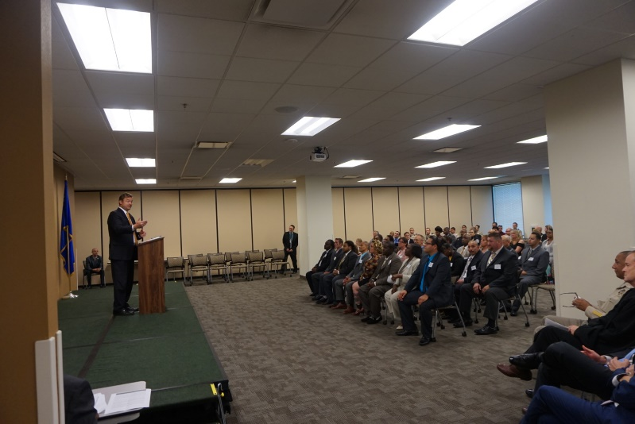  
Heller speaks at the Hope for Prisoners graduation ceremony.*

*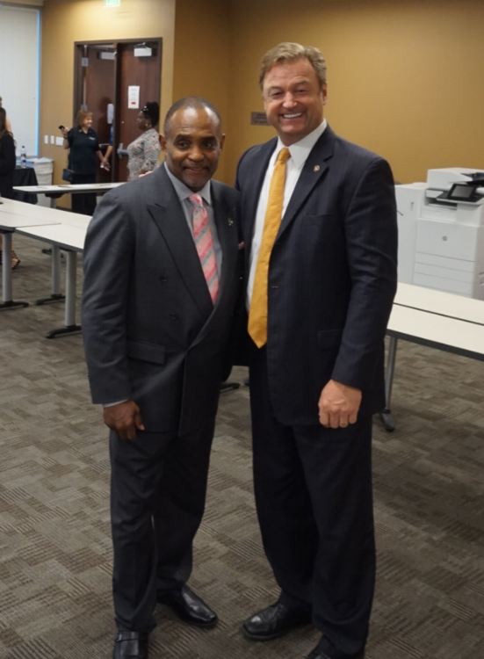  
Heller and Jon Ponder, chief executive officer of Hope for Prisoners.*

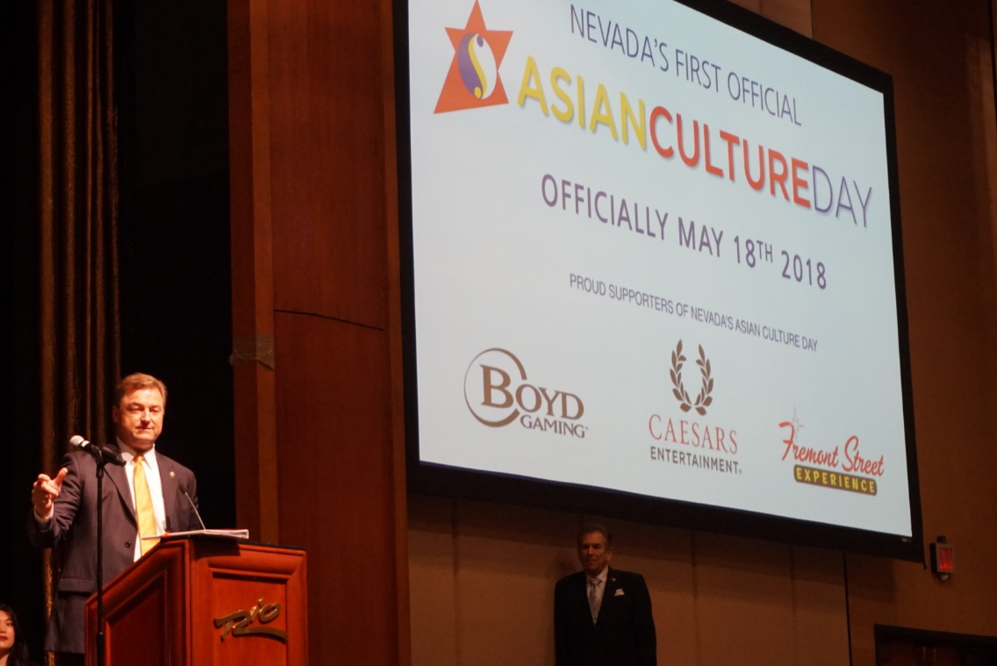  
*Heller speaks to attendees at the first Asian Culture Day.*

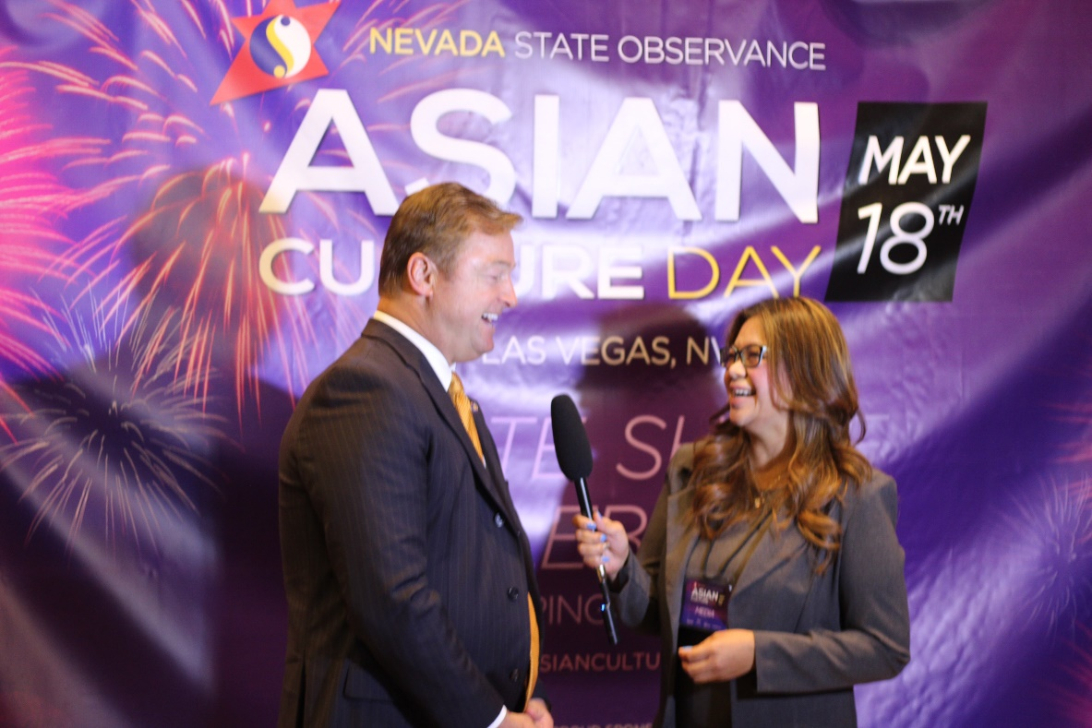

*Heller talks with a reporter from Asian Culture TV about the significance of the celebration.*

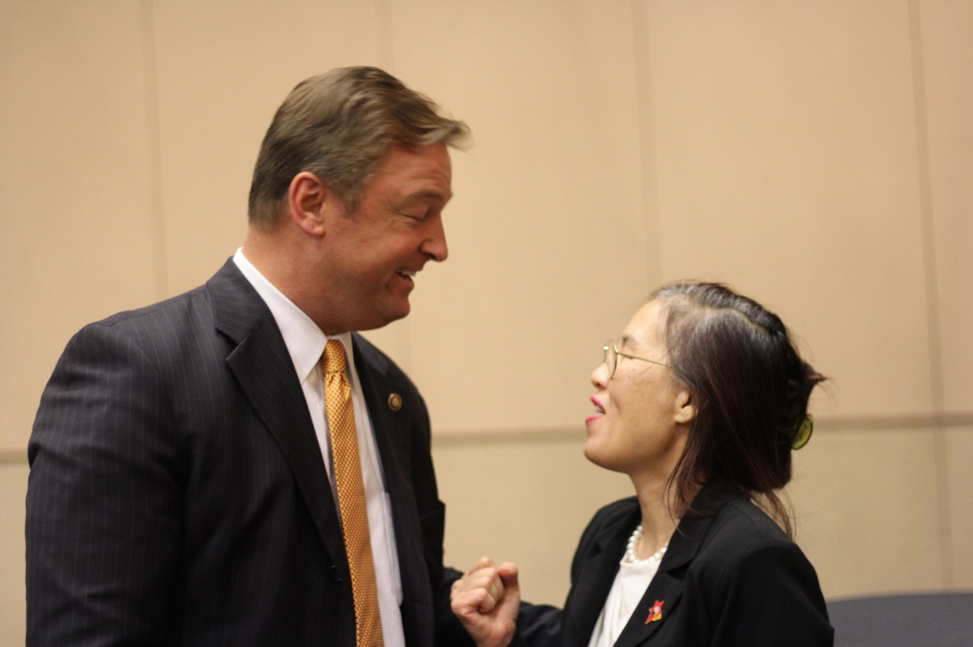  
*Heller talks with Rosaline Schorr, organizer of the Asian Culture Day.*

###

[cid:image002.png@01D454FA.27751A10](http://www.facebook.com/pages/US-Senator-Dean-Heller/325751330177)[cid:image003.png@01D454FA.27751A10](http://twitter.com/SenDeanHeller)[cid:image004.png@01D454FA.27751A10](http://www.youtube.com/user/SenDeanHeller)