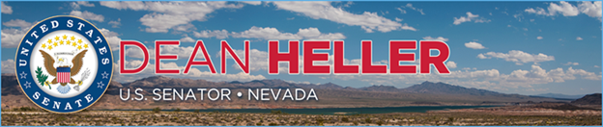

|  |  |
| --- | --- |
| **For Immediate Release:** | **Contact:**[Megan Taylor](mailto:Megan_Taylor@heller.senate.gov) |
| June 13, 2018 | 202-224-6244 |

**PHOTOS: Heller Stands Up for Victims of Domestic Abuse at Key Event with Nevada Advocates** *Heller Delivers Speech Before the National Network to End Domestic Violence*

**WASHINGTON** – Speaking before a group of approximately 70 advocates dedicated to ending domestic violence, U.S. Senator Dean Heller (R-NV) said last night that he will continue fighting for Congress to pass his legislation that supports survivors of domestic abuse and their dependents. Heller delivered a speech before the National Network to End Domestic Violence (NNEDV), a nonprofit group that represents more than 2,000 organizations located across the country, including the Nevada Coalition to End Domestic and Sexual Violence. Sue Meuschke, the executive director of the Nevada Coalition to End Domestic and Sexual Violence, was present and today she met with Heller in his office to discuss the organization’s challenges and priorities.

[Heller is the author of bipartisan legislation that reauthorizes the Family Violence Prevention and Services Act (FVPSA](https://www.heller.senate.gov/public/index.cfm/pressreleases?ID=10B46EC8-A85C-4DD3-BBE7-8FA9DD011EC9)), a historic law enacted in 1984 that directs funding to states and tribes to help provide supportive services such as shelter, counseling, legal assistance and more to victims of domestic abuse and their dependents. Additionally the bill funds prevention programs and 24-hour victim assistance through the National Domestic Violence Hotline, a toll-free helpline in which highly-trained advocates offer victims of relationship abuse assistance over the phone and through their website at <http://www.thehotline.org/>.

“According to the 2016 National Census of Domestic Violence Services, in one day alone hundreds of Nevadans and nearly 73,000 victims around the country were served by programs that the Family Violence Prevention Services Act supports,” **said Heller.** “To put that into perspective: the number of people helped by these programs on a single day could fill a professional football stadium. Now, Congress must act again to ensure that survivors continue to have access to these critical programs.”

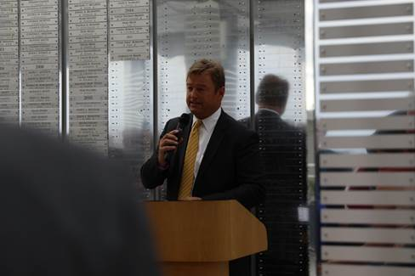

*\*Media has permission to use photo*.

“I commend you for being here in Washington, D.C. to advocate on behalf of those who are most in need of a beacon of hope, and I look forward to continue working with you on solutions that will do just that,” **said Heller.**

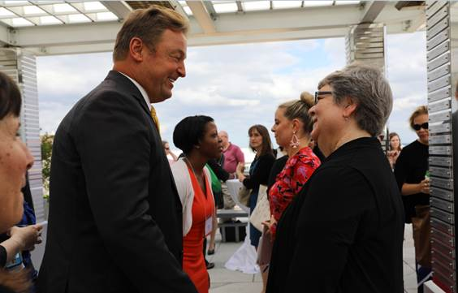

*Heller speaks with Sue Meuschke, the executive director of the Nevada Coalition to End Domestic and Sexual Violence.*

*\*Media has permission to use photo.*

“FVPSA reaches into almost every community in our country as a lifeline for survivors in crisis. This critical federal program is the foundation upon which all domestic violence services are built and delivered**,” said Kim Gandy, President and CEO of NNEDV**. “FVPSA ensures victims and their children have a place to go when they flee their homes to escape life-threatening violence.”

Heller also discussed his [Pet and Women Safety (PAWS) Act](https://www.heller.senate.gov/public/index.cfm/2017/2/heller-peters-introduce-the-pet-and-women-safety-act), a bill he introduced with Senator Gary Peters (D-MI), that protects victims of domestic violence, sexual assault, stalking and dating violence from emotional and psychological trauma caused by violence against their pets. The legislation today passed the U.S. Senate Committee on Agriculture, Nutrition & Forestry as part of broader agriculture legislation.

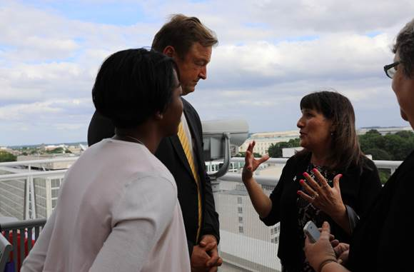

*Heller speaks with leaders from the National Network to End Domestic Violence*

*\*Media has permission to use photo.*

Heller is also a strong supporter of reauthorizing the Violence Against Women Act (VAWA), which will strengthen prevention efforts and help our nation’s most vulnerable find safe haven. Additionally, following [his request to Senate Appropriations Committee earlier this year, funding for VAWA was included in the fiscal year 2018 omnibus package.](https://www.heller.senate.gov/public/index.cfm/2018/3/heller-secures-nv-priorities-in-spending-measure-bill-now-headed-to-the-president-s-desk)



