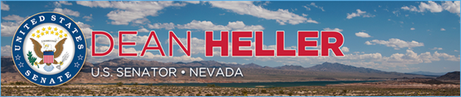

|  |  |
| --- | --- |
| **For Immediate Release:** | **Contact:**[Megan Taylor](mailto:Megan_Taylor@heller.senate.gov) |
| June 25, 2018 | 202-224-6244 |

**PHOTOS:** **President Trump, Heller Applaud Tax Reform’s Impact in Nevada at Roundtable**

**LAS VEGAS** – In case you missed it, [U.S. Senator Dean Heller (R-NV) joined President Donald J. Trump at a tax reform roundtable](https://www.heller.senate.gov/public/index.cfm/2018/6/president-trump-heller-discuss-tax-reform-s-impact-in-nevada-with-hardworking-nevadans-and-local-job-creators) at South Point Hotel Casino & Spa this weekend focused on how the Tax Cuts and Jobs Act has benefitted Nevada’s hardworking families, small business owners, and local employers. Watch the full roundtable [HERE](https://youtu.be/9INXqnPU_8U).  
  
In addition to Heller and President Trump, roundtable participants included: U.S. Department of Labor Secretary Alex Acosta; Nevada Attorney General Adam Laxalt; Steve Witkoff, developer of The Drew; Barbara Erickson, construction project manager for The Witkoff Group; Ryan Growney, general manager for South Point Hotel Casino & Spa; Jason Monge, restaurant manager for South Point Hotel Casino & Spa; Elisa and Richard Slider, co-owners of Silver State Hay; and Cavin Fung, founder and president of Asian Culture Alliance.

“Senator Dean Heller has been somebody that really got in and he fought as hard as anybody I know to make sure that you got that tax cut and reform, and that everybody else in our country got it,” **said President Trump.**   
  
“Positive business activity is made possible when government, private investors, and labor come together in a way that benefits everybody,” **said Steve Witkoff, developer of The Drew.** “Here, on this project — the Fountainebleau, which we will start construction activity in July of 2019 — we will create approximately 11,000 jobs in Nevada. And we will create a solid investment for ourselves, and thereby make a contribution to U.S. GDP growth because of all of this, and because of the President’s policies.”  
  
“Sir, your tax cuts have really helped our business,” **said Elisa Slider, co-owner of Silver State Hay.**“They really have. And we appreciate that. We — recently I was able to hire another family member due to some of the money we’ve been saving, and we’ve had a recent increase in sales — about 30 percent increase this year so far.  Our customers are confident in the economy right now. So, before, they were barely making it, barely able to afford their hay. And right now they’re actually stocking up. So that’s been a huge, huge benefit for us and for them, as well.

“On this property, I can assure you, the tax cuts affected our employees and our business,” **said Ryan Growney, general manager of South Point Hotel Casino & Spa.**“The first is, we were excited about the announcement. We know it’s going to be good for the economy. We know it’s the right move. We wanted to make sure our employees were excited about it. So shortly after the announcement was made, my boss picked up the phone and asked our payroll director, what would it cost us to do a second round of holiday bonus checks. And she says, a little over a half-million dollars. And we just sent them out three weeks prior. And he says, please prepare the checks and get them in the employees’ hands as soon as possible.”

*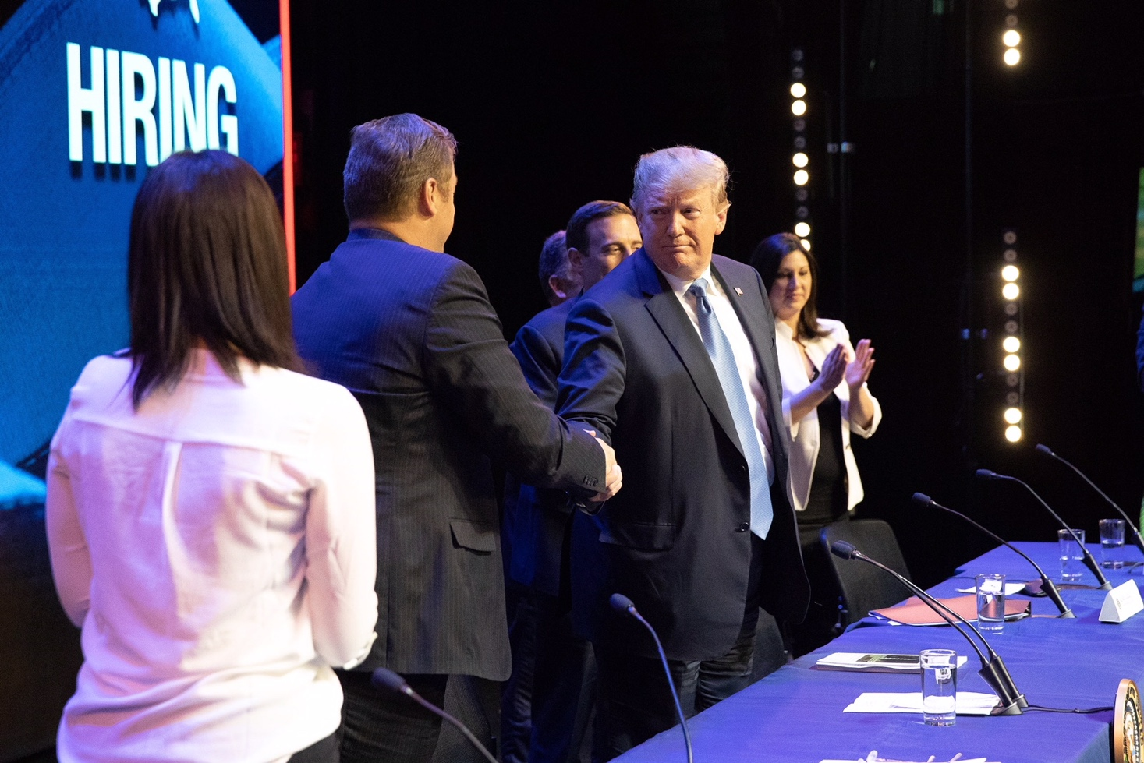  
Sen. Heller and President Trump shake hands at the tax reform roundtable.*

*[Picture provided by the White House]  
  
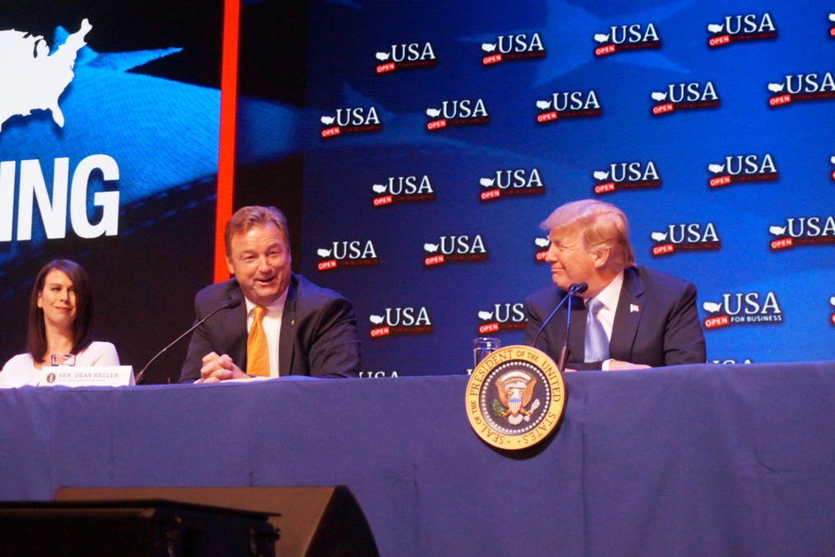  
Sen. Heller delivers remarks at the tax reform roundtable.   
  
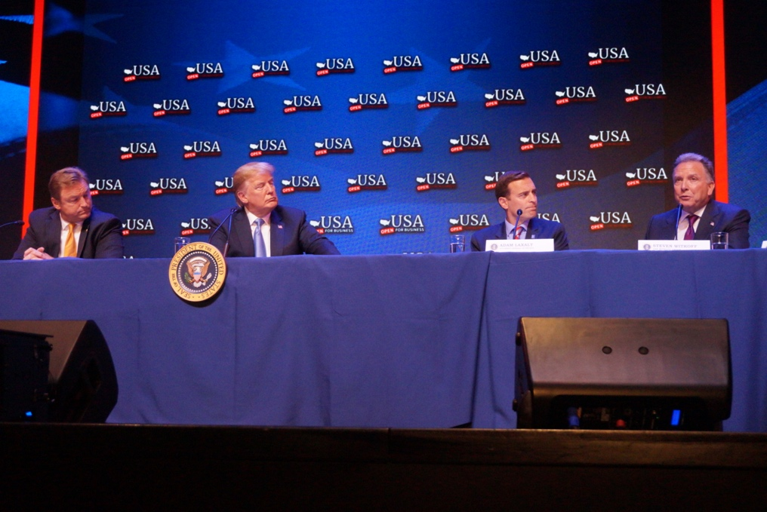  
Steve Witkoff, developer of The Drew, shares how tax reform will jumpstart Southern Nevada’s economy.   
  
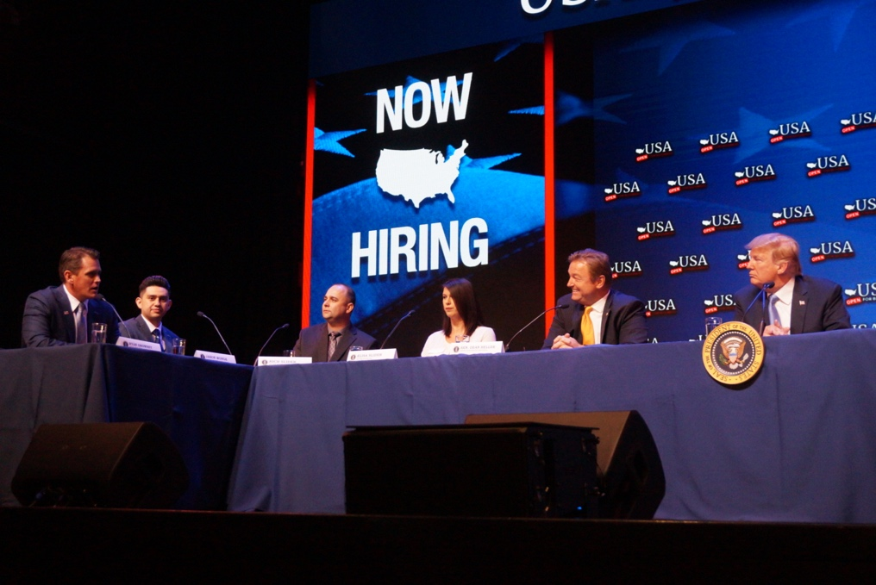  
Ryan Growney, general manager for South Point Hotel Casino & Spa, discusses how tax reform enabled the company to give back to their employees with bonuses.   
  
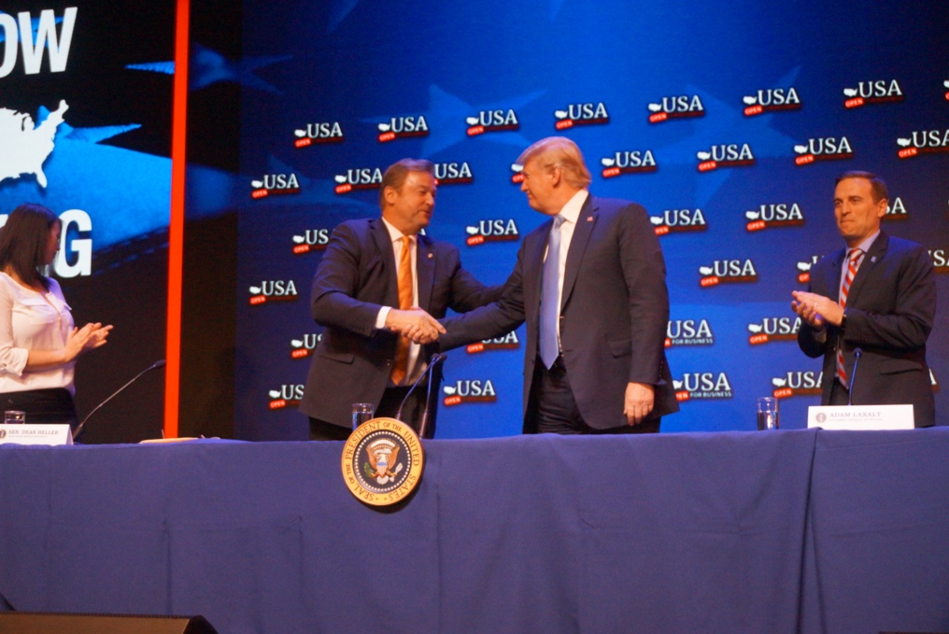  
Sen. Heller and President Trump at the tax reform roundtable.*

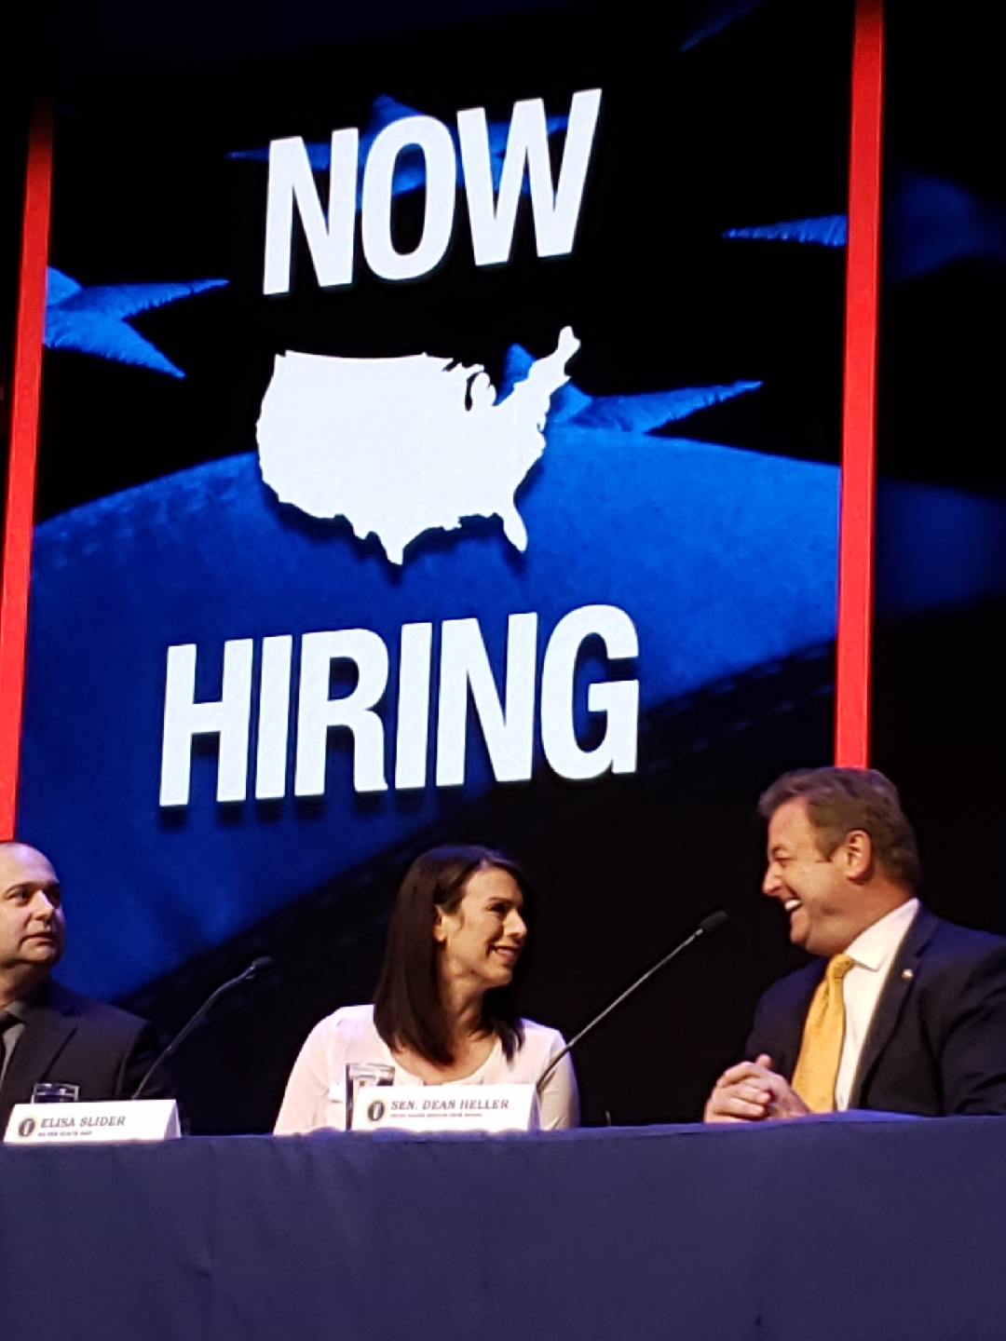

*Sen. Heller speaks with Elisa Slider, co-owner of Silver State Hay.*

[/var/folders/py/y368pz856vq9t8rzxjdkm4ch0000gp/T/com.microsoft.Word/WebArchiveCopyPasteTempFiles/cidimage006.png@01D38BB3.112412E0](http://www.facebook.com/pages/US-Senator-Dean-Heller/325751330177)[/var/folders/py/y368pz856vq9t8rzxjdkm4ch0000gp/T/com.microsoft.Word/WebArchiveCopyPasteTempFiles/cidimage007.png@01D38BB3.112412E0](http://twitter.com/SenDeanHeller)[/var/folders/py/y368pz856vq9t8rzxjdkm4ch0000gp/T/com.microsoft.Word/WebArchiveCopyPasteTempFiles/cidimage008.png@01D38BB3.112412E0](http://www.youtube.com/user/SenDeanHeller)