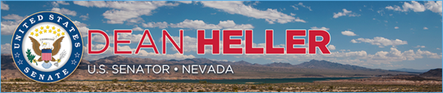

|  |  |
| --- | --- |
| **For Immediate Release:** | **Contact:** [Megan Taylor](mailto:Megan_Taylor@heller.senate.gov) |
| October 10, 2017 | 202-224-6244 |

**President Signs Heller Bill to Help Nevada Investors**

**Washington, D.C.** – U.S. Senator Dean Heller (R-NV) announced that The Fair Access to Investment Research Act of 2017, legislation he introduced to help Nevadans better understand complicated financial investments, has been signed into law by President Donald Trump.

Currently, securities laws provide legal protections for broker-dealers to provide research reports for several asset classes such as listed stocks and corporate debt — but not for Exchange Traded Funds (ETFs). The [Fair Access to Investment Research Act](https://www.heller.senate.gov/public/index.cfm/pressreleases?ID=46592DA0-AEC5-420B-B5C1-243AD357A02D) would create parity in the law by allowing broker-dealers to publish public research reports on ETFs, which millions of households invest in.

“This new law will help Nevadans better understand the financial benefits and risks when they are making tough investment decisions, such as saving for their retirement years, children’s education, or even for an emergency fund,” **Heller said.** “I thank the President for signing my bill into law as well as Senator Gary Peters, Congressman French Hill, and Congressman Bill Foster for helping me push this legislation over the finish line.”

The President [signed Heller’s bill on Friday, October 6, 2017](https://www.whitehouse.gov/the-press-office/2017/10/06/president-donald-j-trump-signs-hr-2519-s-327-s-810-and-s-1141-law). The [U.S. House of Representatives passed Heller’s bill](https://www.heller.senate.gov/public/index.cfm/pressreleases?ID=528B2B38-5244-4158-853E-43AE3AD17BF4) two weeks ago, and the [U.S. Senate unanimously approved the legislation](https://www.heller.senate.gov/public/index.cfm/2017/9/senate-passes-heller-bills-to-aid-nevada-s-small-businesses-investors-and-taxpayers) in early September.

###

[cid:image002.png@01D341B9.49568B00](http://www.facebook.com/pages/US-Senator-Dean-Heller/325751330177)[cid:image003.png@01D341B9.49568B00](http://twitter.com/SenDeanHeller)[cid:image004.png@01D341B9.49568B00](http://www.youtube.com/user/SenDeanHeller)