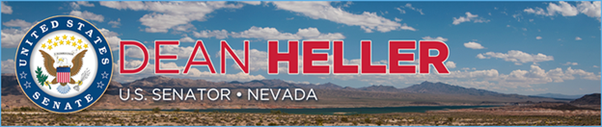

|  |  |
| --- | --- |
| **For Immediate Release:** | **Contact:** [Megan Taylor](mailto:Megan_Taylor@heller.senate.gov) |
| January 8, 2018 | 202-224-6244 |

**President Signs into Law Heller Bill to Reduce National Rape Kit Backlog***National Organization Applauds Heller for his Efforts in Championing the SAFER Act*

**Washington, D.C.** – U.S. Senator Dean Heller (R-NV) announced today that President Trump has signed into law the [Sexual Assault Forensic Evidence Reporting (SAFER) Act](https://www.heller.senate.gov/public/index.cfm/pressreleases?ID=AC843F36-1234-4CB6-BC03-173239BDD647), a bipartisan bill introduced by Heller along with Senators John Cornyn (R-TX), Amy Klobuchar (D-MN), and Michael Bennet (D-CO). This bipartisan legislation reauthorizes, strengthens, and extends the SAFER program in an effort to reduce the nationwide rape kit backlog.

In addition to reauthorizing this program, the legislation highlights the importance of and need for pediatric sexual assault nurse examiners in responding to children suffering from abuse.

“I applaud the President for signing into law this critical piece of bipartisan legislation that will help Nevada law enforcement in their efforts to cut down on the backlog of untested rape kits and ensure that critical evidence isn’t left collecting dust,” **said Heller.** “Victims of sexual assault deserve swift justice and nothing less. As a strong supporter and author of proposals to crack down on these horrific crimes and aid victims on a path to recovery and closure, I am proud to have partnered with Senator Cornyn and my colleagues across the aisle to see this bill enacted into law.”

“The SAFER Act of 2017 helps victims attain justice and aids law enforcement in bringing perpetrators to justice. This is a bipartisan win for survivors of sexual violence, and we appreciate Sen. Heller’s efforts to champion this legislation and support victims,” **said Rebecca O’Connor, RAINN’s Vice President of Public Policy.**

###  
  
[cid:image002.png@01D388A1.F8947F30](http://www.facebook.com/pages/US-Senator-Dean-Heller/325751330177)[cid:image003.png@01D388A1.F8947F30](http://twitter.com/SenDeanHeller)[cid:image004.png@01D388A1.F8947F30](http://www.youtube.com/user/SenDeanHeller)