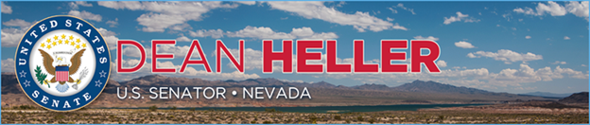

|  |  |
| --- | --- |
| **For Immediate Release:** | **Contact:**[Megan Taylor](mailto:Megan_Taylor@heller.senate.gov) |
| June 23, 2018 | 202-224-6244 |

**President Trump, Heller Discuss Tax Reform’s Impact in Nevada with Hardworking Nevadans and Local Job Creators**

*Yesterday Marked Six Months Since the President Signed the Historic Tax Cuts into Law*

**LAS VEGAS** – Six months after the Tax Cuts and Jobs Act was signed into law, U.S. Senator Dean Heller (R-NV) joined President Donald J. Trump at South Point Hotel Casino & Spa in Las Vegas, Nevada for a roundtable discussion with hardworking Nevadans and local job creators about tax reform’s impact in Nevada.

Since President Trump signed the Tax Cuts and Jobs Act into law, more than 1 million new jobs have been created around the country and more than 500 companies, including dozens in Nevada, have announced special bonuses, pay raises, and expanded benefits as a direct result of the new law. South Point Hotel Casino & Spa, where the event was held, is one of those examples; immediately following the law’s enactment, [the owner of the casino doubled his 2,300 full-time workers’ bonuses.](applewebdata://62DB1646-5200-4A27-82CB-D601412C82E3/%3ehttps:/www.heller.senate.gov/public/index.cfm/pressreleases?ID=406B6212-5D07-4677-89AC-4726F308187D%3c)  
  
The participants who joined the discussion with Sen. Heller and President Trump included: U.S. Department of Labor Secretary Alex Acosta; Nevada Attorney General Adam Laxalt; Steve Witkoff, developer of The Drew; Barbara Erickson, construction project manager for The Witkoff Group; Ryan Growney, general manager for South Point Hotel Casino & Spa; Jason Monge, restaurant manager for South Point Hotel Casino & Spa; Elisa and Richard Slider, co-owners of Silver State Hay; and Cavin Fung, founder and president of Asian Culture Alliance.

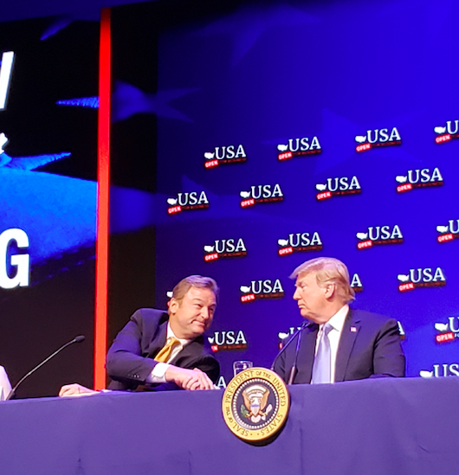

*President Trump and Senator Heller talk about how tax reform has transformed Nevada.*

“The bottom line is America is open for business,” **said President Trump** during the roundtable discussion.

“Mr. President, thanks to your leadership and your push to deliver tax relief, Nevada is booming,” **said Heller.**“Yesterday marked six months since the President signed it into law. Since then, thousands of jobs have been created in southern Nevada, about 13,000 Nevadans got a raise, and more than 10,000 Nevadans – including more than 2,000 employees right here at South Point Hotel Casino & Spa – received special bonuses. On top of that, nearly 25,000 Nevadans may benefit from things like college tuition assistance, increased pension funding, expanded maternity and paternity leave, and more paid holidays. All of this is the direct result of tax reform, and I’m optimistic that Nevada will continue to grow and thrive because of it.”

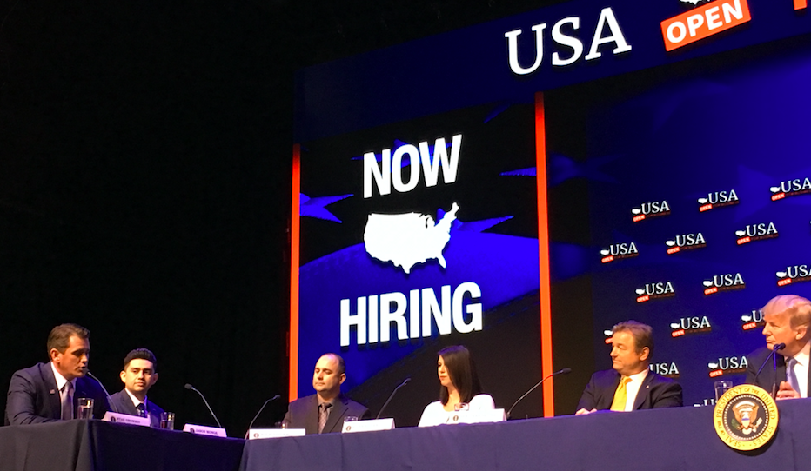

*“On this property, I can assure you that the tax cuts affected our employees and our business,”****Ryan Growney, the general manager for South Point Hotel Casino & Spa, said****during the roundtable discussion.*

A member of the U.S. Senate Finance Committee, Heller [helped craft and pass into law the Tax Cuts and Jobs Act](applewebdata://62DB1646-5200-4A27-82CB-D601412C82E3/%3ehttps:/www.heller.senate.gov/public/index.cfm/pressreleases?ID=BA866358-7F63-4C5E-B72E-57616EBBBA0C%3c). He fought to secure an amendment in the final package that he authored to [increase the child tax credit to $2,000](applewebdata://62DB1646-5200-4A27-82CB-D601412C82E3/%3ehttps:/www.heller.senate.gov/public/index.cfm/pressreleases?ID=ADAE007F-013A-4ADE-B306-8BF1465069EC%3c), or double it from current law. The tax relief law also includes Heller’s measure to make it easier for startups and [businesses to give employees an ownership stake in their company’s success](applewebdata://62DB1646-5200-4A27-82CB-D601412C82E3/%3ehttps:/www.heller.senate.gov/public/index.cfm/pressreleases?ID=42F977DB-BFAF-4668-81AD-AD805E5128E8%3c)by awarding stock options.

“Positive business activity is made possible when government, private investors, and labor come together in a way that benefits everybody. Here on this project, the Fontainebleau, which we will start construction activity in July of 2019, we will create approximately 11,000 jobs in Nevada. That’s 3,500 construction jobs, and 7,000 permanent jobs,” **Steve Witkoff, developer of The Drew, said** during the roundtable discussion.

[/var/folders/py/y368pz856vq9t8rzxjdkm4ch0000gp/T/com.microsoft.Word/WebArchiveCopyPasteTempFiles/cidimage008.png@01D38B16.CEF7E410](applewebdata://62DB1646-5200-4A27-82CB-D601412C82E3/%3ehttp:/www.facebook.com/pages/US-Senator-Dean-Heller/325751330177%3c)[/var/folders/py/y368pz856vq9t8rzxjdkm4ch0000gp/T/com.microsoft.Word/WebArchiveCopyPasteTempFiles/cidimage009.png@01D38B16.CEF7E410](applewebdata://62DB1646-5200-4A27-82CB-D601412C82E3/%3ehttp:/twitter.com/SenDeanHeller%3c)[/var/folders/py/y368pz856vq9t8rzxjdkm4ch0000gp/T/com.microsoft.Word/WebArchiveCopyPasteTempFiles/cidimage010.png@01D38B16.CEF7E410](applewebdata://62DB1646-5200-4A27-82CB-D601412C82E3/%3ehttp:/www.youtube.com/user/SenDeanHeller%3c)

*###*