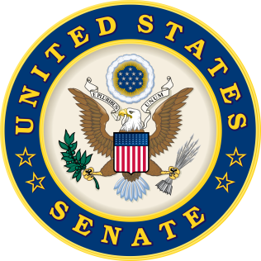
For Immediate Release: | Contacts:
July 13, 2016 | Neal A. Patel 202-224-6244 (Heller)
 | Chip Unruh 202-224-4642 (Reed)

Heller and Reed Power Energy STORAGE Research with Bipartisan Bill
Legislation could help Nevada increase renewable energy markets

(Washington, DC) – U.S. Senators Dean Heller (R-NV) and Jack Reed (D-RI), released the following statements after recently introducing the Storage Technology for Operational Readiness and Generating Energy (STORAGE) Act, S. 3162. The bill authorizes the Secretary of Energy to coordinate efforts among the energy storage research and development programs and authorities at the Department of Energy.

“Energy storage has an important role in both Nevada and the entire nation’s long-term energy strategy. In a state like Nevada with immense renewable energy potential, advances in this technology will improve the reliability, affordability, and flexibility of the electrical grid. I am proud to team up with Senator Reed on the bipartisan STORAGE Act, which will promote the research and development of this state-of-the-art technology,” said Senator Dean Heller.

“Energy storage is a critical part of achieving energy efficiency and this legislation can help drive our national energy policy forward by advancing energy storage research. Better coordination will allow the U.S. Energy Department to maximize the amount of funding that goes towards energy storage research and development, which in turn will make it easier to collaborate on developing technology to modernize and improve the electrical grid,” said Senator Jack Reed.

Background:

The Reed-Heller legislation improves S. 2012 by adding language that guides the Secretary of Energy to coordinate energy storage research and development programs, including the Grid Modernization Initiative, which is the primary energy storage research program at DOE.

Better coordination will maximize the amount of funding that goes towards energy storage research and development while minimizing administrative overhead. This legislation does not request additional funding, but directs the funding already specified in S. 2012 to be used in the most efficient manner under the guidance of the Secretary of Energy.

The Heller-Reed legislation also adds an additional standard to the list of nineteen provisions currently laid out within Section 111(d) of the Public Utility Regulatory Policies Act of 1978 (PURPA) for consideration. It adds energy storage systems to the list of strategies states should consider in an effort to promote energy conservation and promote greater use of domestic energy. The legislation specifically states important market dynamics like total costs, cost effectiveness, improvements in reliability and security, and system performance and efficiency must be factored in. If energy storage doesn’t contribute to these goals, it wouldn’t be utilized.
###

