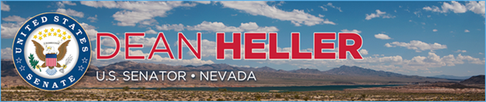

|  |  |
| --- | --- |
| **For Immediate Release:** | **Contact:** [Megan Taylor](mailto:Megan_Taylor@heller.senate.gov) |
| July 20, 2017 | 202-224-6244 |

**Senate Appropriations Committee Approves Spending Bill Without Yucca Mountain Funding**

**Washington, D.C.** – The U.S. Senate Appropriations Committee advanced the Senate’s Energy and Water Appropriations bill today and unlike the version that passed the House of Representatives Appropriations Committee.

“While the Senate Appropriations Committee’s action is good news for the state of Nevada, this fight against Yucca Mountain is far from over,” **said Heller.** “I will continue to lead the Nevada delegation’s efforts against reviving Yucca Mountain. It’s time for the administration and my colleagues to abandon this failed project and I commend the committee for not wasting any more taxpayer dollars.”

Heller has led the fight in Congress against Yucca Mountain and previously submitted [testimony](https://www.heller.senate.gov/public/index.cfm/pressreleases?ID=6E1CC11F-3413-4DCE-9E13-632E509919A7) to the Senate Energy & Water Appropriations Subcommittee reiterating his staunch opposition to wasting more taxpayer dollars on the failed project that Nevada continues to reject. Heller stated that Yucca Mountain “has been strongly opposed by Nevadans from the state, done little to solve our nation’s waste problem, and wasted billions of U.S. taxpayer dollars.”

*###*

[cid:image002.png@01D2FFE8.EB4970C0](http://www.facebook.com/pages/US-Senator-Dean-Heller/325751330177)[cid:image003.png@01D2FFE8.EB4970C0](http://twitter.com/SenDeanHeller)[cid:image004.png@01D2FFE8.EB4970C0](http://www.youtube.com/user/SenDeanHeller)