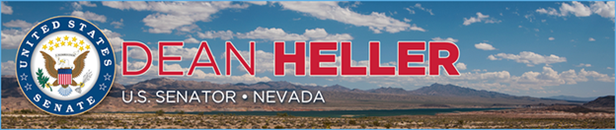

|  |  |
| --- | --- |
| **For Immediate Release:** | **Contact:** [Megan Taylor](mailto:Megan_Taylor@heller.senate.gov) |
| September 15, 2017 | 202-224-6244 |

**Senate Passes Heller-Backed Bills to Stop Human Trafficking**

**Washington, D.C.** – The U.S. Senate passed two bills, cosponsored by U.S. Senator Dean Heller (R-NV), that are designed to help stop human trafficking: the No Human Trafficking on Our Roads Act and the Combatting Human Trafficking in Commercial Vehicles Act. U.S. Sens. John Thune (R-SD), Amy Klobuchar (D-MN), and Bill Nelson (D-FL) introduced the bipartisan legislation earlier this year.

The No Human Trafficking on Our Roads Act prevents individuals who have been convicted of human trafficking from obtaining a commercial driver’s license by adding this particular felony to the list of disqualifying offenses. The Combatting Human Trafficking in Commercial Vehicles Act billrequires the Secretary of Transportation to designate an individual tasked with coordinating human trafficking prevention efforts within the federal agency and further increases support to educate commercial drivers on how to recognize and prevent human trafficking.

“The U.S. Senate has once again acted on legislation aimed at combatting human trafficking,” **said Heller**. “Our legislation is yet another step toward putting an end to this modern day slavery by strengthening prevention efforts at the federal level and keeping criminals who have already been convicted of this horrifying offense off of our roads and away from our kids. We’ll continue to work together to fight human trafficking and protect our most vulnerable from a crime that is all too often hidden in plain sight.”

###  
  
[cid:image002.png@01D32E11.F166E350](http://www.facebook.com/pages/US-Senator-Dean-Heller/325751330177)[cid:image003.png@01D32E11.F166E350](http://twitter.com/SenDeanHeller)[cid:image004.png@01D32E11.F166E350](http://www.youtube.com/user/SenDeanHeller)