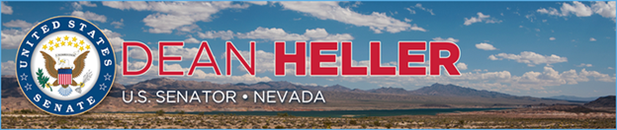

|  |  |
| --- | --- |
| **For Immediate Release:** | **Contact:** [Megan Taylor](mailto:Megan_Taylor@heller.senate.gov) |
| September 15, 2017 | 202-224-6244 |

**Senate Passes Heller-Backed Bipartisan Resolutions Celebrating Hispanic Heritage Month**

**Washington, D.C.** – The U.S. Senate passed bipartisan resolutions, which were introduced by U.S. Senator Dean Heller (R-NV) along with his colleagues, in celebration of Hispanic Heritage Month. One resolution recognizes National Hispanic Heritage Month and the other designates the week of September 18-24 as “National Hispanic-Serving Institutions Week” in honor of the work and achievements of the 470 non-profit Hispanic Serving Institutions (HSIs) throughout our country. Nevada is home to four HSIs, which are defined as degree-granting institutions where total Hispanic enrollment is no less than 25 percent of the total enrollment.

“I’m proud the Senate adopted our bipartisan resolutions that celebrate the many significant contributions of the Latino community in Nevada and throughout the country,” **said Heller.** “I’m also proud of the accomplishments of the four Hispanic-Serving Institutions in Nevada and the work they do to provide a quality education to Latino youth. From tourism to renewable energy, multiple industries in Nevada are booming and that’s in part due to the role these institutions play in preparing students to enter the workforce. Our resolution recognizes the importance of Hispanic-Serving Institutions which not only provide diversity to student bodies throughout the country, they also equip Latino students with the skills they need to fill good-paying jobs in Nevada so that we can keep and attract talent to our state. Nevada and this country are stronger because of our Latino community, and this month in particular we celebrate that. ”   
  
Heller has a history of supporting resolutions that pay tribute to Hispanic Heritage Month. He was an original cosponsor of S.Res.574 which passed the Senate in 2016, as well as S.Res.254 in 2015.

###  
  
[cid:image002.png@01D32E09.EC0F37C0](http://www.facebook.com/pages/US-Senator-Dean-Heller/325751330177)[cid:image003.png@01D32E09.EC0F37C0](http://twitter.com/SenDeanHeller)[cid:image004.png@01D32E09.EC0F37C0](http://www.youtube.com/user/SenDeanHeller)