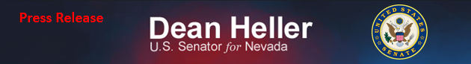
For Immediate Release: Contact: Chandler Smith
June 19, 2014 202-224-6244
Heller Files “No Budget, No Pay” as Amendment to CJS Appropriations
(Washington, D.C.) – U.S. Senator Dean Heller (R-NV) has filed “No Budget, No Pay” as an amendment to the CJS Appropriations Bill (H.R. 4660). The Heller No Budget, No Pay Amendment calls on Congress to adopt legislation requiring passage of a yearly budget and all twelve appropriations bills each fiscal year in order to receive pay.
“Washington’s fiscal mess must be fixed. This amendment aims to do so simply by holding Washington to the same standard as the rest of America: if members of Congress refuse to do their job by failing to pass a budget every year, then they don’t get paid,” stated Senator Heller.
Heller reintroduced “No Budget, No Pay” (S. 124) in the 113th Congress on January 23, 2013. This version of “No Budget, No Pay” requires both chambers of Congress to pass a concurrent budget resolution and all appropriations bills by the beginning of any fiscal year in order to receive pay. Congress adopted a version of “No Budget, No Pay” at the end of January 2013. That measure did not require the House and Senate to go to conference or pass any of their appropriations bills. In contrast, Heller’s legislation would make the “No Budget, No Pay” principle permanent.
###

