

|  |  |
| --- | --- |
| **For Immediate Release:** | **Contact:**[Megan Taylor](mailto:Megan_Taylor@heller.senate.gov) |
| November 17, 2018 | 202-224-6244 |

**Delivering Tax Relief for Nevada**

**WASHINGTON** - As the son of a school cook and auto mechanic, I know the hard work that goes into every paycheck and that’s why I’m pushing the U.S. Senate to pass meaningful tax relief for Nevada families. Whether it’s the single mother from Gardnerville who doesn’t receive child support and works full-time or Andrew in Las Vegas who worries about how he’ll be able to afford daycare for his daughters next year, I continue to hear that families in Nevada are struggling to cover all of their expenses.

*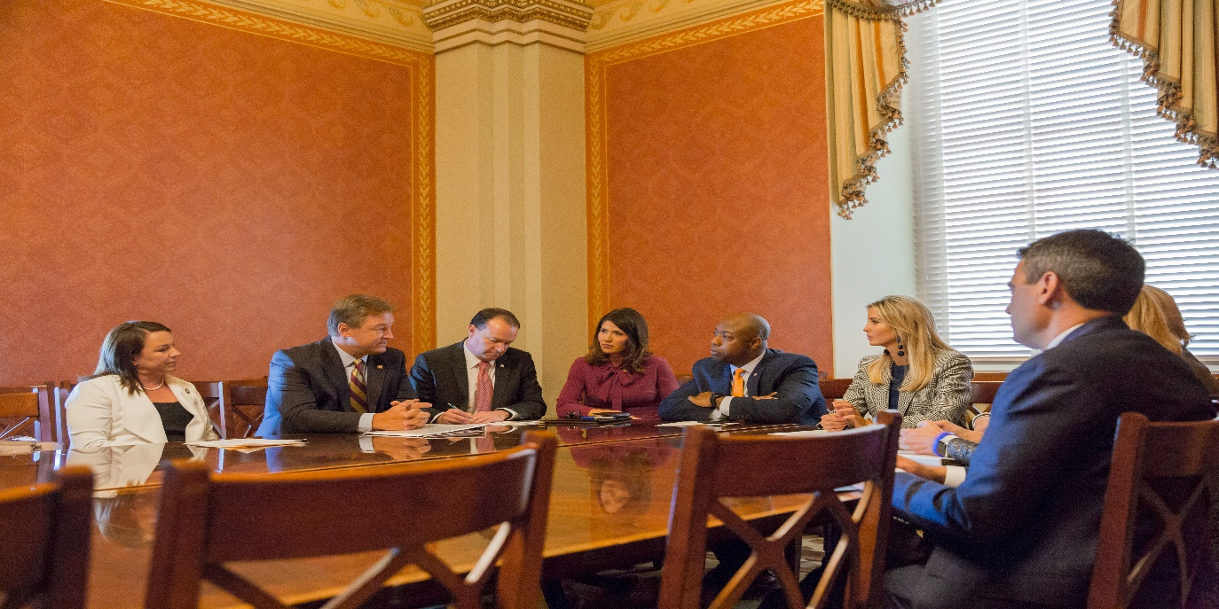Sen. Heller joins Ivanka Trump and his colleagues in discussing how an enhanced child tax credit could help Nevada families.*



*Secretary Mnuchin Joins Heller in Las Vegas to talk tax relief.*

Our tax code is too complex and too costly, it stifles job growth, and it inhibits America’s competitiveness. We must simplify our broken tax system, close special interest loopholes, and provide much-needed tax relief for hard-working middle class families. As a member of the U.S. Senate’s tax-writing committee, I’m going to continue fighting for a major tax overhaul that will help Nevadans and push for policies that will create jobs, boost growth, and make it easier for Nevadans to provide a better life for their kids.

***In the News****:*

* [KOH Radio: Heller Would Double Child Tax Credit](http://www.kkoh.com/2017/11/15/heller-would-double-child-tax-credit/)
* [Las Vegas Review-Journal: House OKs sweeping tax code reform after Trump rallies GOP](https://www.reviewjournal.com/news/politics-and-government/house-oks-sweeping-tax-code-reform-after-trump-rallies-gop/)
* [The Hill: Expanding the Child Tax Credit is Pro-Growth](http://thehill.com/opinion/finance/360548-expanding-the-child-tax-credit-is-pro-growth)
* [Las Vegas Review-Journal: House set to vote on GOP tax bill, but Senate measure faces opposition](https://www.reviewjournal.com/news/politics-and-government/house-set-to-vote-on-gop-tax-bill-but-senate-measure-faces-opposition/)
* [Elko Daily Free Press: Heller Hits Top Issues In Rural Press Call](http://elkodaily.com/news/state-and-regional/heller-hits-top-issues-in-rural-press-call/article_4920c215-ff89-557b-9197-8802241176f1.html)
* [Pahrump Valley Times: Nevada’s Dean Heller presses for tax reform](http://pvtimes.com/news/nevada-s-dean-heller-presses-tax-reform#sthash.kqdZ3qOw.dpbs)
* [Las Vegas Review-Journal: Congressional Republicans ready to put forth a simpler, pro-growth tax code](https://www.heller.senate.gov/public/index.cfm/pressreleases?ID=A55478F6-72E1-4A11-9EB9-DC701FF4BBC6)
* [Channel 8 Vegas: Sec. of Treasury, Heller hold meeting with local business leaders ahead of tax reform hearings](http://www.lasvegasnow.com/news/sec-of-treasury-heller-hold-meeting-with-local-business-leaders-ahead-of-tax-reform-hearings/800450080)
* [AP: US Treasury Secretary, Heller Host Business Meeting in Vegas](https://www.usnews.com/news/best-states/nevada/articles/2017-08-28/us-treasury-secretary-heller-host-business-meeting-in-vegas)
* [KOH: Senator Dean Heller Meets The Treasury Secretary](http://www.kkoh.com/2017/08/29/heller-meets-mnuchin/)

***Videos:***

* [Sen. Heller: It's Time To Deliver Tax Relief](https://www.youtube.com/watch?v=_Pp_kNVYats&feature=youtu.be)
* [Heller Shares How Nevadans Will Benefit From Tax Relief](https://www.youtube.com/watch?v=Q_qrxAKdpPA)
* [Heller Urges the Senate to Work 24/7 to Confirm Judges, Deliver Tax Relief](https://www.youtube.com/watch?v=Y-w3FjRlyY0&feature=youtu.be)
* [Sen. Heller Shares How Tax Relief Will Impact NV Families, Small Businesses](https://www.youtube.com/watch?v=DcB_qo5ycuU&feature=youtu.be)
* [Heller Urges Congress to Deliver a Bigger Child Tax Credit for Nevada’s Hardworking Families](https://www.heller.senate.gov/public/index.cfm/pressreleases?ID=18233858-0422-4D4B-B791-FA2926CF5665)
* [Sen. Heller Discusses his Amendment to Provide Tax Relief to Hardworking Nevadans](https://www.youtube.com/watch?v=aLvsnQHpcf8&feature=youtu.be)
* [Sen. Heller Questions Witnesses on Tax Relief for Nevada’s Small Businesses](https://www.youtube.com/watch?v=muW0mpkWRqY&feature=youtu.be)
* [Sen. Heller Questions Witnesses on Savings for Nevada Families](https://www.youtube.com/watch?v=WH3lgJdOvVo&feature=youtu.be)
* [Ahead of First Tax Hearing, Heller Shares How Tax Relief Will Impact Nevada Families, Small Businesses](https://youtu.be/DcB_qo5ycuU)

***Press Releases:***

* [Heller Votes to Deliver Tax Relief for Nevada families, Double Child Tax Credit](https://www.heller.senate.gov/public/index.cfm/pressreleases?ID=FBD4C390-4CDA-481C-A81B-9DB2C7B06F52)
* [In Case You Missed It: Heller-Scott Amendment Helps Hardworking American Families](https://www.heller.senate.gov/public/index.cfm/pressreleases?ID=172E4796-E5F0-468F-87B8-629ABC759986)
* [Senate Tax Relief Bill Includes Heller Amendment to Make it Easier for Employers to Award Stock to Workers](https://www.heller.senate.gov/public/index.cfm/pressreleases?ID=42F977DB-BFAF-4668-81AD-AD805E5128E8)
* [Heller, Scott Amendment to Double the Child Tax Credit Included in the Senate's Updated Tax Relief Bill](https://www.heller.senate.gov/public/index.cfm/pressreleases?ID=ADAE007F-013A-4ADE-B306-8BF1465069EC)
* [Heller to Senate Colleagues: It's Time to Deliver Tax Relief for Hardworking Families](https://www.heller.senate.gov/public/index.cfm/pressreleases?ID=354BB97A-BA98-4EEB-B6D0-094ED4C862AC)
* [Heller Statement on the Senate Tax Relief Bill](https://www.heller.senate.gov/public/index.cfm/pressreleases?ID=8A43F3E5-A395-423A-9C46-F201371AC014)
* [VIDEO: Heller Joins Trump Administration Officials, Grover Norquist in Urging Tax Relief for Nevada Families, Small Businesses](https://www.heller.senate.gov/public/index.cfm/pressreleases?ID=7A216540-EB5D-4932-BCB8-2A88D2BB57BD)
* [Heller Urges His Colleagues to Work 24/7 to Confirm Judges, Deliver Tax Relief](https://www.heller.senate.gov/public/index.cfm/pressreleases?ID=54712C0D-A6BD-4CAB-99F9-C35C8B858912)
* [Heller Votes to Pave the Way for Tax Relief for Nevada Families](https://www.heller.senate.gov/public/index.cfm/pressreleases?ID=FA5DB998-C963-4C51-815D-95F1229EAFE1)
* [U.S. Senate Passes Heller Amendment to Lower Taxes for Nevada Families with Children](https://www.heller.senate.gov/public/index.cfm/pressreleases?ID=1186EB77-A724-4FB1-86A1-1BA078684C8D)
* [Heller Statement on Unified Framework to Fix Our Broken Tax System](https://www.heller.senate.gov/public/index.cfm/pressreleases?ID=4E245473-4834-448E-AA82-F31E152F2CE1)
* [In Case You Missed It: Heller Questions Witnesses on Tax Relief for Nevada’s Small Businesses, Workers](https://www.heller.senate.gov/public/index.cfm/pressreleases?ID=876790D6-915D-4462-A771-9B7707CB4191)
* [At First Hearing on Tax Relief, Heller Questions Witnesses on Savings for Nevada Families](https://www.heller.senate.gov/public/index.cfm/pressreleases?ID=ACCDB0FC-A0E9-40E5-B3D3-05ED6D29C91D)
* [VIDEO: Ahead of First Tax Hearing, Heller Shares How Tax Relief Will Impact Nevada Families, Small Businesses](https://www.heller.senate.gov/public/index.cfm/pressreleases?ID=D1B1F888-4010-4BD4-964E-CD86F14F3C64)
* [Heller, Heinrich Introduce Bipartisan Bill to Establish Investment Tax Credit For Energy Storage](https://www.heller.senate.gov/public/index.cfm/pressreleases?ID=4FE45481-B2DF-4D2E-957A-B6B967333E28)

###

[cid:image002.png@01D454FA.27751A10](http://www.facebook.com/pages/US-Senator-Dean-Heller/325751330177)[cid:image003.png@01D454FA.27751A10](http://twitter.com/SenDeanHeller)[cid:image004.png@01D454FA.27751A10](http://www.youtube.com/user/SenDeanHeller)