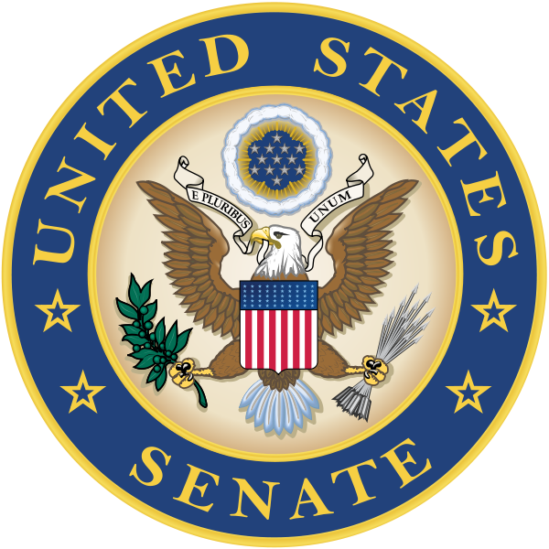

For Immediate Release: Contact: Chandler Smith
May 7, 2013 202-224-6244

Sens. Whitehouse and Heller Reintroduce Bill to
End Breast Cancer by 2020

(Washington, D.C.) – U.S. Senator Sheldon Whitehouse (D-RI) has reintroduced bipartisan legislation to establish a “Commission to Accelerate the End of Breast Cancer,” the purpose of which will be to help end breast cancer by 2020. The legislation, the Accelerating the End of Breast Cancer Act of 2013 (S.865), is cosponsored by Senator Dean Heller (R-NV).

“Breast cancer continues to affect too many of our mothers, wives, sisters, and friends,” said Senator Whitehouse. “This bill sets an ambitious goal of ending breast cancer by 2020, and will help drive our efforts to put an end to this tragic disease.”

“It’s hard to find someone whose life has not been touched by breast cancer,” said Senator Heller. “By establishing a commission to help end breast cancer by 2020, it is my hope that we can help save the lives of countless women and unlock the answers to finally defeating this disease. This bill is a step in the right direction, and I am pleased that Members of Congress were once again able to come together in a bipartisan effort to help end breast cancer once and for all.”

In the United States, 1 in 8 women will be diagnosed with breast cancer in their lifetime, up from 1 in 11 in 1975. In Rhode Island alone, 133 out of every 100,000 women suffer from breast cancer, which is nearly 9 percent above the national average. Nevada is expected to see 1,760 new cases of breast cancer this year, and 360 deaths. Nationwide, health care costs associated with breast cancer totaled $16.5 billion in 2010 and resulted in $12.1 billion in lost productivity, according to an estimate by the National Cancer Institute.

The Accelerating the End of Breast Cancer Act would create a commission to identify promising research, encourage partnerships between the public and private sectors, and create opportunities for trans-disciplinary collaboration that may advance the mission of ending breast cancer.

The bill is also cosponsored by Senators Chuck Grassley (R-IA), Jack Reed (D-RI), Sherrod Brown (D-OH), Robert Casey (D-PA), Mark Warner (D-VA), Mark Begich (D-AK), and Al Franken (D-MN).

###

