

|  |  |
| --- | --- |
| **For Immediate Release:** | **Contact:**[Megan Taylor](mailto:Megan_Taylor@heller.senate.gov) |
| May 1, 2018 | 202-224-6244 |

**Fox 5: Heller Announces Bill to Help Victims of Domestic Violence**

**LAS VEGAS –**In case you missed it,KVVU-TVFox 5 Vegas this morning reported on [legislation introduced by U.S. Senator Dean Heller (R-NV) to aid victims of domestic violence](https://www.heller.senate.gov/public/index.cfm/pressreleases?ID=10B46EC8-A85C-4DD3-BBE7-8FA9DD011EC9) by directing federal resources to emergency shelters, supportive programs, and the National Domestic Violence Hotline. Watch the clip [here](https://youtu.be/zf93dwR0HmA).  
  
Specifically, the legislation reauthorizes the Family Violence Prevention and Services Act (FVPSA), a historic law enacted in 1984 that directs funding to states and tribes to help provide supportive services such as shelter, counseling, legal assistance and more to victims of domestic abuse and their dependents. Additionally the bill funds prevention programs and 24-hour victim assistance through the National Domestic Violence Hotline, a toll-free helpline in which highly-trained advocates offer victims of relationship abuse assistance over the phone and through their website at <http://www.thehotline.org/>.

[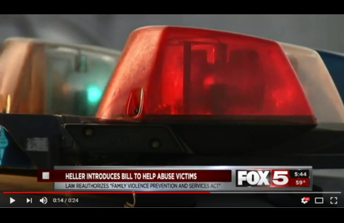](https://youtu.be/zf93dwR0HmA)

Click [HERE](https://youtu.be/zf93dwR0HmA) or the image above to play the clip.

###

[cid:image002.png@01D4707F.057F3FD0](http://www.facebook.com/pages/US-Senator-Dean-Heller/325751330177)[cid:image003.png@01D4707F.057F3FD0](http://twitter.com/SenDeanHeller)[cid:image004.png@01D4707F.057F3FD0](http://www.youtube.com/user/SenDeanHeller)