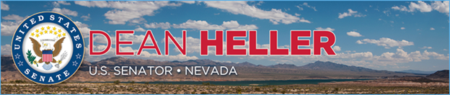

|  |  |
| --- | --- |
| **For Immediate Release:** | **Contact:**[Megan Taylor](mailto:Megan_Taylor@heller.senate.gov) |
| April 24, 2018 | 202-224-6244 |

**Fox 5 Vegas: Heller Urges Facebook to Disclose Number of Nevadans Impacted by Cambridge Analytica Scandal**

**WASHINGTON –**Nevada media yesterday reported on U.S. Senator Dean Heller’s (R-NV) [push for Facebook CEO Mark Zuckerberg to disclose how many Nevadans were impacted](https://www.heller.senate.gov/public/index.cfm/pressreleases?ID=A786F19E-943F-4D84-BA50-77162305C934) by the improper collection of Facebook users’ data after 87 million Facebook users had their information wrongfully obtained by a third party developer without every user’s consent. **Watch Fox 5 Vegas’s clip**[**here**](https://youtu.be/DWSiCGD5zHI)**.**Heller, a member of the U.S. Senate Commerce, Science, and Transportation Committee, asked Zuckerberg during his testimony for the number of Nevadans who had their information wrongfully obtained. Zuckerberg could not answer the question at the time of his hearing. However, [Zuckerberg did acknowledge that Facebook’s 87 million users are victims of having their information given away without their consent](https://www.heller.senate.gov/public/index.cfm/pressreleases?ID=8558CBAD-5047-4460-9F9C-4281A928613D) in response to Heller.

[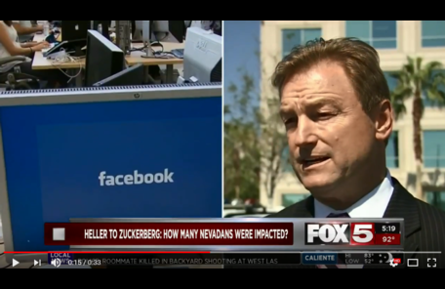](https://youtu.be/DWSiCGD5zHI)  
Click [HERE](https://youtu.be/DWSiCGD5zHI) or the above image to play the video.

  
[**Sen. Dean Heller: Facebook CEO Mark Zuckerberg unable to say how Nevadans’ data compromised**](https://www.nevadaappeal.com/news/local/sen-dean-heller-facebook-ceo-mark-zuckerberg-unable-to-say-how-nevadans-data-compromised/)Nevada Appeal  
Capitol Bureau  
  
Sen. Dean Heller, R-Nev., says Facebook CEO Mark Zuckerberg was unable to tell him how many Nevadans had their data compromised by Cambridge Analytics.  
  
Heller, a member of the Senate Commerce, Science and Transportation Committee, said Zuckerberg acknowledged Facebook's 87 million users had their information released to that company without their consent. But Heller said he expects companies to be transparent about their date practices and comply with their public commitments to protect privacy of their customers.  
  
“Safeguarding Americans' privacy is critically important to me,” he said.  
  
He told Zuckerberg in a letter after his congressional appearance once the company's investigation into the data leak is completed, he would like the company to update his office on how many Nevadans may face misuse of their data.

###

[cid:image002.png@01D4707F.057F3FD0](http://www.facebook.com/pages/US-Senator-Dean-Heller/325751330177)[cid:image003.png@01D4707F.057F3FD0](http://twitter.com/SenDeanHeller)[cid:image004.png@01D4707F.057F3FD0](http://www.youtube.com/user/SenDeanHeller)