

|  |  |
| --- | --- |
| **For Immediate Release:** | **Contact:**[Megan Taylor](mailto:Megan_Taylor@heller.senate.gov) |
| July 11, 2018 | 202-224-6244 |

**Fox Reno: Heller Announces Federal Grant to Help Nevada’s Homeless Veterans Enter the Workforce**

**WASHINGTON**– In case you missed it, KRXI-TV Fox Reno yesterday [reported](https://youtu.be/PdVXwQ2MISw) that Nevada will receive $250,000 as part of a federal grant to help Nevada’s homeless veterans enter the workforce. [Heller recently announced yesterday that the U.S. Department of Labor (DOL)’s Homeless Veterans’ Reintegration Program grant would be directing $250,000 to U.S. VETS – Las Vegas](https://www.heller.senate.gov/public/index.cfm/pressreleases?ID=AD6BD3F9-44D4-48A8-8350-882BA67A19B1). [**Watch the clip here.**](https://youtu.be/PdVXwQ2MISw)

[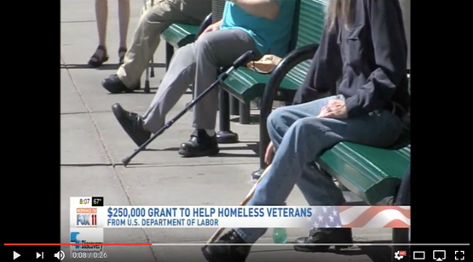](https://youtu.be/PdVXwQ2MISw)  
Click [HERE](https://youtu.be/PdVXwQ2MISw) or the above image to watch the clip.

Heller, a long-time champion of combating veteran homelessness, applauded the grant funding and noted that his office has worked closely with U.S. VETS -Las Vegas, an organization in Las Vegas that assists with transitional housing opportunities for Nevada’s veterans.    
  
“As a senior member of the Senate Veterans’ Affairs Committee representing 300,000 veterans living in Nevada, I will continue to make sure that important organizations on-the-ground, like U.S. VETS, have the federal resources and support they need to continue assisting the men and women who answered our nation’s call,” **said Heller.**

[cid:image005.png@01D41926.8854AF90](http://www.facebook.com/pages/US-Senator-Dean-Heller/325751330177)[cid:image006.png@01D41926.8854AF90](http://twitter.com/SenDeanHeller)[cid:image007.png@01D41926.8854AF90](http://www.youtube.com/user/SenDeanHeller)