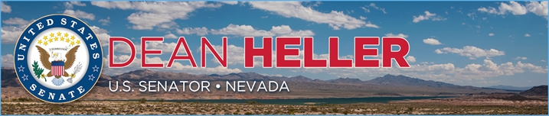

|  |  |
| --- | --- |
| **For Immediate Release:** | **Contact:** [Megan Taylor](mailto:Megan_Taylor@heller.senate.gov) |
| July 26, 2017 | 202-224-6244 |

**Heller on Senate Floor: Health Care Reform Cannot be Balanced on the Backs of Nevada's Low-Income Families**

**Washington, D.C** – Today, U.S. Senator Dean Heller (R-NV) spoke on the U.S. Senator floor to highlight his amendment, Heller #288, that urges patient-centered solutions to Obamacare and the protection of Nevadans who are currently covered by Medicaid.

In discussing the impact of the Medicaid program on Heller's state, he cited that Nevada has seen one of the most significant decreases in uninsured children in the country, the number of uninsured people living in Nevada's rural communities cut in half, and more Nevadans with disabilities have access to care that helps them live independently because of Medicaid.

"My amendment simply reinforces the important role Medicaid has played in my home state and in the states of many of my colleagues here today," Heller opened.

Heller's amendment states that the U.S. Senate Finance Committee should review Medicaid expansion and expresses that the Senate should not review legislation that eliminates or reduces coverage for individuals currently covered under Medicaid or shift costs to the state. The text of the amendment can be found here.

"Make no mistake - Obamacare needs fixing," Heller added. "We're having this debate because I do believe there are common sense solutions that could improve our health care system and I voted to give us the opportunity to fight for them. But as I've said all along - health care reform cannot be balanced on the backs of Nevada's low-income families or sickest individuals. I cannot and will not stand for it." Click [HERE](https://youtu.be/v2ykw0xIO8U) or below to watch Heller’s speech.

[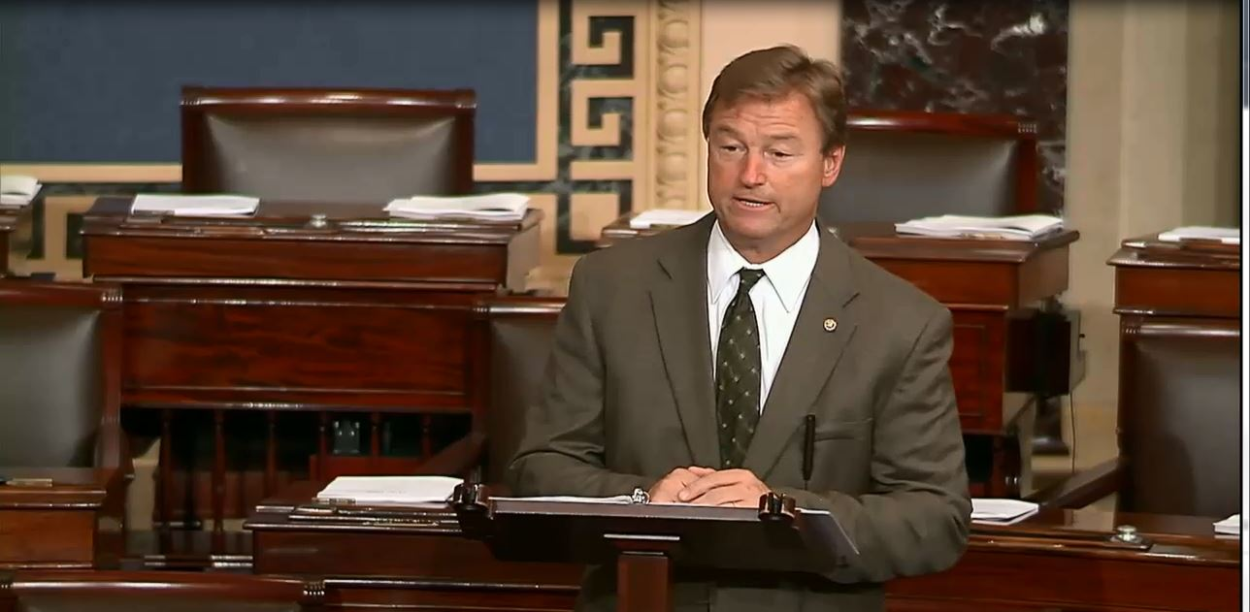](https://youtu.be/v2ykw0xIO8U)  
[Click [here](https://youtu.be/v2ykw0xIO8U) or on the above image to watch.]

**Heller Stands up for Nevada’s Families on Senate Floor**

***In Floor Speech, Heller Defends Nevadans who rely on Medicaid***

**Washington, D.C** – Today, U.S. Senator Dean Heller (R-NV) spoke on the U.S. Senator floor today to highlight his amendment, Heller #288. Heller’s remarks and amendment focus on hardworking Nevadans who rely on Medicaid, and his amendment specifically calls for a committee of jurisdiction to review the issue of the Medicaid expansion for low-income Americans. It also state’s that it is the sense of the Senate that Obamacare should be repealed because it increases costs and decreases choice, and Obamacare should be replaced with patient-centered legislation.

“It’s why I’ve said since the beginning of the health care debate that I will only support a solution that protects Nevada’s most vulnerable. The House’s bill didn’t go far enough to do that and neither did the Senate’s bill. That’s why I voted against it last night,” **Heller said on the Senate floor**. Click [HERE](https://youtu.be/v2ykw0xIO8U) or below to watch Heller’s speech.

[](https://youtu.be/v2ykw0xIO8U)

[Click [here](https://youtu.be/v2ykw0xIO8U) or on the above image to watch.]

**Remarks as prepared for delivery:**

“I rise today to talk about my amendment, Heller #288.

“My amendment simply reinforces the important role Medicaid has played in my home state and in the states of many of my colleagues here today.

“Let me tell you about the impact it’s had on Nevada. As many of you know, Nevada was the first state to expand Medicaid.

“And, before Nevada made that decision, the state’s uninsured rate was 23 percent. One of the highest in the country.

“Think about that - that’s one in four Nevadans who did not have health care coverage.

“Today, Nevada’s uninsured rate is between 11 and 12 percent.

“We’ve also seen the number of uninsured people living in Nevada’s rural communities cut in half. And we’ve seen major gains in the number of children in our state with health care coverage.

“In fact, Nevada has seen one of the most significant decreases in uninsured children in the country.

“In 2013, our state had the highest rate of uninsured children in the country. We were ranked 50th in the nation and now I can proudly say that Nevada is the most improved state when it comes to addressing our rate of uninsured children.  Our state had made significant progress since the state’s decision to expand Medicaid, and that has made an impression on me.

“Over the past few months, I’ve had the privilege of meeting with Nevadans here in Washington, D.C. and back at home to discuss health care.

“The resounding message that I continue to hear is that because of Medicaid expansion, more than 200,000 Nevadans have health insurance today who otherwise wouldn’t.

“The other resounding message I hear is that drastic cuts to the Medicaid program threaten the critical services that Nevadans rely on.

“Let me read you a letter I received from a woman in Las Vegas. She said, “My oldest child has Down syndrome and has depended on Medicaid since the day she was born and was denied health care because of the pre-existing conditions she was born with. My husband and I are hard-working Americans. We started our own business five years ago and have seen that business grow more and more each year. We do not rely on the government for assistance, other than Medicaid coverage. Without it, we would be unable to afford the numerous appointments with specialists and surgeries that keep our daughter happy, healthy, and progressing in life.”

“This is one example of the real stories behind the numbers, and I want to do everything I can to make sure that they are protected and their coverage isn’t threatened. I want to make sure that they have the health care coverage they do today, tomorrow.

“Medicaid also plays a crucial role in Nevada when it comes to covering the elderly and people with disabilities.

“More than 30,000 of Nevada’s seniors receive health care through Medicaid, including nursing home care and services that help them live at home. In fact, more than half of Nevada’s nursing home residents are covered by Medicaid.

“And nearly 50,000 people with disabilities in Nevada now have access to care that helps them live independently thanks to Medicaid.

“Karen from Henderson recently contacted me and said that her adult son has MS and depends on Medicaid to help cover the cost of his medication that costs $300 per month. Without Medicaid, he can’t afford it.

“And one Nevadan traveled all the way from Las Vegas to talk with me about her two sons with cystic fibrosis. She’s worried about any legislation that would jeopardize access to care for people with serious, chronic illnesses like the one her sons are struggling with.

“In total, over 631,000 people in Nevada are covered by the Medicaid program. That’s low income children, pregnant women, adults, seniors, and people with disabilities.

“And it’s why I’ve said since the beginning of the health care debate that I will only support a solution that protects Nevada’s most vulnerable. The House’s bill didn’t go far enough to do that and neither did the Senate’s bill. That’s why I voted against it last night.

“Nevada faces unique challenges when it comes to health care. I’ve spent these past few months trying to find ways to protect the Nevadans who depend on Medicaid, preserve coverage for those with pre-existing conditions, all while bringing down costs and improving quality and access to care.

“I’ve also been having discussions with Nevadans in Washington and back home to hear from them how potential changes could impact their care.

“Whether it’s a mom in Reno who has a son with a heart condition and is terrified about the future of his treatments…or the nurses from Las Vegas who came all the way to D.C. because they’re worried that their patients will lose coverage – I’ve been listening. And I understand.

“Make no mistake – Obamacare needs fixing. It’s led to higher costs and fewer choices in Nevada. For the past seven years, I’ve said that we need more competition to drive down costs and increase choices for Nevadans.

“I cannot, however, support anything that jeopardizes the health care of the Nevadans who have coverage today because of Obamacare.

“My role as a United States Senator is doing the very best I can for my state.

“And that’s standing up for the Nevadans who depend on Medicaid.

“We’re having this debate because I do believe there are commonsense solutions that could improve our health care system and I voted to give us the opportunity to fight for them. But as I’ve said all along – health care reform cannot be balanced on the backs of Nevada’s low income families and sickest individuals. That’s something that I cannot and will not stand for.

“We ***can*** work to find a way to lower costs, increase choices, and improve the quality of care Nevadans receive. But we can do it in a way that also protects our most vulnerable.

“That’s why for the past few months I’ve been working with my colleagues here in the Senate who also understand the unique challenges expansion states face, and we’ve been fighting for solutions that will protect those who currently rely on the Medicaid program. It hasn’t been easy, but that’s ok.

“I’m here to roll up my sleeves, get to work, and fight for policies that will be in the best interests of Nevadans.  
  
“So, I encourage my colleagues to vote in support of Heller amendment #288 today to reiterate the value of Medicaid in our states and that we have much work ahead of us to improve the health care system for Nevadans and Americans across the country.”

*###*

[cid:image002.png@01D3054D.46997880](http://www.facebook.com/pages/US-Senator-Dean-Heller/325751330177)[cid:image003.png@01D3054D.46997880](http://twitter.com/SenDeanHeller)[cid:image004.png@01D3054D.46997880](http://www.youtube.com/user/SenDeanHeller)