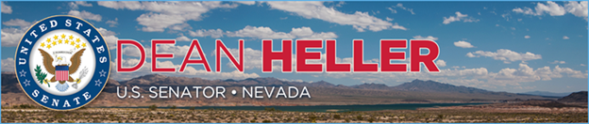

|  |  |
| --- | --- |
| **For Immediate Release:** | **Contact:**[Megan Taylor](mailto:Megan_Taylor@heller.senate.gov) |
| May 8, 2018 | 202-224-6244 |

**Heller: “The Iran Deal Was Never Good For America or Our Friends in the Middle East”**

**WASHINGTON**– U.S. Senator Dean Heller (R-NV) today released the below statement on President Trump’s announcement that the United States will withdraw from the Joint Comprehensive Plan of Action (JCPOA), commonly referred to as the Iran nuclear deal, an Obama-era agreement reached between the U.S., Iran, United Kingdom, Russia, France, China, and Germany.  
  
“The Iran deal was never good for America or our friends in the Middle East. This agreement has done nothing to stop Iran from acquiring a nuclear weapon or promote peace – in fact, it has done just the opposite,” **said Heller.** “Iran has been emboldened since President Barack Obama signed the Joint Comprehensive Plan of Action three years ago. In the face of this agreement, Iran has conducted ballistic missile tests, harassed U.S. naval ships in the Middle East, and helped prop up the murderous Assad regime in Syria. Members of Iran’s parliament have shouted ‘death to America’ and its Supreme Leader Ayatollah Ali Khamenei has said ‘Israel will not exist in 25 years.’”  
  
**Heller continued,** “Clearly, Iran is not a trusted partner in America’s foreign policy goals. The agreement, which handed Tehran billions of dollars to help bolster its military and spread terror around the world, represented a volcano waiting to erupt. Make no mistake, Iran has been preparing for when the agreement was set to expire in 2025, and that’s why leaving this agreement and pursuing additional sanctions is the right choice.”

###

[cid:image002.png@01D4707F.057F3FD0](http://www.facebook.com/pages/US-Senator-Dean-Heller/325751330177)[cid:image003.png@01D4707F.057F3FD0](http://twitter.com/SenDeanHeller)[cid:image004.png@01D4707F.057F3FD0](http://www.youtube.com/user/SenDeanHeller)