

|  |  |
| --- | --- |
| **For Immediate Release:** | **Contact:**[Megan Taylor](mailto:Megan_Taylor@heller.senate.gov) |
| May 22, 2018 | 202-224-6244 |

**Heller Ahead of U.S. Senate Vote on Passage of VA MISSION Act: This Bill Honors Nevada’s Veterans**

**WASHINGTON**– At a press event today on the importance of the VA MISSION Act, landmark legislation the Senate will begin to consider this afternoon, U.S. Senator Dean Heller (R-NV) highlighted how the bill allows Nevada’s military veterans to continue accessing the critical health care they need closer to home. Heller, a senior member of the Senate Veterans’ Affairs Committee, also secured three of his proposals in the sweeping legislation that will reform and improve veterans’ community care programs.  
  
Specifically, the package includes Heller’s [Veterans Transplant Coverage Act](https://www.heller.senate.gov/public/index.cfm/2017/11/u-s-house-passes-heller-bill-to-aid-veterans-in-need-of-transplants), which allows veterans to receive organ transplants from non-veterans; [the VA Bonus Transparency Act](https://www.heller.senate.gov/public/index.cfm/pressreleases?ID=F37A2278-20CE-476D-A75A-BF2B1D949A9A), which requires the VA to annually report on the bonuses awarded to critical positions within the VA; and the Maximizing Efficiency and Improving Access to Providers at the VA Act, which requires the VA to hire medical scribes for patient data entry so physicians can spend more time with the veteran patient.  
  
“Just last week, Bob from Gardnerville said that he prefers to see his doctor at the clinic one mile down the road from his home, but even under the Choice Program – he is forced to travel 100 miles roundtrip to see his cardiologist and his foot doctor. That doesn’t make any sense, and it is exactly what the VA MISSION Act aims to fix,” **Heller said at the event.  
  
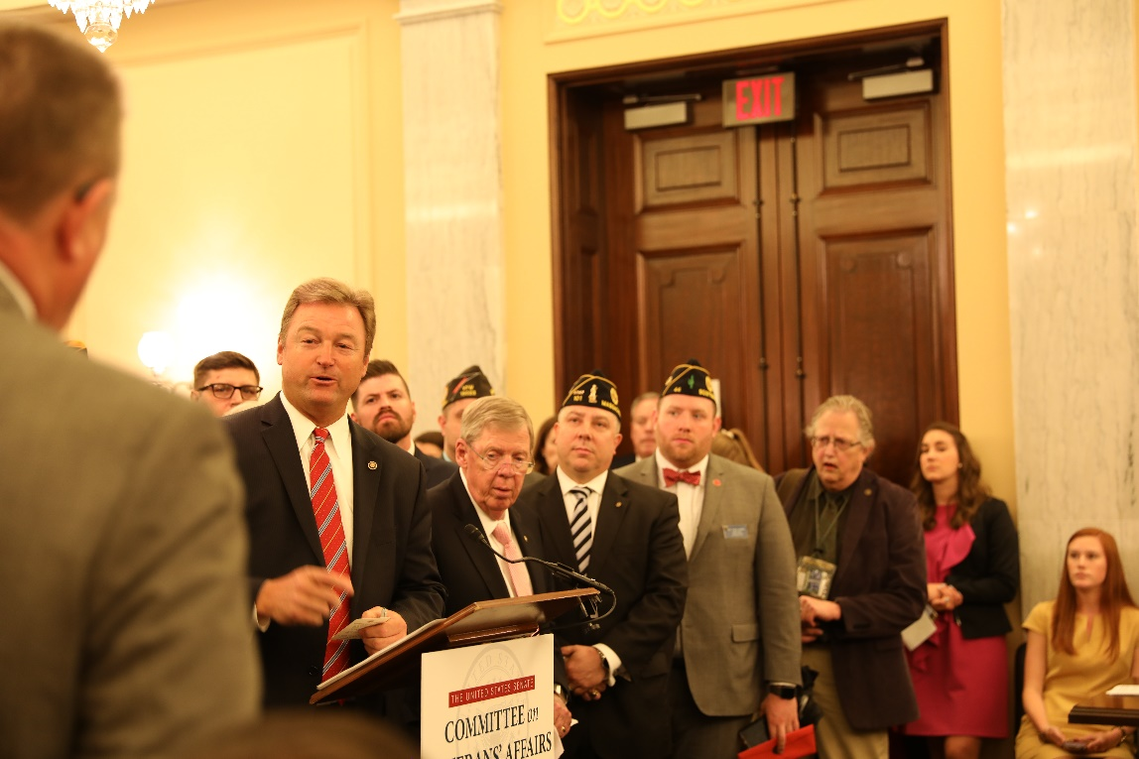**

*Heller discussing the importance of the VA MISSION Act at a press conference.*\*\*Media has permission to use this picture**

“As we approach Memorial Day, we are reminded of those who paid the ultimate price for our freedoms, as well as the sacrifice that our military veterans – and their families – make each day. They deserve to know that our nation will support them when they return from the frontlines, and that’s what this bill is all about: empowering veterans. I’m hopeful the Senate will swiftly pass this important initiative and send it to the President’s desk,” **said Heller.**

**Heller Provisions Included in The VA MISSION Act:**

* [**The Veterans Transplant Coverage Act:**](https://www.heller.senate.gov/public/index.cfm/2017/11/u-s-house-passes-heller-bill-to-aid-veterans-in-need-of-transplants) This bill allows veterans to receive organ transplants from a non-veteran with their VA coverage. Currently, the VA can deny a transplant to a veteran if the live donor is a non-veteran.
* [**The VA Bonus Transparency Act:**](https://www.heller.senate.gov/public/index.cfm/pressreleases?ID=F37A2278-20CE-476D-A75A-BF2B1D949A9A) This bill requires the VA to submit an annual report on performance awards and bonuses given to high-level VA employees.
* **The Maximizing Efficiency and Improving Access to Providers at the VA Act**: This requires VA to establish a pilot program to hire medical scribes for patient data entry so physicians can spend more time with the veteran patient.

###

[cid:image002.png@01D454FA.27751A10](http://www.facebook.com/pages/US-Senator-Dean-Heller/325751330177)[cid:image003.png@01D454FA.27751A10](http://twitter.com/SenDeanHeller)[cid:image004.png@01D454FA.27751A10](http://www.youtube.com/user/SenDeanHeller)