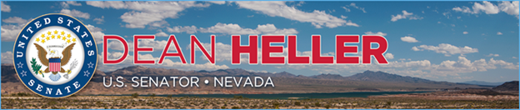

|  |  |
| --- | --- |
| **For Immediate Release:** | **Contact:**[Megan Taylor](mailto:Megan_Taylor@heller.senate.gov) |
| September 21st, 2018 | 202-224-6244 |

**Heller Announces Over $3 Million in DOJ Grants Awarded to Nevada Tribal Communities to Help Fight Crime, Support Victims of Domestic Abuse**

**WASHINGTON –** U.S. Senator Dean Heller (R-NV) welcomed the Department of Justice (DOJ) announcement that the Fallon Paiute-Shoshone Tribe, the Moapa Band of Paiutes, the Pyramid Lake Paiute Tribe, and the Inter-Tribal Council of Nevada have been awarded over $3 million in grants to improve public safety in American Indian and Alaska Native communities through the Coordinated Tribal Assistance Solicitation.

Specifically, these grants will provide funding for crime reduction, victim assistance, and community policing programs. This announcement comes amid DOJ efforts to combat the disproportionate levels of violent crime and domestic violence in American Indian and Alaska Native communities. Funding was also included for the Violence Against Women Tribal Governments Program funded through the Office on Violence Against Women. This program is designed to better enable tribes to respond to violent crimes against Indian women and enhance victim safety efforts.

“I welcome the DOJ announcement that it will provide more than $3 million in funding to Nevada’s tribal communities to fight crime and protect victims of domestic violence,” **said Heller.** “As a champion for victims and a strong proponent of the Violence Against Women Act, I will continue fighting to advance policies that will strengthen efforts to crack down on crime, help deliver justice to victims, and support and protect survivors.”

**The full breakdown can be found** [**HERE**](https://www.justice.gov/tribal/page/file/1095161/download?utm_medium=email&utm_source=govdelivery) **and below:**

* Fallon Paiute-Shoshone Tribe Total: $1,004,552
* Moapa Band of Paiutes Total: $299,900
* Pyramid Lake Paiute Tribe Total: $1,350,000
* Inter-Tribal Council of Nevada Total: $450,000

###

[cid:image002.png@01D451AC.3BAE7220](http://www.facebook.com/pages/US-Senator-Dean-Heller/325751330177)[cid:image003.png@01D451AC.3BAE7220](http://twitter.com/SenDeanHeller)[cid:image004.png@01D451AC.3BAE7220](http://www.youtube.com/user/SenDeanHeller)