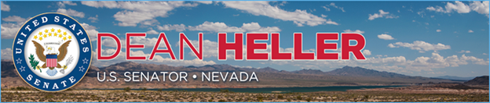

|  |  |
| --- | --- |
| **For Immediate Release:** | **Contact:**[Megan Taylor](mailto:Megan_Taylor@heller.senate.gov) |
| September 21st, 2018 | 202-224-6244 |

**Heller Announces Over $5.1 Million in Funding for Ely Airport**

**WASHINGTON –** U.S. Senator Dean Heller (R-NV) today announced that the U.S. Department of Transportation (DOT) has awarded $5,186,819 to White Pine County to support additional operations at the Ely Airport (Yelland Field) and help the airport improve safety by reconstructing its current taxiway. This additional funding comes from the Consolidated Appropriations Act (Public Law 115-114), which Heller supported earlier this year and included $1 billion in new infrastructure funding for airport improvement projects, particularly targeting small and rural airports like Ely’s.

“As a member of the U.S. Senate Committee that oversees transportation as well as the Aviation Operations, Safety, and Security Subcommittee, I welcome today’s announcement that the Ely Airport has been awarded over $5 million to improve their operations and enhance safety measures,” **said Heller**. “This funding will go a long way toward promoting the economic success of Ely and the surrounding areas, and I thank Secretary Chao for recognizing the needs of our rural communities.”

Heller has worked with U.S. Secretary of Transportation Elaine Chao on various infrastructure projects in Nevada, and most recently, they [announced that the City of Reno and Flirtey, a Nevada-based drone delivery service company, was selected for the highly competitive Unmanned Aircraft Systems (UAS) Integration Pilot Program](https://www.heller.senate.gov/public/index.cfm/pressreleases?ID=CCE90940-D6F0-4B14-9D99-B2106ADBB4B8). In April, Heller also joined Secretary Chao in Carson City to announce a [$7.5 million DOT grant to complete the South Carson Street Project](https://www.heller.senate.gov/public/index.cfm/2018/4/heller-joins-u-s-transportation-secretary-elaine-l-chao-to-announce-7-5-million-grant-for-carson-city-additional-funding-for-nevada) and improve transportation safety in Northern Nevada.

###

[cid:image002.png@01D451CC.1CF518F0](http://www.facebook.com/pages/US-Senator-Dean-Heller/325751330177)[cid:image003.png@01D451CC.1CF518F0](http://twitter.com/SenDeanHeller)[cid:image004.png@01D451CC.1CF518F0](http://www.youtube.com/user/SenDeanHeller)