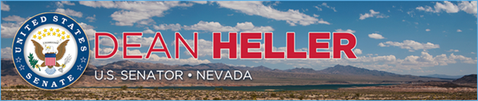

|  |  |
| --- | --- |
| **For Immediate Release:** | **Contact:** [Megan Taylor](mailto:Megan_Taylor@heller.senate.gov) |
| June 22, 2017 | 202-224-6244 |

**Heller Touts Record PILT Funding**

**Washington, D.C.** – U.S. Senator Dean Heller (R-NV) welcomed Department of Interior Secretary (DOI) Ryan Zinke to Nevada as well as the department’s announced $464.6 million in Payments in Lieu of Taxes (PILT) funding for 2017 – the largest amount ever allocated in the program’s history.

PILT payments are federal dollars that are paid out to local governments in order to offset losses in property taxes due to non-taxable Federal lands within their boundaries. Approximately 85 percent of Nevada lands are managed by the federal government, and funding levels are critical to local communities.

“As a vocal and outspoken supporter of the PILT program, I applaud Secretary Ryan Zinke for investing record resources in the program and sending a message I’ve long echoed to rural Nevada: you are not forgotten. Unlike other states, approximately 85 percent of Nevada lands are managed by the federal government, making the PILT program critical for local governments’ ability to maintain essential services like public safety and education,” **said Heller.** “I thank Secretary Zinke for recognizing the important role the program plays in our communities.”

“As a kid who grew up in northwest Montana and whose sons graduated from the same high school as I did, I know how important PILT payments are to local communities that have Federal lands. These investments are one of the ways the federal government is fulfilling its role of being a good land manager and good neighbor to local communities,” **said Secretary Zinke.** “Rural America, especially states out west with large federal land holdings, play a big part in feeding and powering the nation and also in providing recreation opportunities, but because the lands are Federal, the local governments don’t earn revenue from them. PILT investments often serve as critical support for local communities as they juggle planning and paying for basic services, such as public safety, fire-fighting, social services and transportation.”

*###*

[cid:image002.png@01D2CD66.FDD0BF00](http://www.facebook.com/pages/US-Senator-Dean-Heller/325751330177)[cid:image003.png@01D2CD66.FDD0BF00](http://twitter.com/SenDeanHeller)[cid:image004.png@01D2CD66.FDD0BF00](http://www.youtube.com/user/SenDeanHeller)