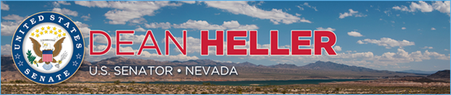

|  |  |
| --- | --- |
| For Immediate Release: | **Contact:** [Megan Taylor](mailto:Megan_Taylor@heller.senate.gov) |
| October 11, 2017 | 202-224-6244 |

**Heller Applauds $1 Million DOJ Grant for Nevada in Response to Las Vegas Tragedy**

**Washington, D.C.** – U.S. Senator Dean Heller (R-NV) today applauded the U.S. Department of Justice’s (DOJ) announcement that it will award the Nevada Department of Public Safety a $1 million grant for law enforcement’s response to the October 1, 2017 shooting in Las Vegas, NV.

“I welcome the DOJ’s announcement that Nevada will receive $1 million to help cover costs associated with law enforcement’s response to the tragedy in Las Vegas,” **said Heller**. “I’m incredibly proud of our first responders who ran toward violence and chaos and undoubtedly saved many lives. As our community continues down the long road toward recovery, it’s important that Nevada has the resources it needs to rebuild and I’m committed to working to make sure of it.”

 ###

[cid:image002.png@01D342AE.27818A20](http://www.facebook.com/pages/US-Senator-Dean-Heller/325751330177)[cid:image003.png@01D342AE.27818A20](http://twitter.com/SenDeanHeller)[cid:image004.png@01D342AE.27818A20](http://www.youtube.com/user/SenDeanHeller)