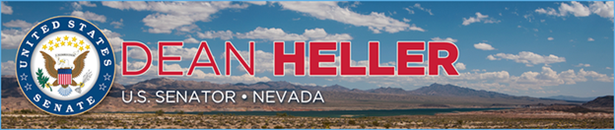

|  |  |
| --- | --- |
| **For Immediate Release:** | **Contact:** [Megan Taylor](mailto:Megan_Taylor@heller.senate.gov) |
| August 15, 2017 | 202-224-6244 |

**Heller Applauds Centene’s Pledge to Offer Health Plans in Nevada’s Bare Counties**

**Reno, N.V.** – U.S. Senator Dean Heller (R-NV) released the below statement after Centene announced today that its Nevada subsidiary, SilverSummit, will offer plans on Nevada’s health insurance exchange in 2018, ensuring that no county in the state will be at risk of having no insurance options.

“I welcome Centene’s announcement that it will offer plans on the Nevada exchange, providing Nevadans with additional health care options so that no county in our state is bare.I was proud to work with Governor Sandoval to make sure that people living in all of Nevada’s 17 counties have the option to purchase coverage on the exchange next year,” **said Senator Dean Heller.** “Nevadans have been left with dwindling choices when it comes to their health care coverage, and it’s more evidence that Obamacare is failing. That’s why I continue to work for health care solutions – like the Graham-Cassidy-Heller plan – that return power to the states, protect Nevada’s most vulnerable, and repeal Obamacare’s onerous mandates that continue to squeeze hardworking Nevadans who can least afford it.”

*###*[cid:image002.png@01D315C1.644AA000](http://www.facebook.com/pages/US-Senator-Dean-Heller/325751330177)[cid:image003.png@01D315C1.644AA000](http://twitter.com/SenDeanHeller)[cid:image004.png@01D315C1.644AA000](http://www.youtube.com/user/SenDeanHeller)