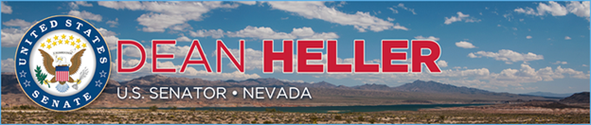

|  |  |
| --- | --- |
| For Immediate Release: | **Contact:** [Megan Taylor](mailto:Megan_Taylor@heller.senate.gov) |
| December 1, 2017 | 202-224-6244 |

**Heller Applauds EPA Announcement to Help Nevada’s Mining Industry***Follows Heller’s Call for Agency to Eliminate Harmful Obama-Era Rule*

**Washington, D.C.** – U.S. Senator Dean Heller (R-NV) today applauded the Environmental Protection Agency’s (EPA) announcement that it will eliminate an Obama-era rule that would have expanded EPA’s authority to unnecessarily burden Nevada’s mining industry.

The announcement comes [after Heller led a July letter with the Senate Western Caucus](https://www.heller.senate.gov/public/index.cfm/2017/7/heller-to-epa-end-unnecessary-obama-era-rule-that-could-harm-nevada-s-mining-industry) stressing that the “Financial Responsibility Requirements Under the Comprehensive Environmental Response, Compensation and Liability Act (CERCLA) for Classes of Facilities in the Hardrock Mining Industry” rule would result in excessive compliance costs and discourage mining companies from investing and providing good-paying jobs to communities that rely on this critical industry.

“The Environmental Protection Agency’s decision today is a win for Nevada’s mining industry, which helps employ nearly 25,000 workers in our state alone,” **said Heller.** “The CERCLA rule would have discouraged investment, development, and job creation in the very communities that rely on this industry. I was proud to have led the congressional effort against this anti-mining, government-overreach rule and I’m thankful Administrator Scott Pruitt recognized its harmful economic impact.”

Earlier this year, Heller also urged the EPA to allow for additional time to review the impact this rule would have on the mining industry. As a result, the [EPA extended the comment period from 60 days to 120 days](https://www.heller.senate.gov/public/index.cfm/2017/2/heller-and-barrasso-praise-extension-of-comment-period-for-epa-s-proposed-mining-rule) and Heller and his colleagues welcomed the opportunity to express their concerns and encourage their constituents to make their voices heard.

###

[cid:image002.png@01D36AD0.C38CC200](http://www.facebook.com/pages/US-Senator-Dean-Heller/325751330177)[cid:image003.png@01D36AD0.C38CC200](http://twitter.com/SenDeanHeller)[cid:image004.png@01D36AD0.C38CC200](http://www.youtube.com/user/SenDeanHeller)