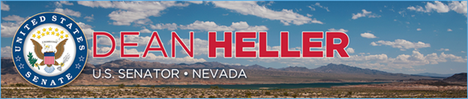

|  |  |
| --- | --- |
| For Immediate Release: | **Contact:** [Megan Taylor](mailto:Megan_Taylor@heller.senate.gov) |
| October 12, 2017 | 202-224-6244 |

**Heller Applauds Executive Action Allowing Health Insurance to Be Sold Across State Lines**

*President Signs Executive Order to Promote Competition, Expand Coverage Options*

**Washington, D.C.** – U.S. Senator Dean Heller (R-NV) today applauded President Trump’s executive order that will make it easier for small employers to band together to buy health insurance through association health plans. By exempting association health plans from some of Obamacare’s onerous regulations, small employers will have the option to buy insurance across state lines, a move that Heller has championed for years through legislation.

“I welcome President Trump’s executive order allowing insurance to be sold across state lines, which will promote competition in the health care marketplace, increase choices for consumers, and ultimately drive down costs,” **said Heller.** “For years, I have said that we need to allow insurance companies to offer a number of different products and enable consumers to purchase insurance across state lines to encourage competition and lower costs. That’s why I introduced legislation that would do just that. While I am disappointed that Congress has not successfully acted to repeal and replace Obamacare, I applaud President Trump’s action on this issue and I look forward to working with my colleagues to move my legislation forward in the Senate.”

As a member of the U.S. Senate Finance Committee, which has jurisdiction over health care, Heller [introduced legislation that would allow insurance to be sold across state lines](https://www.congress.gov/bill/115th-congress/senate-bill/1516) to increase the affordability and accessibility of health care. Heller also filed an amendment in July of 2017 during the health care debate to permit health insurance to be sold across state lines.

###

[cid:image002.png@01D34353.D8EF62F0](http://www.facebook.com/pages/US-Senator-Dean-Heller/325751330177)[cid:image003.png@01D34353.D8EF62F0](http://twitter.com/SenDeanHeller)[cid:image004.png@01D34353.D8EF62F0](http://www.youtube.com/user/SenDeanHeller)