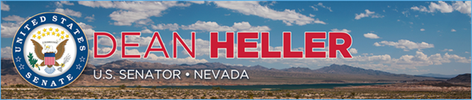

|  |  |
| --- | --- |
| **For Immediate Release:** | **Contact:** [Megan Taylor](mailto:Megan_Taylor@heller.senate.gov) |
| August 21, 2017 | 202-224-6244 |

**Heller Applauds VA Action to Aid Veterans in Rural Communities  
*VA’s Action Follows Heller’s Request for Reform***

**Washington, D.C.** – U.S. Senator Dean Heller (R-NV) welcomed Department Veterans Affairs (VA) Secretary David Shulkin's announcement that the VA will alter the formula in its ranking system for awarding grants under the State Veterans Home Construction Grant Program. The proposed changes follow Heller's requests to reform the grant program to help veterans living in rural areas, and represent a step toward securing federal dollars for the new State Veterans Home in Northern Nevada.

Heller attended the [groundbreaking](https://www.heller.senate.gov/public/index.cfm/pressreleases?ID=42F8A28A-8F81-4D85-93DB-26DA3DCAC631) for the new Northern Nevada State Veterans Home in July and has been leading the effort to secure federal funds for the project. In [July 2016](https://www.heller.senate.gov/public/_cache/files/26ca54ba-a1fb-40d7-aafd-b96ac72564ae/07142016%20Heller%20Letter%20to%20VA%20re%20State%20Home%20Grant%20Funding.pdf) and again earlier this month, [Heller specifically urged Secretary Shulkin and the VA to reform the State Veterans Home Construction Grant Program to better assist large rural states](https://www.heller.senate.gov/public/index.cfm/pressreleases?ID=EF69B3A1-B7CE-4443-A24B-BA2A35A25E15). Heller cited Northern Nevada communities such as Reno, Sparks, and Carson City and how it would be unreasonable to expect veterans in these communities to move 500 miles away from home to access the State Veterans Home in Boulder City**.**

“I applaud today's announcement from the VA as it is a step toward my goal of ensuring that every Nevada veteran has access to quality and timely care in their own community," **said Heller.** "As asenior member of the Senate Veterans’ Affairs Committee, I continue to work hard to make sure that the Northern Nevada State Veterans Home has the federal resources it needs to support our commitment to Nevada's veterans."

*###*

[cid:image002.png@01D315C1.644AA000](http://www.facebook.com/pages/US-Senator-Dean-Heller/325751330177)[cid:image003.png@01D315C1.644AA000](http://twitter.com/SenDeanHeller)[cid:image004.png@01D315C1.644AA000](http://www.youtube.com/user/SenDeanHeller)