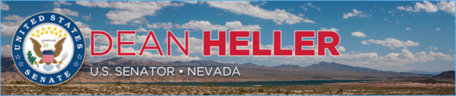

|  |  |
| --- | --- |
| **For Immediate Release:** | **Contact:**[Megan Taylor](mailto:Megan_Taylor@heller.senate.gov) |
| October 23, 2018 | 202-224-6244 |

**Heller Attends Reno-Stead Airport’s 75th Anniversary Celebration Event Honoring Service Members and Marking Grand Re-Opening of Main Runway**

**RENO** – U.S. Senator Dean Heller (R-NV) today joined veterans, service members, local leaders, and community members at the culmination of the Reno-Stead Airport’s year-long 75th anniversary celebration for an event that honored the military heroes and civilians who served at the air base since its inception in 1942 and marked the grand re-opening of the airport’s main runway that was recently reconstructed. Commander of the Nevada National Guard Brigadier General Bill Burks, Reno-Tahoe Airport Authority Board Chair Lisa Gianoli, Reno-Stead Airport President & CEO Marily Mora, and members of the Reno-Stead High Sierra Squadron were also in attendance.

In 1942, Reno Army Air Base began operations at what ultimately became Stead Air Force Base, which was home to the Strategic Air Command’s Survival School, Flying Training Wing, and Reno Air Defense Sector. In 1966, Reno-Stead Airport began operating as a general aviation airport, and today, it also hosts the National Guard, Bureau of Land Management (BLM) firefighting air tankers, and major drone testing for high-tech companies and the National Aeronautics and Space Administration (NASA). Last year, the BLM tankers broke records for flights, supporting up to 90 flights a day and fighting raging wildfires in Nevada and northern California.

“The most important reason to be here is to celebrate our veterans, military heroes and civilians, and the impressive military history at this airport. We are also here to celebrate the grand re-opening of runway 8/26. This is a significant moment for the airport because the grant - $21 million – is the largest in the airport’s history,” **Heller stated at the event.** “I supported this effort because of how important this airport is to Nevada’s safety and competitiveness. This airport hosts the National Guard. It hosts the BLM firefighting tankers. And it is a major drone testing site for tech companies and the FAA. There are not many general aviation airports in this country that could make a mark like that.”

In early 2018, the Reno-Stead Airport received a $21 million grant, which Heller strongly supported, from the Federal Aviation Administration (FAA) for runway reconstruction that will enhance operational safety. It’s been 25 years since the runway was last reconstructed, and it’s the largest amount of funding that Reno-Stead has ever received from the FAA.

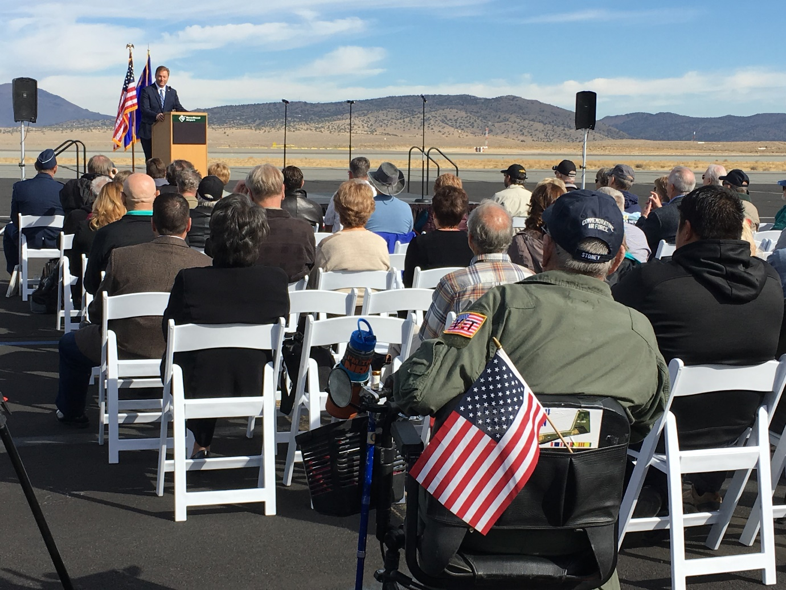

*Heller delivering remarks at the ceremony.*

A member of the U.S. Senate Committees on Veterans’ Affairs and Commerce, Science, and Transportation, Heller has been a strong advocate for Reno-Stead. He supported legislation that is now law to provide $1 billion for new infrastructure funding for airport improvement project, and  he worked with U.S. Transportation Secretary Elaine Chao to secure funding for Nevada’s airports. Most recently, [Heller announced over $5.1 million in funding for White Pine County to support additional operations at the Ely Airport (Yelland Field) and help the airport improve safety by reconstructing its current taxiway](https://www.heller.senate.gov/public/index.cfm/2018/9/heller-announces-over-5-1-million-in-funding-for-ely-airport).

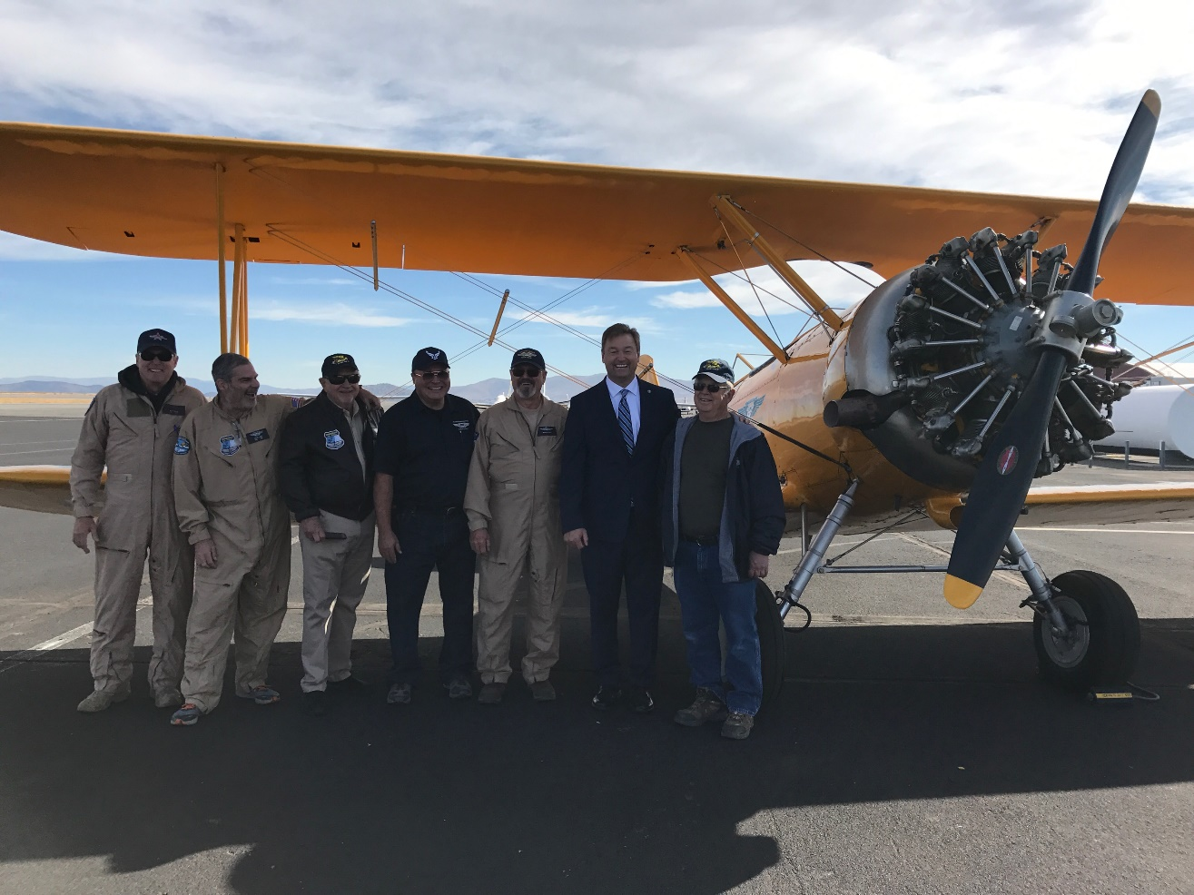

*Heller and the Reno-Stead High Sierra Squadron, a group committed to preserving historically significant military aircraft.*

Additionally, Heller helped pass into law a five-year FAA Reauthorization Act, bipartisan legislation that included [14 of Heller’s provisions, including his proposals to improve air travel for disabled individuals, boost Nevada’s travel and tourism economy, promote aviation safety, help veterans find employment, and advance the state’s drone industry.](https://www.heller.senate.gov/public/index.cfm/pressreleases?ID=EAAD6DD9-13CB-4C27-9756-9F60E26E76F6)

“This law builds on the work this airport is doing on drone testing and it makes sure the airport can access resources to attract new airlines routes. My job in DC is to make sure this airport has the resources it needs to meet Nevada’s growth and promote safety for the state,” **Heller added.**

###