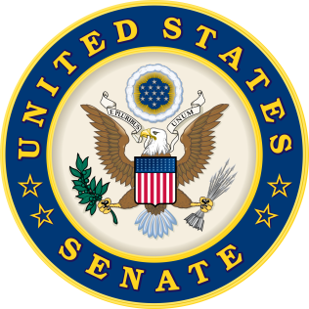
For Immediate Release: | Contacts:
June 30, 2016 | Neal A. Patel 202-224-6244 (Heller)
 | John Rizzo 202-228-6367 (Casey)

Heller and Casey Seek Transparency for VA Bonuses
Legislation highlights importance of quality leadership on the ground

(Washington, DC) – Recently, Chairs of the VA Backlog Working Group, U.S. Senators Dean Heller (R-NV) and Bob Casey (D-PA), released the following statements after introducing the Department of Veterans Affairs Bonus Transparency Act (S. 3112). The bill requires the Department of Veterans Affairs (VA) to annually report on the bonuses awarded to critical positions within the VA, including VA Regional Office (VARO) directors, VA hospital directors, and Veterans Integrated Service Network (VISN) directors.
“VA leadership on the local level, whether it is a VA hospital director, or a Regional Office director exerts significant control over the quality of care and benefits Nevada’s veterans receive. That is why I personally meet with these individuals and work with them closely to address challenges on the local level and keep them accountable. Therefore, Members of Congress should be informed of whether VA leaders in their districts or states are being awarded bonuses based on performance. This measure is critical to bringing greater transparency and accountability to the VA,” said Senator Dean Heller.
“This legislation will provide an important measure of transparency and accountability at the VA,” Senator Bob Casey said. “Given the concerns that have been raised over VA bonuses, this is a necessary measure to ensure that the American people know exactly which positions are receiving these dollars.”
A PDF copy of the legislation can be found here.
###

