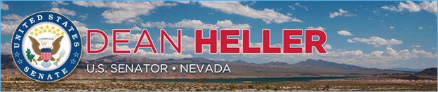

|  |  |
| --- | --- |
| **For Immediate Release:** | **Contact:**[Megan Taylor](mailto:Megan_Taylor@heller.senate.gov) |
| August 9th, 2018 | 202-224-6244 |

**Heller Celebrates Grand Opening of Interstate-11 in Boulder City**

*Heller Longtime Champion of I-11, Transportation Projects in Nevada*

**BOULDER CITY** – U.S. Senator Dean Heller (R-NV) today joined local officials, the Nevada Department of Transportation, the Southern Nevada Regional Transportation Commission, and hundreds of Nevadans at the grand opening ceremony for the Boulder City Bypass, a 15-mile segment of Interstate-11. A member of three U.S. Senate committees responsible for developing transportation policies, Heller has been a champion for the I-11 project and has worked to help fund the freeway.

In 2015, Heller [introduced legislation to extend I-11 from Las Vegas to Northern Nevada.](https://www.heller.senate.gov/public/index.cfm/pressreleases?ID=f0b7befb-61f2-44d1-ab0d-be49ae502e2a) He secured [this extension and designation of I-11 as a high-priority corridor](https://www.heller.senate.gov/public/index.cfm/pressreleases?ID=D94FBB96-DF60-4ED3-9AB7-6E6EFC351F0E) of the National Highway System in the Fixing America’s Surface Transportation (FAST) Act, the first long-term highway bill in a nearly a decade to be approved by Congress and signed into law.  
  
“We have a lot to be proud of today with the Boulder City Bypass, and it is because this state collaborates and works well together. Thank you to the Nevada Department of Transportation and the Southern Nevada Regional Transportation Commission for making this project a reality,” **said Heller.** “Above all, we should thank the residents of Clark County who voted to ensure there is available funding for infrastructure projects like this one.”

*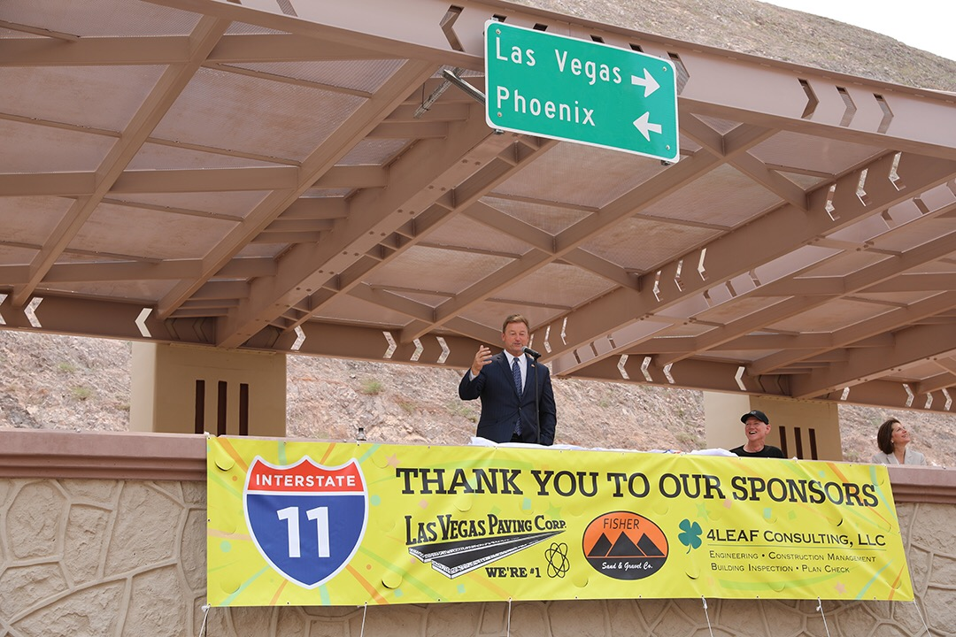  
Sen. Heller delivers remarks at the grand opening of I-11 in Boulder City.*

“Southern Nevada understands that connecting Las Vegas to Phoenix will boost our economy. I-11 is going to attract more tourists, new businesses, and new residents, allowing Nevada to further build on its recent explosion of growth,” **added Heller.**This bypass is expected to save commuters 30 minutes when traveling between Henderson and the Hoover Dam.  
  
“Looking forward, we need to match Nevada’s growth by ensuring our roads, bridges, and infrastructure can keep pace with new and increased demands,” **said Heller.** “That is why I-11 remains one of my top infrastructure priorities and why I am going to keep fighting to ensure that Nevada has the resources and funds to complete this project all the way up to northern Nevada.”

###