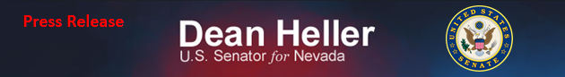
For Immediate Release: Contact: Neal A. Patel December 3, 2014 202-224-6244

Heller Saving Commissary Funding from Chopping Block
(Washington, DC) – United States Senator Dean Heller (R-NV) issued the following statement after an amendment he filed was included in the final FY2015 National Defense Authorization Act (NDAA) protecting funding for military commissaries across the globe. The amendment requires the Department of Defense to issue an impact report detailing what a reduction in the commissary benefit will have on eligible beneficiaries:
“Commissaries, like the ones at Fallon Naval Air Station and Nellis Air Force Base, offer significant savings that our nation’s military families rely on during these difficult economic times. I find the Department of Defense’s proposal to slash funding for commissaries to be wrong and unfair. The Pentagon should not balance its budget on the back of our military community. As a member of the Senate Committee on Veterans’ Affairs, I am pleased to see this amendment included in the FY2015 NDAA. No matter where these brave men and women are serving, they should never have to worry their earned benefits will be cut.”

Attached is a copy of the amendment in PDF format.

###

