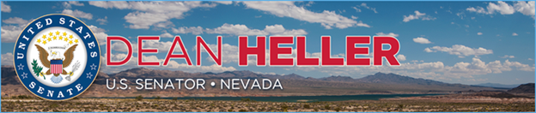

|  |  |
| --- | --- |
| **For Immediate Release:** | **Contact:** [Megan Taylor](mailto:Megan_Taylor@heller.senate.gov) |
| February 12, 2018 | 202-224-6244 |

**Heller Defends Important Nevada Public Lands Program**

**WASHINGTON, D.C.**– U.S. Senator Dean Heller (R-NV) today released the below statement on the Administration’s proposal to gut the Southern Nevada Public Land Management Act’s (SNPLMA) special account at the Department of the Interior. The proposal suggests a recession of $230 million from the program.

Enacted in 1998, SNPLMA is a program that allows the Bureau of Land Management (BLM) to sell public land within a specific boundary around Las Vegas, Nevada. The revenue generated by those sales is invested in important public works projects, ecological restoration, and conservation efforts across the state.

“The Southern Nevada Public Land Management Act was passed by Congress in 1998 to increase economic development and promote conservation in Southern Nevada. It represents a good-faith agreement between local, state, and federal officials,” **said Heller.** “This program has invested over $3.4 billion in over 1,200 conservation projects across Nevada, including wildfire prevention, restoration efforts at Lake Tahoe, and the development of parks, trails, and other natural areas. That is why I will continue to defend this program from any attempt to rescind its funding, and I urge the Administration to keep it intact.”

###

[cid:image002.png@01D3A3FD.20A42CC0](http://www.facebook.com/pages/US-Senator-Dean-Heller/325751330177)[cid:image003.png@01D3A3FD.20A42CC0](http://twitter.com/SenDeanHeller)[cid:image004.png@01D3A3FD.20A42CC0](http://www.youtube.com/user/SenDeanHeller)