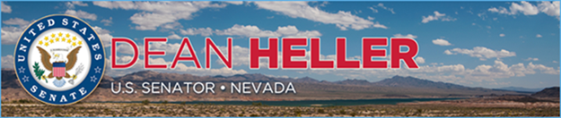

|  |  |
| --- | --- |
| **For Immediate Release:** | **Contact:** [Megan Taylor](mailto:Megan_Taylor@heller.senate.gov) |
| August 28, 2017 | 202-224-6244 |

**Heller Discusses Airlines’ Links to NV Jobs, Economy**

*Speaks at 22nd Annual Boyd Group International Aviation Forecast Summit*

**Las Vegas, N.V.** – U.S. Senator Dean Heller (R-NV) spoke today about his efforts to boost tourism and jobs as well as the need for infrastructure improvements to airports in Nevada and throughout the country during the 22nd Annual Boyd Group International Aviation Forecast Summit held in Las Vegas, NV.

Heller and Rossi Ralenkotter, president and CEO of the Las Vegas Convention and Visitors Authority, participated in a panel discussion at the beginning of the summit with moderator Mike Boyd, president and CEO of Boyd Group International.

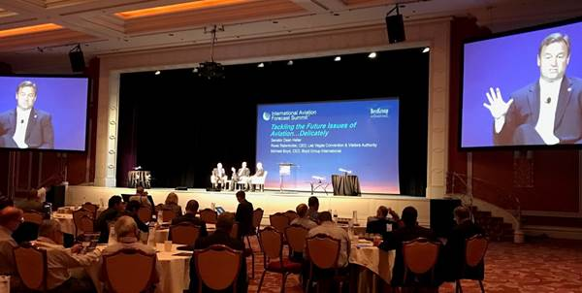

*Heller talks about tax reform and the FAA Reauthorization Act at the summit*

This is the third year that the summit is taking place in Las Vegas. The three-day event brings airline and airport leaders together to discuss the industry’s current landscape, trends, data, and perspectives that will inform the future of aviation.  
  
“Nevada’s economy depends on tourism, which is why I continue to champion policies that will boost and grow this industry within the state. One such way is through improving our infrastructure - both in the air and on the ground – to make travel in and out of Nevada a positive experience for visitors,” **Heller said.** “From expanding I-11 to pushing for airports like McCarran International to use federal dollars for building multimodal systems to improve tourist access, I’m proud of our progress on that front, but we have more work to do. Encouraging more domestic and global air travelers to Nevada and the U.S. helps spur economic growth, job creation, and strengthens our local economies, particularly Southern Nevada’s. With nearly 44 percent of Southern Nevada jobs alone supported directly and indirectly by tourism, I’m doing all that I can to break down regulatory barriers so that more individuals choose Nevada for business or leisure.”

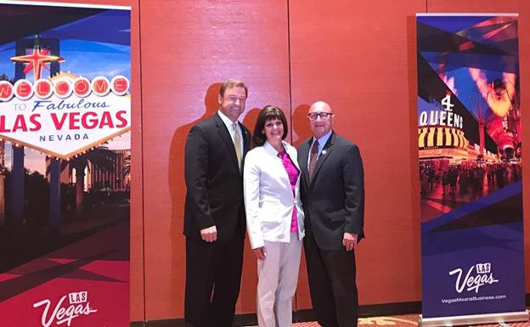  
*Heller with Ralenkotter and Rosemary Vassiliadis, Clark County’s director of aviation*

A member of the Senate Committee on Commerce, Science and Transportation and the Senate Travel & Tourism Caucus, Heller briefed the audience on the outlook for Senate action on the Federal Aviation Administration (FAA) Reauthorization Act of 2017 and Air Traffic Control Reform. [Heller secured several provisions](https://www.heller.senate.gov/public/index.cfm/2017/6/heller-secures-significant-wins-for-nevada-in-faa-reauthorization-billl) in the FAA Reauthorization Act that will boost Nevada’s travel and tourism economy, help veterans find employment, and promote the state’s drone industry.

He also touched on provisions in the FAA Reauthorization Act that will put consumers first after the United Airlines incident in April.

“The Senate bill has a ban on involuntarily removing customers from a flight after they’ve boarded,” Heller said. “We provide accountability over airlines boarding and bumping practices and fees.”

Heller added, “As a member of the Senate Finance and Commerce Committees, I have the opportunity to stand up for our tourism economy as we tackle issues ranging from tax reform to reauthorizing the Federal Aviation Administration this fall. Investing in airport infrastructure projects will not only help us meet the demand of travelers, but also draw more visitors to our state and allow our communities and industries to thrive.”

*###*

[cid:image003.png@01D31FF6.8CCDF4C0](http://www.facebook.com/pages/US-Senator-Dean-Heller/325751330177)[cid:image004.png@01D31FF6.8CCDF4C0](http://twitter.com/SenDeanHeller)[cid:image005.png@01D31FF6.8CCDF4C0](http://www.youtube.com/user/SenDeanHeller)