

|  |  |
| --- | --- |
| **For Immediate Release:** | **Contact:** [Megan Taylor](mailto:Megan_Taylor@heller.senate.gov) |
| September 12, 2017 | 202-224-6244 |

**In Case You Missed It: Heller Discusses Health Care Reform at Finance Committee Hearing**

Washington, D.C. – During a U.S. Senate Finance Committee hearing this morning, U.S. Senator Dean Heller (R-NV) spoke today about the Graham-Cassidy-Heller health care proposal, legislation that provides states with the money and flexibility needed to determine how to best cover health care costs. Under this proposal, states would be able to implement tailor-made solutions to their health care challenges. Click [HERE](https://youtu.be/V90UMKttFt8) to watch the video.

[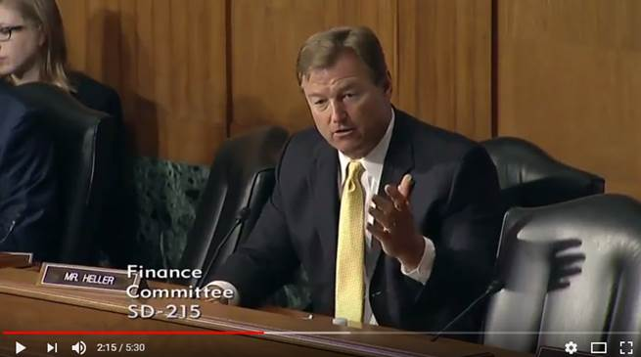](https://www.youtube.com/watch?v=V90UMKttFt8&feature=youtu.be)

[Click [here](https://www.youtube.com/watch?v=V90UMKttFt8&feature=youtu.be) or the above image to watch]

“As someone who has been working with my colleagues on innovative solutions to our health care system, I will continue fighting on behalf of Nevadans and working to ensure they have access to high-quality, affordable care they rely on. I believe the goal of health care reform should be to lower costs, increase access, and improve the quality of health care in this country,” **Heller said.** “One critical way to accomplish these goals is to provide states with the tools they need to meet the unique health care needs of their citizens. That’s why I’ve been working with my colleagues Senators Cassidy and Graham on a proposal that will take the decision making and money out of Washington and bring it back to the states.”

###  
  
[cid:image004.png@01D32BCB.9F000350](http://www.facebook.com/pages/US-Senator-Dean-Heller/325751330177)[cid:image005.png@01D32BCB.9F000350](http://twitter.com/SenDeanHeller)[cid:image006.png@01D32BCB.9F000350](http://www.youtube.com/user/SenDeanHeller)