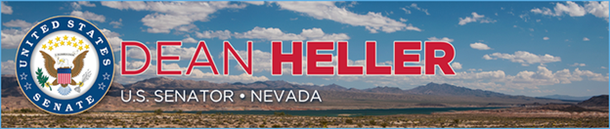

|  |  |
| --- | --- |
| **For Immediate Release:** | **Contact:** [Megan Taylor](mailto:Megan_Taylor@heller.senate.gov) |
| March 6, 2018 | 202-224-6244 |

**Heller Discusses Relocation of U.S. Embassy to Jerusalem with Nevadans Representing AIPAC**

*Heller Authored Legislation to Move American Embassy to Jerusalem*

**WASHINGTON, D.C.** – U.S. Senator Dean Heller (R-NV) today met with a number of Nevadans who traveled from Las Vegas, Henderson, Reno, and Carson City to Washington, D.C. on behalf of the American Israel Public Affairs Committee (AIPAC). During the meeting, Nevadans discussed various legislative proposals, including Heller’s Jerusalem Embassy and Recognition Act, as well as Heller’s work to hold Iran accountable.

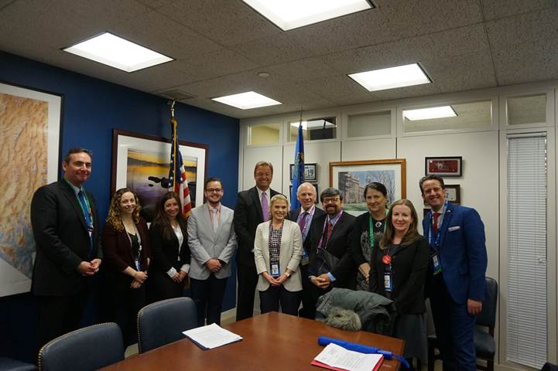

*Sen. Heller meets with Nevadans representing AIPAC.*

Heller along with Senators Ted Cruz (R-TX) and Marco Rubio (R-FL) introduced the [Jerusalem Embassy and Recognition Act](https://www.heller.senate.gov/public/index.cfm/pressreleases?ID=15329846-E3DD-46F0-A16E-784700B8358B) to fulfill our commitment to Israel by enacting current law. In 1995, Congress passed legislation that recognized Jerusalem as the capital of Israel by moving the U.S. Embassy from Tel Aviv to Jerusalem. However, although the bill became law later that year, the U.S. Embassy was not moved to Jerusalem. Heller’s Jerusalem Embassy and Recognition Act would relocate the U.S. embassy to Jerusalem by forcing the U.S. Department of State to do just that or face a penalty.

In December of 2017, the Administration announced it would develop a plan to relocate the American Embassy to Jerusalem. [Heller applauded the White House’s decision](https://www.heller.senate.gov/public/index.cfm/pressreleases?ID=89936C1E-D142-4F37-8C9A-9546F84277D8), and welcomes the Administration’s work to expedite the U.S. Embassy’s relocation timeline. According to reports, the U.S. Embassy in Jerusalem is expected to open in May, and the facility will be completed by the end of 2019.

“I appreciate the opportunity to have Nevadans from Carson City to Las Vegas in my office to talk about what Congress is doing to support one of our strongest allies in the fight against terrorism and in promoting peace in the Middle East – Israel,” **said Heller.** “We discussed the Administration’s work to fast-track its plan to relocate the American Embassy to Jerusalem, a move that I have repeatedly pushed for by introducing legislation that demands the United States no longer turns a blind eye to its promise. We also spoke about defense aid to Israel, as well as the importance of holding Iran accountable for its aggression and preventing the regime from developing a nuclear weapon. I’ll continue to be a voice for Nevadans and work to see that Congress’ actions reflect the United States’ unwavering commitment to Israel.”  
  
As a strong opponent of President Obama’s dangerous deal with Iran, Heller has used his role on the U.S. Senate Banking Committee, which has jurisdiction over sanctions, to hold Iran accountable. He introduced the [Iran Ballistic Missile Sanctions Act](https://www.heller.senate.gov/public/index.cfm/2017/6/heller-files-amendment-to-double-down-on-iran-s-ballistic-missile-program), which imposes new sanctions on individuals, entities, and sectors that aid in Iran’s unlawful ballistic missile program, and filed it as an amendment to the Countering Iran’s Destabilizing Activities Act, which is also aimed at mitigating the damage of President Obama’s Iran deal. He also voted in support of Countering America's Adversaries Through Sanctions Act (PL 115-44), which imposes additional sanctions on Iran, Russia, and North Korea. Heller cosponsored and voted in support of Countering Iran’s Destabilizing Activities Act, bipartisan legislation that imposes sanctions on Iran for its violation of arms embargoes and continued weapons tests, support of terrorism, and efforts to prop up the Assad regime.

 ###

[cid:image003.png@01D3B56A.5F12E130](http://www.facebook.com/pages/US-Senator-Dean-Heller/325751330177)[cid:image004.png@01D3B56A.5F12E130](http://twitter.com/SenDeanHeller)[cid:image005.png@01D3B56A.5F12E130](http://www.youtube.com/user/SenDeanHeller)