

|  |  |
| --- | --- |
| **For Immediate Release:** | **Contact:** [Megan Taylor](mailto:Megan_Taylor@heller.senate.gov) |
| April 3, 2018 | 202-224-6244 |

**Heller Discusses School Safety with Clark County Law Enforcement**

**HENDERSON**– U.S. Senator Dean Heller (R-NV) today visited Clark County School District Police Department (CCSDPD) headquarters where he met with law enforcement officials to discuss the department’s role in keeping schools safe as well as the recently-signed STOP School Violence Act.

Earlier this year, Heller helped introduce the bipartisan [STOP School Violence Act](https://www.heller.senate.gov/public/index.cfm/pressreleases?ID=3F93A8C9-9C29-4A65-8F50-7BFBB155CE9A'), which funds school security improvements and invests in early intervention and prevention programs to stop school violence before it happens. The bill was signed into law by the President on March 23, 2018 as part of the omnibus package.

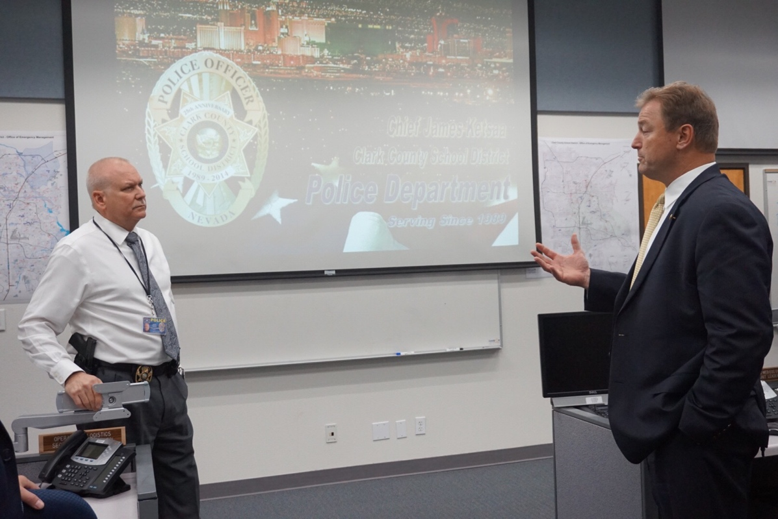

*Heller at the Emergency Operations Center with CCSDPD Chief James Ketsaa*

During Heller’s visit, law enforcement personnel briefed the Senator on CCSDPD’s work – 161 officers service 357 schools in the county. CCSDPD is the fourth largest school district police force in the United States.

Heller and Chief James Ketsaa also discussed funding for the Urban Areas Security Initiative, also known as UASI, a program within the Department of Homeland Security that helps Las Vegas and other cities protect themselves against terror attacks. The president recently signed legislation, which Heller supported, that provides a boost in funding for the program. [Heller has worked extensively to see that Las Vegas has adequate resources from this program to protect itself from attacks.](https://www.heller.senate.gov/public/index.cfm/pressreleases?ID=4CBFC0DA-B7E8-48E1-8625-BD83FB2B6C71)

The group also shared with Heller CCSDPD’s response in the wake of the October 1st tragedy, in which the department manned police command posts on the strip and provided psychological assistance.

“I’m deeply grateful for our police officers in Clark County and their tireless efforts to protect students. Nevada’s law enforcement is on the frontlines every day, keeping watch and often putting themselves in harm’s way to protect the public from danger. Whether it is combating the drug epidemic or holding perpetrators responsible for their heinous crimes, I will never forget the important role they play in our community. That’s why I will continue to push Congress to ensure that Nevada’s police departments – including Clark County School District Police Department –  have the federal resources they need,” **Heller said.** “As a father of four and grandfather of two, I strongly believe that every student should feel safe in the classroom, and I look forward to working with Clark County officials, the Governor and the Administration to ensure that Nevada is equipped.”

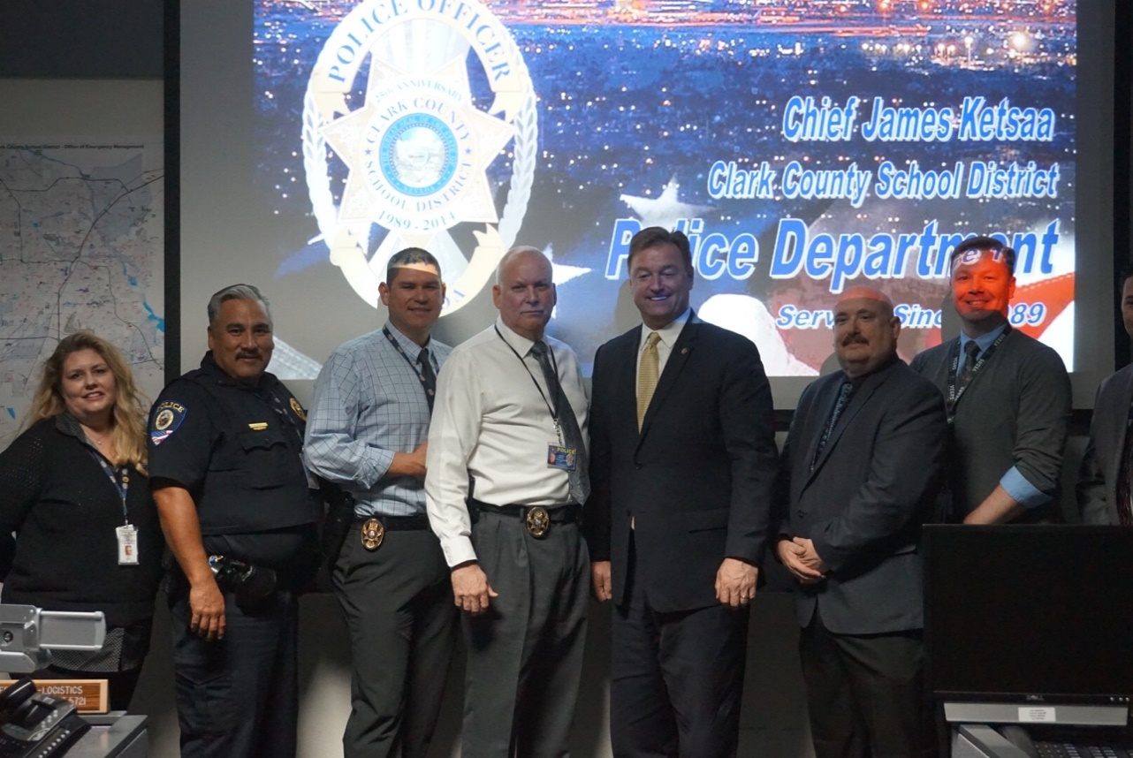

*Heller and officials with the CCSDPD*

The visit comes on the heels of Heller announcing that he worked with Chairman of the Senate Commerce, Justice, and Science Department Appropriations Subcommittee Richard Shelby (R-AL) [to provide additional funding in the recently-signed omnibus legislation to help defray the costs incurred by law enforcement in Nevada following the October 1st shooting](https://www.heller.senate.gov/public/index.cfm/pressreleases?ID=59DFAEB0-B94D-46C6-A4C8-12CAB3CFC345). The state of Nevada will have to apply for the grant, and the Attorney General has 10 days to respond to the state’s request.

*###*