

|  |  |
| --- | --- |
| **For Immediate Release:** | **Contact:** [Megan Taylor](mailto:Megan_Taylor@heller.senate.gov) |
| September 27, 2017 | 202-224-6244 |

**In Case You Missed It: Heller Drives Need to Reduce Nevada’s High Veteran Suicide Rate**

**Washington, D.C.** – During a U.S. Senate Veterans’ Affairs Committee hearing this morning, U.S. Senator Dean Heller (R-NV) spoke about Nevada’s troubling veteran suicide rate – 3rd highest in the U.S. – and asked how families can be empowered to prevent veteran suicides and what can be done to reduce or prevent post-traumatic stress (PTS) during service. Click [HERE](https://youtu.be/fIpBTS3N3js) to watch the video.

[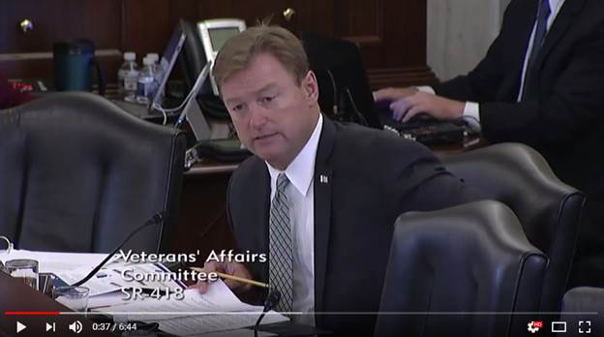](https://youtu.be/fIpBTS3N3js)

[Click [here](https://youtu.be/fIpBTS3N3js) or the above image to watch]

A senior member of the U.S. Senate Veterans’ Affairs Committee, Heller has been a long-time champion of efforts to address veterans’ [mental health services](https://www.heller.senate.gov/public/index.cfm/2014/11/heller-demands-improvement-of-backlog-to-address-poor-mental-health-of-veterans), [including recruitment of medical professionals in rural areas](https://www.heller.senate.gov/public/index.cfm/pressreleases?ID=F65727FA-396E-45FE-8368-736A23289DCA), and help curb the veteran suicide rate. In 2015, he cosponsored the Clay Hunt SAV Act, bipartisan legislation signed into law aimed at reducing and preventing veteran suicides.

Additionally, Heller recently cosponsored the National Suicide Hotline Improvement Act of 2017 (S.1015), a bill to study and improve the national suicide hotline.

Last month, Heller [hosted VA Secretary David Shulkin in Reno](https://www.heller.senate.gov/public/index.cfm/pressreleases?ID=E5B0E4D8-6124-47F1-AC54-DD1D0DF301B5), Nevada, where they discussed this issue and toured the VA Sierra Nevada Health Care System. Heller signed a declaration reaffirming his commitment to preventing suicide among Nevada veterans.

**Below is his opening statement as prepared for delivery:**

*Chairman Isakson and Ranking Member Tester—thank you for holding this hearing.*

*I know that for Senator Tester, this issue has hit Montana the hardest with the highest veteran suicide rate in the nation.*

*Unfortunately, Nevada is right up there with the third highest suicide rate. Nevada is losing a veteran to suicide every three days.*

*It’s devastating, and the impact trickles down to friends, family, and the veterans’ military comrades.*

*But what we are learning is that improving VA health care is not the only answer.*

*There are too many veterans out there who don’t go to the VA, aren’t seeking help, and are falling through the cracks.*

*I’ve talked about this at my Veterans Roundtables in Las Vegas and Reno.*

*And what I’ve found is that Nevada veterans are committed to looking out for each other, not just relying on the VA or non-profits.  It’s a community mentality.*

*But at this point, we need all options on the table for how to prevent these tragedies.*

*In August, I hosted Secretary Shulkin in Reno to discuss this crisis and sign a declaration to show our commitment to preventing veteran suicides.*

*I am going to keep that commitment to “be there” for our veterans, and this hearing is an opportunity to find out what more we can do to zero out veteran suicides.*

###

[cid:image003.png@01D33792.79D56F20](http://www.facebook.com/pages/US-Senator-Dean-Heller/325751330177)[cid:image004.png@01D33792.79D56F20](http://twitter.com/SenDeanHeller)[cid:image005.png@01D33792.79D56F20](http://www.youtube.com/user/SenDeanHeller)