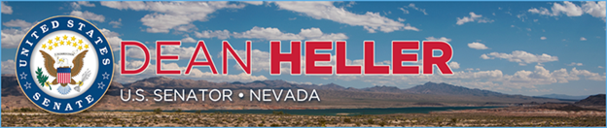

|  |  |
| --- | --- |
| For Immediate Release: | **Contact:**[Megan Taylor](mailto:Megan_Taylor@heller.senate.gov) |
| March 21st, 2018 | 202-224-6244 |

**Heller Ensures Efforts to Revive Yucca Mountain Stopped by Spending Bill**

*FY2018 Omnibus Does Not Include Funding For Licensing Activities at Yucca Mountain*

**WASHINGTON, D.C.** – U.S. Senator Dean Heller (R-NV) today announced that the FY2018 omnibus spending measure does not include the [$150 million requested by the Department of Energy (DOE) and the Nuclear Regulatory Commission (NRC) to support and fund licensing activities at the Yucca Mountain nuclear repository](https://www.heller.senate.gov/public/index.cfm/pressreleases?ID=526CDC21-D0DB-40ED-AF19-7A3A737E9B98). Heller has repeatedly expressed Nevada’s strong opposition to the failed Yucca Mountain project to Administration officials as well as his colleagues who are members of the committees of jurisdiction.

Even though the U.S. House of Representatives [advanced](https://www.heller.senate.gov/public/index.cfm/pressreleases?ID=8EF79DF1-BC92-4F29-88BC-A9FF5CD73120) funding aimed at jumpstarting Yucca Mountain, Heller was able to ensure that the U.S. Senate Appropriations Committee [did not include any funding for the project in its Energy and Water Appropriations Bill](https://www.heller.senate.gov/public/index.cfm/pressreleases?ID=691E36A0-8C66-4C9F-B730-01AACAEA879A). Earlier this month, it was [reported](https://www.politicopro.com/energy/whiteboard/2018/03/simpson-no-go-from-senate-on-yucca-funding-in-omnibus-748331) that the Chairman of the U.S. House of Representatives Energy and Water Development Appropriations Subcommittee signaled that the spending package would not include Yucca Mountain because of objection from the U.S. Senate.

“I worked to ensure that funding to revive the Yucca Mountain project was excluded from this spending bill, and I’m pleased that Nevada’s message was heard. Just last week, I had the opportunity to question Secretary Perry about his efforts to resume the licensing process at Yucca Mountain, and I doubled down on my fight to ensure that the failed project doesn’t see the light of day,” **said Heller.** “While this is a positive development, my work to stop Yucca Mountain is far from over. That is why I will continue to tell Washington, D.C. that Nevada will not turn into the nation’s nuclear waste dump.”

Last week, Heller discussed DOE’s budget request with Secretary Perry at a U.S. Senate Commerce, Science, and Transportation hearing. Heller noted that the $120 million requested to fund licensing activities at Yucca Mountain was denied last year and that it will be denied again this year. He asked the Secretary if he anticipates making the same request again for the next fiscal year. Secretary Perry suggested that in 2019 that agency will make the same funding request, but he added that he “suspect(s) the result will probably be about the same." You may watch the exchange between Secretary Perry and Heller by clicking [here](https://www.youtube.com/watch?v=qIf4DeZgP2Q&feature=youtu.be) or on the image below.

[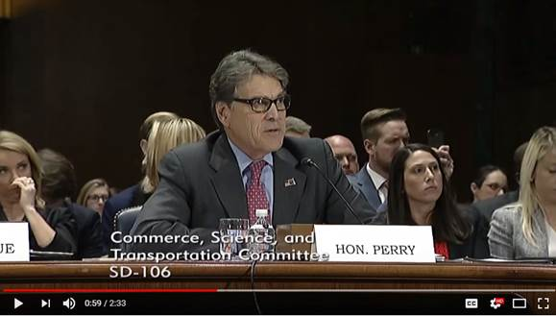](https://youtu.be/qIf4DeZgP2Q)

[Click [HERE](https://youtu.be/qIf4DeZgP2Q) or on the image above to watch the video.]

In April of 2017, [Heller testified before a U.S. House of Representatives Energy and Commerce Subcommittee on Environment hearing on legislation to revive Yucca Mountain](https://www.heller.senate.gov/public/index.cfm/videos?ID=B6E5E92F-B192-4670-8DC8-44B025E09B84). During the hearing, he urged the consideration of [his Nuclear Waste Informed Consent Act](https://www.heller.senate.gov/public/index.cfm/pressreleases?ID=5D20600D-88C2-4BBE-9E9D-4A23006D0264), bipartisan legislation that permits the NRC to authorize construction of a nuclear waste repository only if the Secretary of Energy has secured written consent from the governor of the host state, affected units of local government, and affected Indian tribes.

###