Rocky Hills HMA

HMA Overview
The Rocky Hills HMA is located 50 miles southwest of Carlin, Nevada in Eureka County. . It is approximately 83,998 acres in size, and is 15 miles wide, and 13 miles long. The HMA encompasses the Rocky Hills, and Simpson Park Mountains, with elevations ranging from the highest point at 8,100 feet, to 5,500 feet in elevation throughout the valleys that surround the Mountain ranges. The northern boundary of the HMA runs along JD Ranch Road. The HMA is bordered on the west by Grass Valley, and on the east by Denay Valley.

The Rocky Hills Herd Management Area (HMA) is within the JD and Grass Valley Allotments

Herd Management Area Composition
HMA | Allotment | Acreages | % of the HMA
Rocky Hills | Grass Valley | 33,321 | 40
 | JD | 50,676 | 60
 | Total | 83,997 | 100

Herd Considerations

Appropriate Management Level (AML)
The AML for the Rocky Hills HMA has been established as 86-143 wild horses. The Grass Valley Allotment Final Multiple Use Decision (FMUD) in 2002, and the JD Allotment FMUD in 2004 established the AMLs for this HMA.

Wild Horse Gather History
The most recent gather of the Rocky Hills HMA was completed in January 2009. The HMA was gathered as part of a Complex with the Callaghan and Bald Mountain HMAs.

Due to the distribution and concentration of wild horses near the existing waters within the HMA, the gather was completed in 2 days with 145 total captured. This area was gathered after the 1999 wildfires burned nearly half of the HMA. Horses were removed and held in a contract facility for 3 years and horses released back to the HMA in 2002. These horses were freezemarked on the neck, and a number “5” freezemarked on the hip. We gathered many of these horses again, and they are doing very well. Most horses were Body Condition Score 4.5-5+. The Rocky Hills HMA horses are in very good body condition (this herd is limited by water, not foage).

There were a few of the older (25-30 years of age) horses that were thin/poor. In contrast to the gather of the Callaghan HMA, we gathered numerous “older” horses that were 15 and older (18, 20, 25, 30, etc.) These age groups are part of a normal age structure, and were lacking from the horses gathered from the Callaghan HMA. 19 of the 145 captured (13%) were 15 years of age or older. The population modeling completed for the HMA indicated that only 15 (9%) would be 15 years or older. The overall health, size, and age structure of the Rocky Hills HMA is very good.

The WinEquus population modeling indicated that horses 2 years of age and younger should be able to be removed, and low AML achieved on the HMA, allowing for the release of horses 3 years of age and older. As the sorting of captured horses began, it became apparent that there were many horses 3 years of age and older (more than anticipated). The removal objectives were modified slightly, yet only about half of the horses 3 years of age and a hand full of horses 4 years of age were shipped to PVC. Only a few horses 5 years old or older were shipped to PVC, thereby minimizing the number of horses that may go to long term holding.

Overall, weather for this portion of the gather was clear and cool/warm with highs in the low 50’s.

On January 10, 32 studs were released back to the HMA. Fertility control was administered to 32 mares, which were subsequently released on January 13. During sorting of the Callaghan and Rocky Hills mares at the holding corrals, one Rocky Hills mare jumped the panels and escaped into the Callaghan HMA. There is no fence between the Callaghan and Rocky Hills HMAs, and the mare should be able to return to the Rocky Hills HMA if she desires. Fertility control has not been administered to the horses in this HMA in the past.

The previous gather took place as a result of the Trail Canyon wildfire that burned through the Simpson Park Mountains and 47% of the Rocky Hills HMA during the summer of 1999. The following is a break out of the gather results:

Total captured 256 Brand Inspector Impound 1
Total shipped to PVC 251 Adopted orphans 2
Total euthanized/died 3 Released back to HMA 0
Est. remaining in HMA 6
Nearly all of the horses gathered were fleshy, healthy and in overall good condition. Only a few thin or very thin horses were captured. The horses captured in the Rocky Hills HMA were relatively large in size, with some animals reaching 17 hands high. Many paint and appaloosa horses were captured, in addition to those that were brown, bay, black, red roan, buckskin, chestnut and grulla (mouse colored).

Table 9: Rocky Hills HMA Gather 1999
Category | Totals | %
Mares | 96 | 37.5
Studs | 109 | 42.6
Foals | 51 | 19.9
Totals | 256 | 100

Table 10: Rocky Hills HMA 1999 Color Patterns
Color | HMA Totals
 | %
bay | 32
brown | 20
black | 26
sorrel | 6.3
pinto | 3
gray | 1.6
red roan | 3
blue roan | 0.8
chestnut | 1
buckskin | 0.8
appaloosa | 6.3
white | 0.8

In 1997, the Grass Valley allotment portion of the HMA was gathered. The gather was completed in conjunction with the Callaghan HMA gather. Of the 445 horses gathered from the Rocky Hills HMA, 333 were shipped to Palomino Valley north of Sparks, Nevada for the adoption program. The remaining 112 horses, ages 10 to 25 years of age, were released back into the HMA.

Wild Horse Movement Patterns
Slight interchange likely occurs between the Rocky Hills HMA and the Roberts Mountain, Callaghan and Bald Mountain HMAs. Some Rocky Hills HMA wild horses gathered in 1999 and observed in the field since then exhibit pinto markings, which is consistent with the Callaghan HMA and to a lesser extent Bald Mountain HMA. Census data does not indicate that more than a few individuals per generation may be moving between the areas.

Herd Characteristics
A wide variety of colors exist in the HMA including paint, buckskin, grulla, appaloosa, roan and dun. The Rocky Hills HMA wild horses are large horses and display a unique variety of coloration. These horses may reach 16 hands or taller, and may reflect some draft horse traits such as heavy muscling, and large bone structure. In 2000, some of the Rocky Hills wild horses were offered in the 1st ever satellite downlink adoption event. The MLFO has received positive feedback about the size, coloring and disposition from those who have adopted wild horses from this HMA.

Rocky Hills HMA population has been affected through nearly complete removal of the population in 1999, then release of 74 horses in 2002. The wild horses released reflected older age groups with only 22% of them 9 years old or younger. Follow-up census flights in 2005 and 2008 suggest that the population has not increased at MLFO average levels. Two and a half years after the release, and two foaling seasons later in 2005, MLFO staff observed just 95 horses. Three years later, in March 2008, 146 were observed. The reduced growth rates of the population can likely be attributed to the “older” population, which, have been subject to higher mortality and lower foaling rates.

Wild Horse Background/Herd History

The Rocky Hills HMA has a unique history because several of the horses in this area exhibit traits which can be traced back to Tom Dixon who is accredited with introducing the Curly Horse to Nevada. Tom Dixon was a well known horse breeder who came to Eureka, Nevada in 1869. He is given the credit for introducing the curly horse (originally from Russia) to Nevada, releasing one near Pete Hanson Canyon near the Tonkin Ranch. Another was released in White Pine County.

Over the years, the curly horses increased in number and were often spotted on the range in herds of wild mustangs. The Demale family owned and operated several ranches in the vicinity of the Rocky Hills HMA and Simpson Park Mountains at one time or another. These included the Tonkin Ranch, JD Ranch, 3 Bars Ranch and Dry Creek Ranch. John Demale and his sons adored horses and used them extensively for the ranch work throughout the late 1800's and early 1900's. The Damale family noticed the curly haired horses in the vicinity of the 3 Bar and JD ranches in the early 1900's.

The Damele family took an interest in the hardiness of the Curly horses seen on the harsh Nevada range and began selecting these traits from their domestic stock herds, which intermingled with the wild Curly stallions. In the late 1950’s, Benny Damele captured a 6-7 year old Chestnut Curly stallion to tame and integrate into his breeding program on the Dry Creek Ranch. The stallion became known as Copper D, with gentle disposition and desired characteristics this stallion became an important part of the Damele’s life and breeding program.

It was reported during the 1960’s Tom and Pete Damele bred Curly horses to Percheron, Morgan, Saddlebred, Quarterhorse, Thoroughbred, Appaloosa, Shire, Belgian and Clydesdale and may have released horses in the vicinity of the JD and Tonkin Ranches. Their herd included up to 300 horses of which 30 were curly horses. Curly stallions used by the Damales included Sorrel, Brown, Grulla, Pinto, Buckskin, Appaloosa, Chestnut. In the early years, the Damale family also raised teams of draft type animals to pull the wagons.

In the mid 1970’s Benny Damele turned Copper D loose allowing him to run free in the area of Bates Mountain. It is thought that horses in the area with curly hair are the progeny of Copper D. Ownership of the Dry Creek Ranch was signed over to Peter J. Damele’s sons prior to Benny’s death. Today, the ranch remains in the ownership of Peter and Tom Damele.

The book entitled “The Damales and the American Curly Horse” by Dale Wooley, 1993, describes some of the history of the wild horses which recently populated the Rocky Hills HMA and Simpson Park Mountains.

The curly traits, and especially the original curly genetics derived from Tom Dixon and the Damale family are highly sought after. Currently, researchers at Texas A&M are studying the curly gene in wild and domestic horses to learn more about the trait. Today, curly horses should still exist within the Rocky Hills HMA, have been observed within the Fish Creek HMA, and may be found in other herds. The Simpson Park Mountains is not a designated HMA, and all horses (including curly horses) were removed from the area in 2005.

In November 1999, 256 wild horses were captured within the Rocky Hills HMA due to the Trail Canyon Wildfire. The Trail Canyon Wildfire burned approximately 47% of the Rocky Hills HMA. During the gather 46 wild horses were captured from the Grass Valley Allotment portion of the Rocky Hills HMA and 210 wild horses were captured from the JD Allotment portion of the Rocky Hills HMA. Twenty wild horses were observed in February 2002 within the JD and Grass Valley Allotments. Seventy-four of the wild horses removed in November 1999 were released back into the Rocky Hills HMA during the last part of October 2002. Thirty wild horses (15 mares and 15 studs) were released in the Grass Valley Allotment portion of the HMA at Pat Canyon. Forty-four wild horses (22 mares and 22 studs) were released in the JD Allotment portion of the HMA at Indian Creek. The horses selected for release back into the HMA represent a large variety of colors including paints, buckskins, grullas, appaloosas, red roans and duns and were larger in size.

1999 Wild Fires
In July and August 1999, a series of lightning caused fires burned a total acreage in excess of 1.6 million acres within the state of Nevada.

The Trail Canyon fire occurred of Grass Valley, and burned the west slope of the Simpson Park Mountains and portions of the Rocky Hills, and Horse Creek Valley west of Highway 278, and north of Highway 50. The Trail Canyon fire impacted the Rocky Hills HMA and an area inhabited by wild horses known as the Simpson Park Mountains. 39,759 acres or 47% of the Rocky Hills HMA burned.

The fire burned primarily sagebrush/grass communities in the lower elevations of 5500 to 6500 feet. The higher elevations consisted of primarily Pinyon-Juniper plant communities throughout the elevations 6500-7500 feet. 39,759 acres, or 47% of the Rocky Hills HMA burned. Within the HMA, McClusky Creek, Pat Canyon, Fye Canyon, and several springs to include Dugout Spring, Cadet Trough Spring, and Rye Patch Spring burned in the Trail Canyon fire. The fire burned many of the water sources within the Rocky Hills HMA.

An emergency gather was conducted in November 1999 to completely remove all wild horses within the HMA and place them in temporary holding facilities until rangeland conditions improved sufficiently to support the population. A total of 256 horses were removed and sent to Palomino Valley Center for processing into the adoption program and temporary holding. An estimated six horses were still remaining in the HMA post gather. The horses captured in the Rocky Hills HMA were relatively large in size, with some animals reaching 16 hands high. Several paint, several curly and many appaloosa horses were captured, in addition to those that were brown, bay, black, red roan, buckskin, chestnut and grulla (mouse colored). Many of the horses also exhibited draft horse characteristics.

BLM WHB Specialists selected horses exhibiting historical or desirable traits. These horses were separated and held in a temporary holding facility. All of these horses were freezemarked in the traditional way (left side of neck) and were freezemarked with a number on the left hip indicating which HMA the horse had originally been gathered from.

In October of 2002, the range conditions on the Rocky Hills HMA had improved sufficiently to allow the return of the horses. Seventy-four of the displaced horses were returned to the area. All of these horses were freezemarked in the traditional way (left side of neck) and were also freezemarked with a number on the left hip indicating which HMA the horse had originally been gathered from. The horses selected for release back into the HMA represent a wide variety of colors including paints, buckskins, grullas, appaloosas, red roans, and duns, and were large in size. Three stallions strongly exhibiting the Curly traits were also released. One Curly was an older sorrel. The other two were two-year-old studs, one red roan and one sorrel.

Field observations established suitable locations to release the horses. Two sites in the area of Indian Creek and Pat Canyon were chosen based on water availability and accessibility by stock trailer. Forty-four wild horses (22 mares, 22 studs) were released in the upper portions of Indian Creek in the JD Allotment. During the same period, 15 mares and 15 studs were released at the mouth of Pat Canyon in the Grass Valley Allotment. After the release, the estimated population was 94-98 wild horses within the Rocky Hills HMA. The total number of horses released back onto the HMA was 74. According to a February 2002 flight, 20 horses were observed in the HMA in the area of Geyser Creek and BLM staff estimated 20-24 animals remained within the HMA.

Cumulative Considerations

Habitat Considerations

Rangeland Vegetation Resources

The vegetation resources within the Callaghan Complex as a whole are dictated by geologic and climatologic factors within the Great Basin, which determine what type of plant communities can be sustained. Climate is characterized by warm, dry summers and cold winters. Mean average temperatures range from 45 to 48 degrees F. The area receives an annual average 70-75% of maximum possible sunshine and pan evaporation averages 48 to 50 inches per year.

Many of the valley bottoms within the Complex receive just 5-8 inches of annual precipitation, and support some of the lowest forage production. Low, poorly drained elevations and lower alluvial fans support salt tolerant vegetation and salt desert shrub communities interspersed with Wyoming big sagebrush plant communities. These sites are typically not highly productive and will support less than 450 lbs/acre of vegetation in a normal year, with only 25% of that comprised of grasses. Because of the low elevation, these sites have often been heavily utilized in winter months.

Mid elevations and alluvial fans support 8-14 inches of annual precipitation, but vary widely across the Complex due to aspect, soils, and general steepness of the terrain. Wyoming big sage, low sage and black sage communities are common throughout the lower and middle elevations of the Complex consisting of rolling hills, alluvial fans, and benches. These sites are generally more productive, and located on well-drained and deeper soils. Wyoming big sage sites should produce 600 lbs/acre of annual vegetation in normal years, with 55% comprised of deep rooted perennial key grasses such as Indian ricegrass, Thurber’s Needlegrass and bluebunch wheatgrass. These sites should also support a diverse forb component important to many species of wildlife.

Cheatgrass, an annual non-native species, is prevalent in the vegetative communities located within 5,000-7,000 feet elevation. Pinyon-Juniper woodlands are also common at mid elevations. These communities vary in the amount of understory grasses that are available due to the density of the trees and the soil composition. In general, wild horses do not prefer thickly timbered areas, but may frequently use open Pinyon-Juniper and individual trees for shade in summer or shelter in winter. Because of the position on the landscape, these middle elevations are sometimes used throughout the year by wildlife, livestock, and wild horses. Lower elevations provide important winter habitat where snow depth does not deter use.

The highest elevation mountainous areas vary greatly throughout the Complex. These areas may receive more than 14 inches of precipitation annually. In many cases, the higher elevations provide important summer habitat for wild horses, and support higher production of forage and water than lower elevations. The highest elevations vary widely in species composition and vegetation production potential. Large expanses of the Complex consist of mountain ridges and steeper slopes, cut by perennial or ephemeral drainages. Annual, above ground vegetation production in normal years varies from 250 lbs/acre for mountain ridges to a potential of 1,700 lbs/acre on loamy slopes receiving more than 14 inches of precipitation annually.

The headwaters of many important streams originate as springs in the higher elevations. These areas may support quaking aspen or willow vegetation, which is important wildlife habitat. Other common vegetation types include mountain big sagebrush, low sagebrush, black sagebrush, curl leaf mountain mahogany, and meadows. Important wildlife browse species such as snowberry and serviceberry are also present in various amounts. Understory grass composition varies and in addition to grass species cited above, may include mountain brome, productive needlegrasses, bluegrasses and fescues.

Since 1999, 82 fires have burned approximately 100,000 acres within the Callaghan Complex. Over half of the fires were controlled at less than 10 acres. The average size was approximately 1,000 acres, with the largest being the 1999 Trail Canyon Fire which was a total of 55,000 acres in size. Other large fires included the 2007 Elephant Head Fire, which reached 28,094 acres, the 2007 Carico Fire at 3,282 acres, and the 2000 Berndt Fire, which burned 2,840 acres.

The larger fires have received emergency stabilization and rehabilitation treatments, which mostly included seeding of native and non-native vegetation species. Livestock closures were implemented where deemed necessary and some of the fires have been fenced to keep livestock and wild horses out of the burned areas until recovered. Success of the rehab and seeding of these areas has been mixed from complete failure to total success. Failed rehab has occurred when inadequate precipitation was received to germinate seed, or when implemented on marginal sites with low potential. Success has been reflected by moderate production of native or non-native grass, forb, and shrub species, and has been more prevalent where fires did not burn intensely and where annual precipitation levels and soil conditions were ideal.

Livestock and wild horse use for the majority of the upper elevations is determined through monitoring of riparian and wetland areas. However, monitoring of the mid and upper elevations has determined that key perennial grasses are limited or are present at levels below the potential. These areas do not support desired plant communities. Fortunately, many of these areas receive the moderate to high precipitation, which increases the potential for improvement in the future with proper management. Many of the higher elevations are utilized primarily by wild horses and by sheep that are trailed through the mountainous areas.

The Rocky Hills HMA is one of the smallest administered through the MLFO. This HMA also has a unique history from the others in that wildfires in 1999 burned nearly 40,000 acres or 47% of the HMA. As a result, most of the wild horses were removed and the area closed to livestock to allow the burned rangeland to recover. Various species of native and introduced perennial grasses, forbs, and shrubs were seeded to the burned areas. The areas were re-opened to livestock and wild horses in 2002. Additionally, the FMUD issued in 2004 implemented changes for livestock within the JD allotment including the establishment of use areas and changes to season of use.

As a result, the vegetation within the Rocky Hills HMA is comprised of rehabbed burned areas, naturally recovered burned areas and native unburned areas in mixed ecological condition. Many of the rehabbed areas currently support heavy production of crested wheatgrass and forage kochia among other native and non-native perennial species. Some areas did not rehab well and support mixed cheatgrass, mustard, and other undesirable annuals. Ecological condition of native unburned vegetation varies within the HMA depending upon historic use levels by wild horses and livestock, and by annual precipitation levels and soils.

Many of the lower elevations support diminished populations of key perennial grasses in the understory; however, the key species are still present in these communities providing a source for future improvements. These sites are primarily salt desert shrub and black sagebrush sites. Wyoming big sagebrush is one of the common vegetation types in the middle elevations, dissected by communities of Pinyon Juniper and by perennial and ephemeral drainages. These areas reflect mixed ecological condition depending upon distance to water, which has influenced use by wild horses and cattle.

The precipitation patterns for central Nevada near the Callaghan Complex meet the definition for drought 4 years out of every 10. Within the past 13 years, the weather station nearest the Complex reported precipitation that met the definition of drought 46% of the years, or 1 out of every 2.16 years. From 2002-2007 (since the last Callaghan HMA gather), the average precipitation received has been 85% of the 36-year period of record average. Because of the inherent low precipitation levels received in the Great Basin and the frequency of drought occurrence, vegetation recovery from past grazing abuse or wildfire can be very slow. Improvement can be further impeded and can even be precluded should these areas continue to receive continuous over use by wild horses.

Riparian-Wetland Resources and Water Quality

Rocky Hills HMA Lotic Resources (Streams)
Site Name | Riparian Functional Condition Rating |  |  |  |  | Total Miles
 | PFC | FAR-UP | FAR-NA | FAR-DN | NF
Indian Creek | 0.9 |  |  | 0.04 | 0.1 | 1.1
Coils Creek | 3.3 |  |  |  |  | 3.3
Denay Creek |  |  |  | 1.2 |  | 1.2
McClusky Creek |  | 1 | 4.3 |  |  | 5.3
Total Miles | 4.2 | 1 | 4.3 | 1.24 | 0.1 | 10.9
% Miles | 39% | 9% | 39% | 11% | 0.9% | 100%

Rocky Hills HMA Lentic Resources (Springs, Seeps, Meadows)
Site Name | Riparian Functional Condition Rating |  |  |  |  | Total Acres
 | PFC | FAR-UP | FAR-NA | FAR-DN | NF
Indian Complex | 5.7 |  | 0.7 | 0.4 | 0.01 | 6.8
Rooster Complex | 0.2 |  |  | 0.1 | 0.1 | 0.4
Black Complex |  |  | 7 |  |  | 7
Coils Complex | 0.08 |  |  | 0.7 |  | 0.7
Denay |  | 0.02 | 0.44 | 0.04 |  | 0.5
Cadet Trough |  |  |  |  | 0.02 | 0.02
Total Acres | 6 | 0.02 | 8.1 | 1.24 | 0.13 | 15.5
% Acres | 39% | 0.1% | 52% | 27% | 0.8% | 100.0%

Rocky Hills HMA has a total of 10.9 miles of streams/creeks (lotic) and 15.5 acres of springs/meadows (lentic) that were assessed as riparian and wetland ecosystems. Functioning Condition Assessment was conducted in the Grass Valley and JD Allotments during 2000 and 2001, respectively. Of the lotic areas assessed, 39% were functioning properly, 59% were functioning at risk, and 0.9% were non-functioning. Lentic sites in the Rocky Hills HMA assessed at 39% functioning properly, 79.1% functioning at risk and 0.8% non functioning.

The majority of surface water features in Rocky Hills HMA occur in the JD Allotment. Riparian and wetland assessments indicated extensive hoof action due to heavy use by horses. Soil compaction, stream bank shear, and severing of riparian vegetative roots have reduced functionality of physical processes. With non-equilibrium conditions created in incised channels, a lowered water table has influenced riparian plant communities. Recent fires have exacerbated conditions with increased sediment sources and water concentrations from lack of infiltration. Hoof action was documented as disturbing the Cadet spring. Limited water availability has increased the use on this spring.

Monitoring and Climate Information
Loamy 8-10” p.z. (28B-10, 24-005) range sites are common within the lower elevations of the HMA, supporting Wyoming big sagebrush with an understory of perennial grasses. These sites are interspersed with Loamy 5-8” p.z. (28B-017) sites, which are comprised of bud sage, shadscale and perennial grasses. Shallow Calcareous Loam 8-10” p.z. (28B-11) a black sagebrush site is also common. The middle elevations are dissected by communities of pinyon juniper and by perennial and ephemeral drainages. These areas reflect mixed ecological condition depending upon distance to water, which has influenced use by wild horses and cattle. Significant acreages burned in 1999 and now support crested wheatgrass, forage kochia, and other seeded and native species.

The key grass species that should be present throughout most of these sites is Indian ricegrass. Many of the lower elevations support diminished populations of key perennial grasses in the understory; however, the key species are still present in these communities providing a source for future improvements. Areas closest to water and on mild slopes support limited understories of perennial grasses, and many are dominated by less desirable perennial grasses such as Sandberg’s bluegrass and bottlebrush squirreltail. Cheatgrass is also prevalent in many locations. Moderate slopes and areas several miles from water are generally located in higher precipitation zones, so are inherently more productive. Where heavy wild horse concentrations have occurred, the understories reflect minimal levels of perennial grasses, especially the key desirable species.

The higher elevations of the HMA that are not in pinyon juniper vegetation consist of Claypan 12-14” p.z. (28B-037), Mountain Ridge, (28B-041, and Loamy 10-12” p.z. (28B-007) range sites. Encroachment of pinyon and juniper is common throughout these sites, diminishing the potential for understory forage production. Many of these sites produce substantial understories of bluebunch wheatgrass and other species that may be producing as much as 200-300 lbs/acre. Unfortunately, wild horses are currently not making use of these areas due to heavy tree cover or other unknown reasons.

The Geyser Creek area has been and currently is heavily utilized by wild horses. Upland meadows are dry and do not support proper species composition or production. Other locations still produce moderate production of perennial grasses, and since the 2004 JD Allotment FMUD, it is likely that improvement of the riparian areas and the uplands is occurring. Heavy use by wild horses is occurring in preferred locations, limiting the presence of key species in the understory. With proper management of wild horses, these locations would be expected to improve as well.

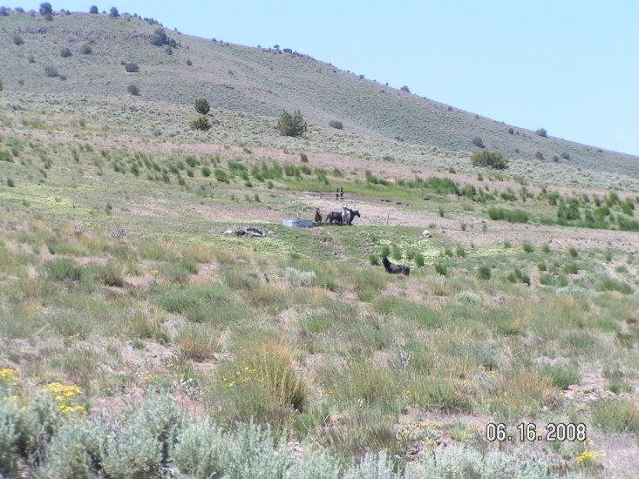  Cadet Spring Trough. This area burned in 1999. Note production of grasses and other species. The light colored vegetation is white top, an invasive noxious weed. June 2008. | 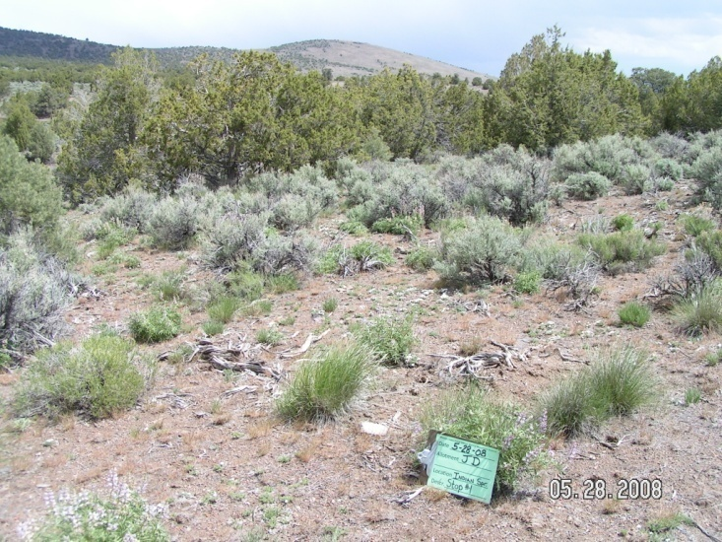  Central portion of the HMA. Note grass production. Area not being utilized by wild horses. May 2008.
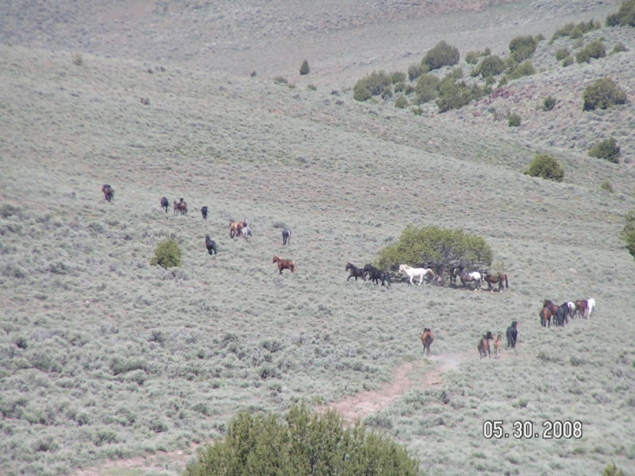  Geyser Creek area. Heavy wild horse presence in this part of the HMA. May 2008. | 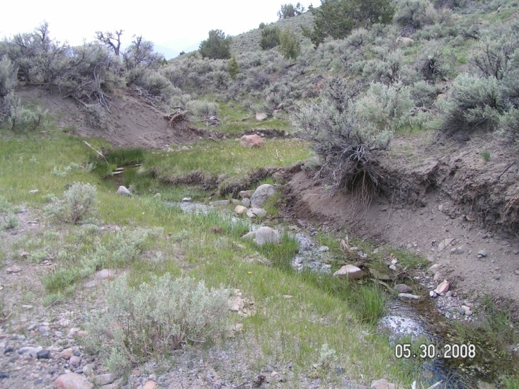  Geyser Creek. May, 2008.
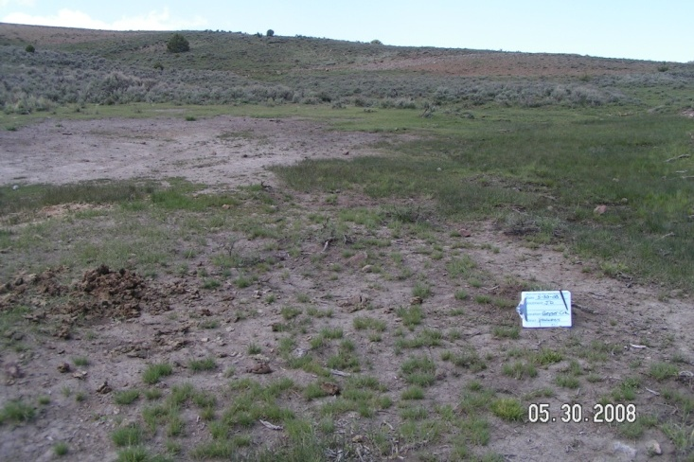
Upper Headwaters of Geyser Creek. Springs are dry,
and wild horse presence is high. May 2008.

The vegetation communities within the Rocky Hills HMA are currently adequate to support the wild horse AML range for the HMA. Severe winters that cause lower elevations to become covered with thick snow could cause forage shortages. Overall, however forage is not the limiting factor within the HMA. Waters are limited, and many historically used sources exist on private land and have been fenced. Few perennial streams exist, and many of the drainages go dry in summer. Additionally, some springs have gone dry due to heavy use compounded by years of drought conditions. Water and space are the limiting factors for this HMA.

